NAME THESE MONSTERS!

Can you name these monsters and/or the name of the movies that they are from? One point per correct answer!

You can get extra bonus points on the last one if you can name not only the movie, the monster/actor, the heroine and one of the character actors plus the same answers on the original movie it was based on!

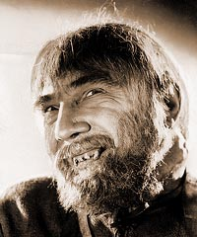

The Monster: _______________________ The Movie: ______________________________

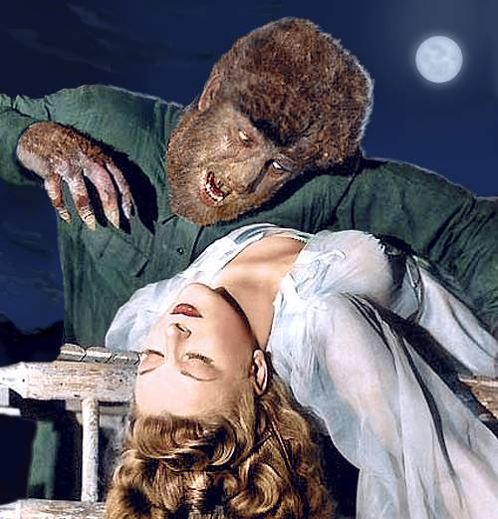

The Monster: _______________________ The Movie: ______________________________

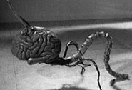

The Monster: _______________________ The Movie: ______________________________

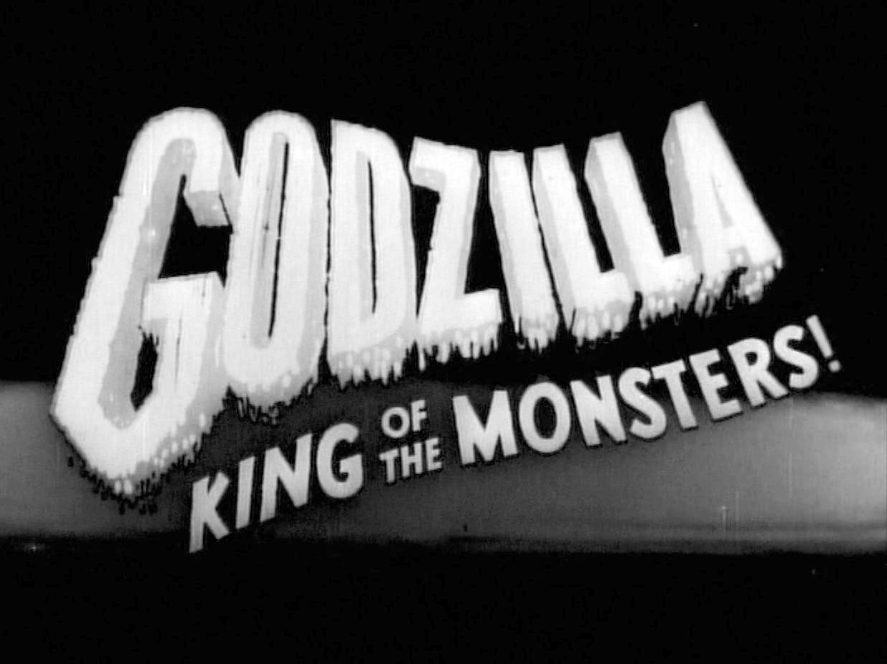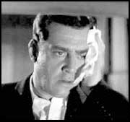

The Monster: _______________________ The Movie: ______________________________

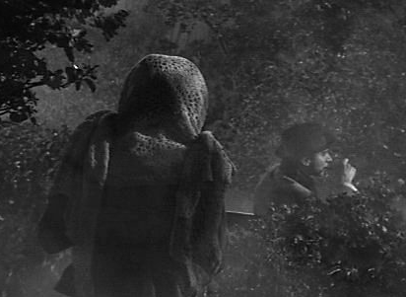

The Monster: _______________________ The Movie: ______________________________

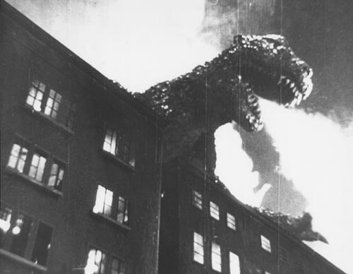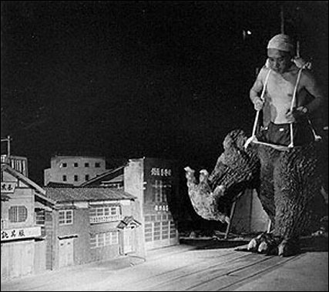

The Monster: _______________________ The Movie: ______________________________

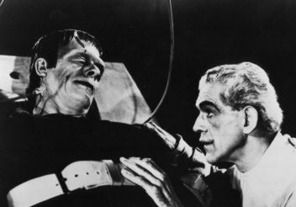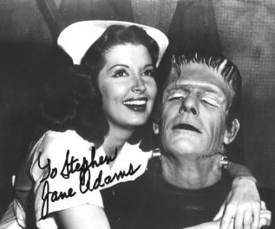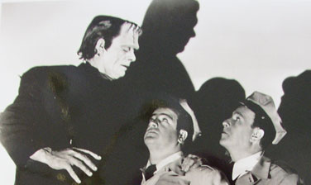

The Monster: _______________________ The Movie: ______________________________

The Monster: _______________________ The Movie: ______________________________

The Monster: _______________________ The Movie: ______________________________

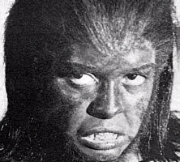

The Monster: _______________________ The Movie: ______________________________

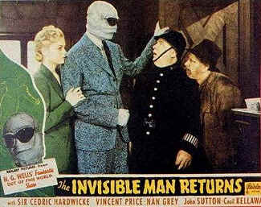

The Monster: _______________________ The Movie: ______________________________

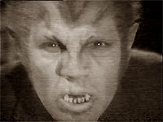

The Monster: _______________________ The Movie: ______________________________

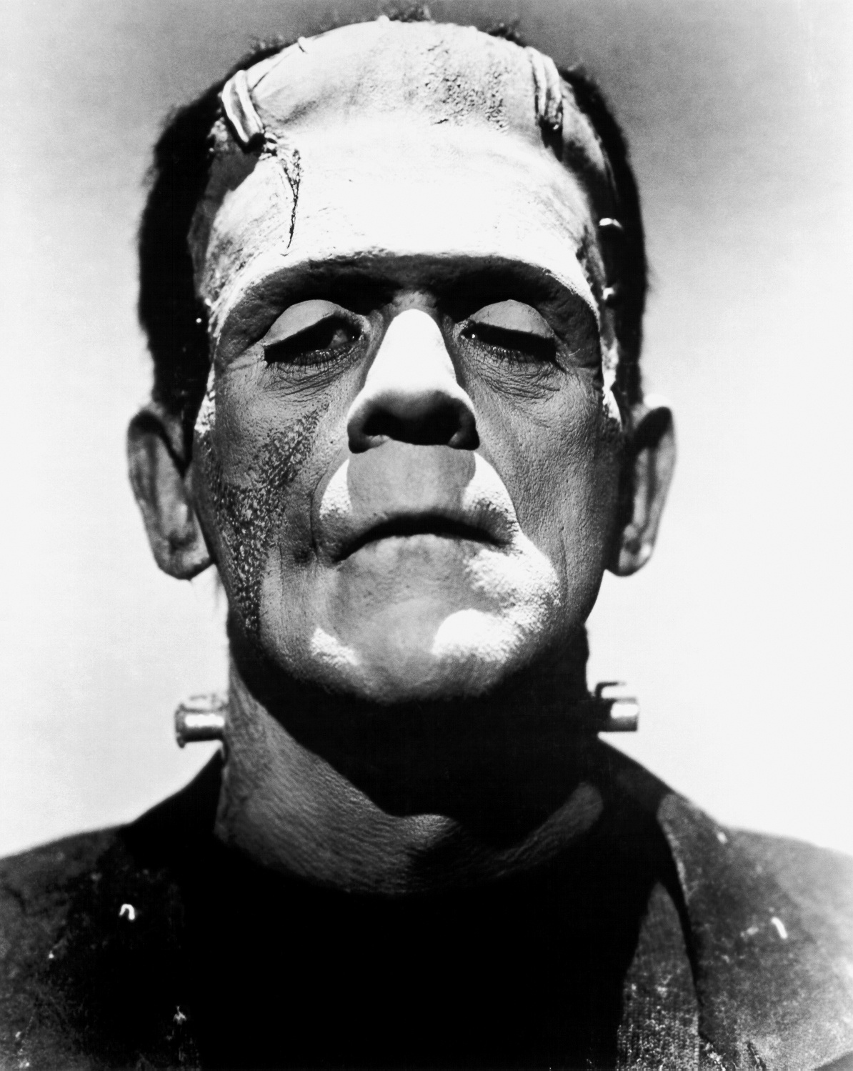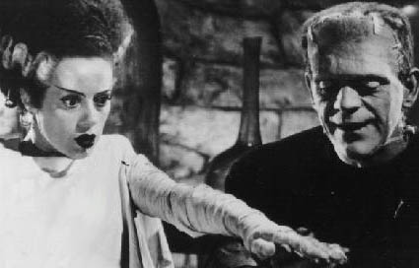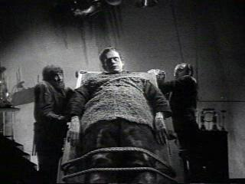

The Monster: _______________________ The Movie: ______________________________

The Monster: _______________________ The Movie: ______________________________

The Monster: _______________________ The Movie: ______________________________

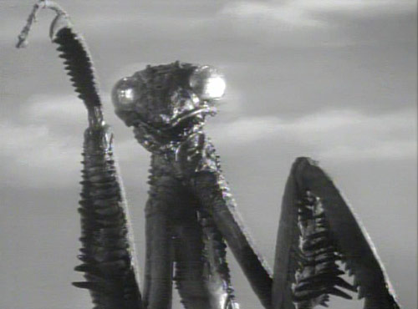

The Monster: _______________________ The Movie: ______________________________

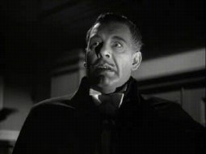

The Monster: _______________________ The Movie: ______________________________

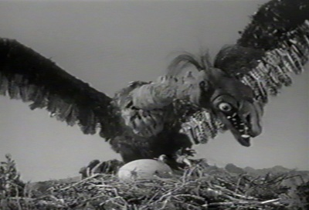

The Monster: _______________________ The Movie: ______________________________

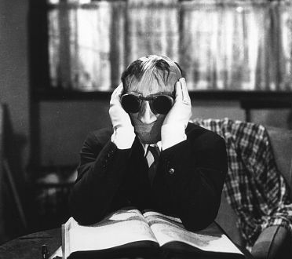

The Monster: _______________________ The Movie: ______________________________

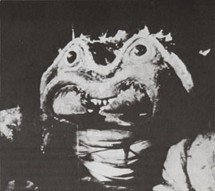

The Monster: _______________________ The Movie: ______________________________

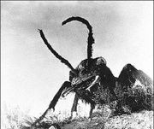

The Monster: _______________________ The Movie: ______________________________

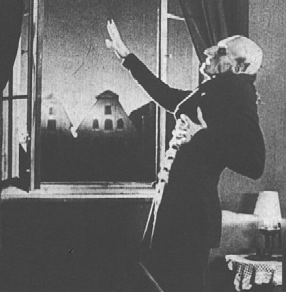

The Monster: _______________________ The Movie: ______________________________

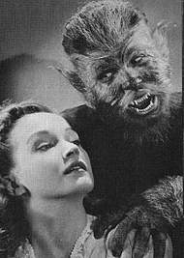

The Monster: _______________________ The Movie: ______________________________

And Now . . .

For Extra Credit!
. . .

For five (5) extra points: Name the movie, actor who plays the monster, and the actress/heroine . . . and for the original movie!

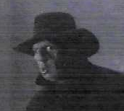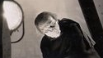

The Movie: ________________ The Original: _______________

The Monster: ______________ The Monster: _______________

The Heroine: ______________ The Heroine: _______________

