SEPTEMBER, 2007 VOLUME 2, Issue 9

The Old Movie Maven

CHARLIE CHAN LIVES;
Or, To Heck With the Politically Correct Peril!

~~~

The Old Movie Maven (TOMM) is published once a month for
those lovers of classic movies and the actors, directors,
costume designers, make-up artist, cameramen
and the other people who never got enough
credit for all their hard work
over the years.

COMMENTS, QUESTIONS AND SUGGESTIONS ABOUT SUBSCRIPTIONS AND BACK ISSUES CAN BE SENT TO

Virginia Johnson
Publisher/Editor

P.O. Box 54493 theoldmoviemaven@yahoo.com Hurst, TX 76054 http://theoldmoviemaven.tripod.com

SUBSCSRIPTION:
One (1) Issue - $ 5.00
Six (6) Months - $15.00
One (12) Year - $30.00
Back Issues - $ 5.00 @

<><><><><><><><><><><><><><><><><>

ALL MOVIES ARE AVAILABLE COMMERCIALLY OR ON YOUR
LOCAL CABLE CHANNELS UNLESS OTHERWISE NOTED.

<><><><><><><><><><><><><><><><><>

TABLE OF CONTENTS:

FROM MAVEN’S DESK: PAGE: 3

ARCHITECTURE OF THE MONTH:
The Oakland Bay Bridge PAGE: 11

B-FEATURE: Mr. Moto’s Gamble (1938) PAGE: 22

BACK ISSUES: PAGE: 26

BLOOPERS:
Charlie Chan’s Secret (1936) Audio Commentary PAGE: 5

HOLLYWOOD MARRY-GO-ROUND:
Hamilton McFadden and Violet Dunn PAGE: 7

LOCATIONS: The Black Camel (1931) PAGE: 11

MAIN EVENT: Charlie Chan’s Secret (1936) PAGE: 19

MAVEN’S BOOKSELF: Earl Derr Biggers PAGE: 9

MAVEN’S CREAM OF THE CROP: PAGE: 25

MAVEN’S SERIES: SURPRISE! PAGE: 11

PERSON OF THE MONTH: Abbott and Costello PAGE: 8

QUOTE OF THE MONTH:
CHARLIE CHAN/Warner Oland PAGE: 4

UNIVERSAL MONSTERS GENEALOGY:
Abbott and Costello Meet Frankenstein (1948) PAGE: 14

WEBSITE OF THE MONTH:
www.newattheroyal.com PAGE: 18
<><><><><><><><><><><><><><><><><>


FROM MAVEN’S DESK: Jeez, It’s the Cops!

Yes, Maven admits it.
She’s been a Charlie Chan Fan for the last . . . yes, since she was a mere youngster of twenty or so.
Twentieth Century-Fox Studio brought out their third volume of Chan films and Maven has had a chance to watch them.
WOW!
The set not only includes Behind That Curtain and The Black Camel, but Charlie Chan on Broadway and Charlie Chan at Monte Carlo.
The studio has also included a still restoration of Charlie Chan’s Chance (1932) similar to Turner Classic Movie Channel’s London After Midnight with Lon Chaney, Sr.
One big difference that audiences will find is the disconcerting audio of the script that goes along with it. . . . There are too many Chan films out there for Warner Oland fans to be entirely comfortable with somebody else voice on the restoration.
But it’s something to have in lieu of actually finding the lost film.
There are other goodies in this set and Maven does love her goodies.
One is Dr. Henry Lee: The Modern Day Charlie Chan.
The modern day equivalent of Chan from the O.J. Simpson trial appears to talk about the forensics that Chan used back in the thirties.
Like the still new test for gunshot residue on possible perpetrators hands.
One irony is that Charlie Chan does use magnifying lenses in Charlie Chan at the Circus (1936) to find out that hairs left at the scene of the crime were . . . gorilla hairs. Not only that but they are dead gorilla hairs.
Personally, they would have to be dead gorilla hairs for Maven to collect them for a gorilla suit but that’s just her!
Dr. Lee enjoys the moment to say that Charlie was not only ahead of the pack in 1936 but he would need modern microscopic equipment to get down to the cell level to tell even what animal, much less whether it was dead or not.
Maven knew Chan was an incredible detective but even she never knew how good he was!
They also have Charlie Chan and the Rise of the Modern Detective as a nice companion piece to boot.
Various stores will quote prices for the set at $40.00 + but Fox threw in some extra featurettes besides Dr. Lee’s documentary.
And Maven is lucky enough to know one of the other participants: Rush Glick, of www.charliechan.info and our Chan Chat Room that congregates on Monday nights at 8:00 P.M. (Eastern time) with the Chan movie of the night starting at 8:30.
The World of Charlie Chan covers all of the cities that Charlie Chan covered in his career as a Honolulu detective plus how these cities mattered in the current events of the times.
The Aphorisms of Charlie Chan has many of the memorable sayings that were in the movies. Not all of them or the comic bits that ensued but still a fun segment!
And finally Charlie Chan Is Missing: The Last Days of Warner Oland.
Maven had heard quite a lot about how Oland had exited the series but this feature goes over new material plus photographs. What makes it even better is inclusion of family.
One last note on the set.
For some reason Fox hasn’t brought out the early Chan movies in chronological order.
But it can work as is since this set includes two of the earliest Chans still existing plus Warner Oland’s farewell appearance in . . . at Monte Carlo.
The first one is Behind That Curtain from the Earl Derr Biggers’ Chan mystery that was done over for Warner Baxter with Boris Karloff in a small part.
It’s a good story. Converting it to a romantic movie for Baxter may have been a good idea at the time but this was 1929, folks, and even Warner Baxter did some considerable chewing of the scenery.
And Charlie gets maybe two minutes maximum on screen plus his big scene when he shots the bad guy is off screen.
Darn it.
The Black Camel was made two years later and is much better, plus the ironic inclusion of Bela Lugosi and Dwight Frye as suspects right after they had made Dracula.
There is still some overacting and Oland is still growing in the part of Charlie Chan but it’s a great movie with great actors with great photography, etc.
Charlie Chan Collection # 3.
Maven recommends it for movie lovers in general, Chan fans certainly and for students of film.
Now . . . what is that popcorn . . . ?

QUOTE OF THE MONTH: CHARLIE CHAN (Warner Oland)

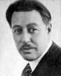

Always harder to keep murder secret than for egg to bounce on sidewalk.

The Black Camel (1936)
BLOOPERS: Charlie Chan’s Secret (1936) Audio Commentary
and The Black Camel (1931)

Maven has found a major blooper in the third set of the classic Chinese Detective series, Charlie Chan!
And it wasn’t made by the studio!
Ken Hanke (author of Charlie Chan at the Movies, McFarland, 1989) and John Cork (film historian who put together the featurettes on the third boxed set of Charlie Chan movies) did a great job on the audio commentary of Charlie Chan’s Secret (1936) . . . except for one tiny, little mistake.
Charlie Chan is meeting with Mrs. Lowell (Henrietta Crosman) and her family: her daughter, Janice Gage (Astrid Allwyn); her son-in-law, Fred Gage (Edward Trevor) and her lawyer, Warren T. Phelps (Jonathan Hale).

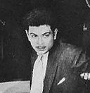
(Edward Trevor as Fred Gage)

The only thing is that they confuse Edward Trevors’s character of Fred with Charles Quigley’s Dick Williams.
They do get it right that Williams is a newspaper reporter and in love with Mrs. Lowell’s other daughter, Alice (Rosina Lawrence).

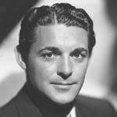
(Charles Quigley)

What makes it more amusing is that they do describe Trevor right, as not being “leading man” quality with a rather screwy light voice, but give him Quigley’s name of Dick Williams and his much longer career (including the deliciously named The Crimson Ghost, 1946).
Maven just has to wonder just how long has it been since they looked at the opening credits, www.imdb.com, www.charliechan.info or Maven’s own records of her favorite Charlie Chan movie?! . . . .
But there are lots of regular old bloopers in Charlie Chan’s Secret!
From how do the folks back home know that the murdered-victim-to-be, Allan Colby, was on his way home to how the bad guy gets everything done when it would take at least two to three people and sometimes in two or more places at the same time!
There is the scene at the start of the movie where Charlie has hired a boat crew to dive for survivors of a ship that may have gone down with Allan Colby.
One of the divers comes up and the briefcase that he brings up switches from wet to dry and back and some of the papers inside look like they were never wet to begin with!
Their commentary is very informative about the only Chan movie that Fox made on location—The Black Camel [1931], also in this collection—about the director (Hamilton McFadden) and his techniques, the actors (Bela Lugosi), the plot, the makeup, and even the dress designer Dolly Tree!

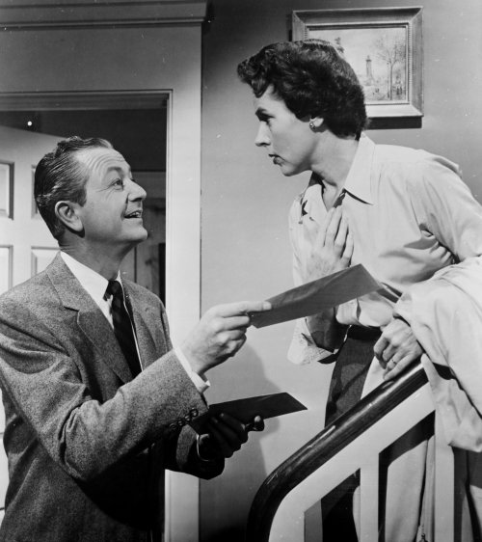
(Robert Young with Jane Wyatt as Jim and Margaret Anderson in
their classic television show Father Knows Best [1954 – 1960])
There are other bloopers, too, like how does Charlie not notice Tarneverro (Bela Lugosi) and Julie O’Niel (Sally Eilers) hiding pieces of a picture strewn all over the floor?
The picture is of an actor, Denny Mayo. Other pictures of him are seen cut out of a newspaper in the local library.
It’s a plot device to hide his picture that doesn’t make sense once you find out who done it.
And there is a scene of Warner Oland’s Chan with J.M. Kerrigan and Mary Gordon (Mrs. Hudson to Basil Rathbone’s Sherlock Holmes) as the MacMasters. He mentions talking to them earlier in the day but there is no scene.
Probably it was deleted but the studio either forgot about the reference or considered it too expensive to correct.

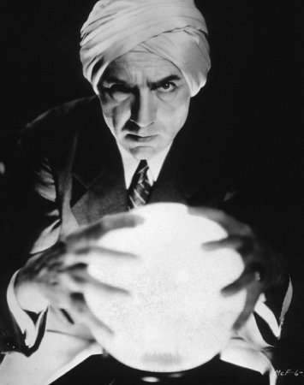
(Bela Lugosi as Tarneverro in The Black Camel [1931])

There are other bloopers but The Black Camel definitely worth watching, as a mystery and an early talky and to watch Bela Lugosi still at his best, right after Dracula, as the psychic, Tarneverro.
He has an excellent scene with Dorothy Revier as Shelah Fane over a crystal ball that is beautifully scripted, lighted, and acted . . . well-worth watching.
Charlie Chan’s Secret and The Black Camel have plot holes and bloopers but they have always been among Maven’s favorite movies of all time.
They are even more worth watching now that Fox has restored them to like-new along with the other movies in this collection: . . . on Broadway, . . . Monte Carlo, Behind That Curtain (the 1929 Derr Biggers book made into a Warner Baxter romantic movie).
Definitely a good buy!

HOLLYWOOD’S MARRY-GO-ROUND:
Hamilton McFadden and Violet Dunn

Check out Hamilton McFadden’s entry over at the www.imdb.com/name/nm05321871. . . . He is rather unusual among the actors in the Chan films:

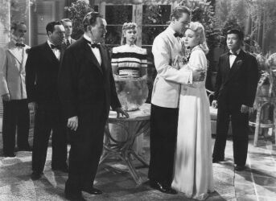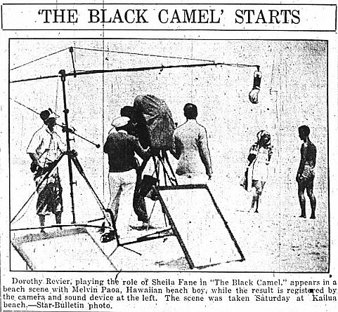
(Hamilton McFadden on the far left in Charlie Chan in Rio [1941] and his back
in the center of the right-hand picture in the Honolulu Star-Bulletin.
Let Maven know if you come across any better shots of him!)

He directed three of them: Charlie Chan Carries On, 1931; The Black Camel, 1931; and the first week’s shooting on Charlie Chan in Paris, 1935.
He acted in three: Charlie Chan’s Greatest Case, 1933; Charlie Chan in Reno, 1939; Charlie Chan in Rio, 1941.

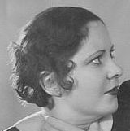
(Violet Dunn)

And he was married in private life to Violet Dunn, who played an important role in The Black Camel. . . . Okay. . . . [SPOILER!] . . . . She’s the killer!
This in addition to the fact that McFadden is one of those actors that little is known about other than on www.imdb.com and in the Chan movies.
So PLEASE let Maven know if you come across any information and/or photos about this mystery man and/or his wife, Violet Dunn!
You can always reach me at theoldmoviemaven@yahoo.com!

PERSON OF THE MONTH: Abbott and Costello

Maven is departing from her usual interviews in honor of Abbott and Costello Meet Frankenstein (1948) this month as part of her Universal Monster Genealogy.
Maven has two goodies from Abbott and Costello: links to both a video of their “Who’s On First?” routine from their television show and to a text version of it. Maven has a copy of the text that runs to eleven pages so you can see why you’re getting the link and not the actual pages!!

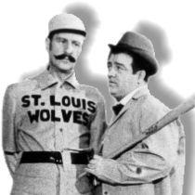
(Abbott and Costello)

So click, sit back with your popcorn and soda and enjoy!

www.youtube.com/watch?v=IEaKjRyPjVY (video)

www.baseball-almanac.com/humor4.shtml
(This is the text version. There is a link to the audio at the bottom of the page.)

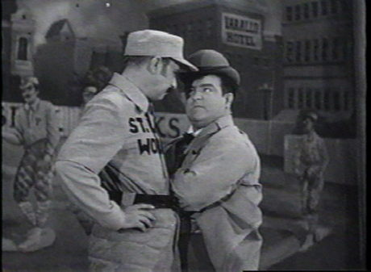
(Abbott and Costello doing their “Who’s On First?” routine)
MAVEN’S BOOKSHELF: Earl Derr Biggers

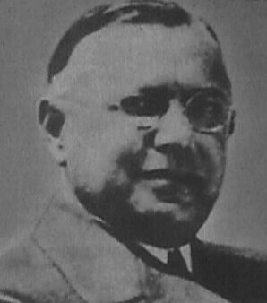
(Earl Derr Biggers)

Earl Derr Biggers wrote five Charlie Chan novels, four of which became Hollywood movies (including The Black Camel [1931]); one, The Keeper of the Keys [1932], became a Broadway play.
But Biggers wrote other stories as well, several of which are still available.

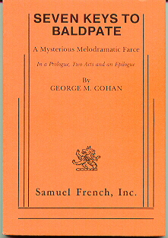
(A Vintage version of
Seven Keys to Baldpate)

One, Seven Keys to Baldpate (1913), is on Maven’s Bookshelf.
The plot is basically a good one: a writer goes to an isolated inn on a frozen mountain. A perfect place to write his Great American Novel.
Except that people keep popping up and trying to pop each other off.
Sheesh!
How irritating can guests get?!
It’s been made into a movie several times but Maven has only seen the 1947 version with Phillip Terry and Margaret Lindsay. It’s well-worth checking out.

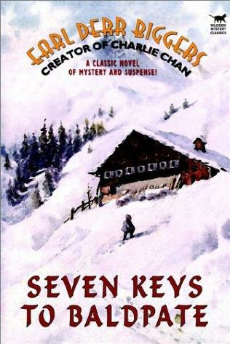
(www.wildsidepress.com - $35.00)

You can check it out for yourself by reading the e-text at http://arthursclassicnovels.com/arthurs/biggers/sevbal10.html. If you want a hard text, you can troll the internet for a copy or check out www.wildsidepress.com for their $35.00 beautifully-made version among their many old and new books.
Maven must warn you that it can be difficult to read if you’re not used to the style of writing practiced pre-World War I:
I

WEEP NO MORE, MY LADY

A YOUNG woman was crying bitterly in the waiting room of the railway station at Upper Asquewan Falls, New York. A beautiful young woman? That is exactly what Billy Magee wanted to know as, closing the waiting-room door behind him, he stood staring just inside.
Were the features against which that frail bit of cambric was agonizingly pressed of a pleasing contour? The girl’s neatly tailored corduroy suit and her flippant but charming millinery augured well. Should he step gallantly forward and inquire in sympathetic tones as to the cause of her woe? Should he carry shivery even to the lengths of Upper Asquewan Falls?
No, Mr. Magee decided he would not. The train that had just roared away into the dusk had not brought him from the regions of skyscrapers and derby hats for deeds of knight errantry up state. Anyhow, the girl’s tears were none of his business. A railway station was a natural place for grief—a filed of many partings, upon whose floor fell often in torrents the tears of those left behind . . . .

Maven has been a readaholic for decades since the ripe old age of twelve but even she had difficulty slogging through this, Charlie Chan completist that she is.
But Maven wants to be fair to her readers.
You have been warned!

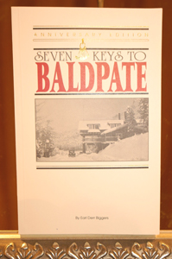
(www.baldpateinn.com)

[Those who would like to know more about the actual Baldpate Inn can click on the website above, especially since it’s for sale.
Or contact Maven at theoldmoviemaven@yahoo.com for a free copy of the stories of the HAUNTINGS at the old Inn!]
MAVEN’S SERIES: SURPRISE!

Maven is being factious because this whole issue is basically given over to Charlie Chan!!
Maven will just take this opportunity to mention that her favorite actor to play Charlie Chan was Warner Oland who reminds her of her beloved grandfather, Albert M. Griffith.

(Warner Oland)

And Maven has an article by fellow Chanfan Steve Rhodes, called “Warner Oland Insights,” available through http://tommenterprises.tripod.com/id8.html, complete with photographs.
For free no less!

ARCHITECTURE OF THE MONTH: The Oakland Bay Bridge

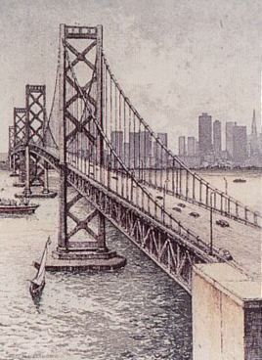
(The Oakland Bay Bridge, San Francisco, CA)

The Oakland Bay Bridge is briefly featured in Charlie Chan’s Secret (1936) and bridge and movie were both ironically made in 1935 and restored in 2007.

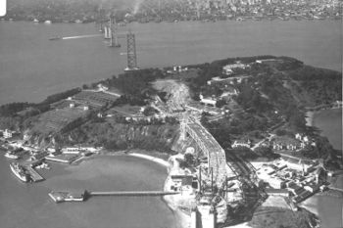

Unfortunately, Maven doesn’t have a shot of the bridge in the movie in that scene from the movie but you can see it through the window/porthole of the clipper that Charlie Chan is traveling on early in the movie.

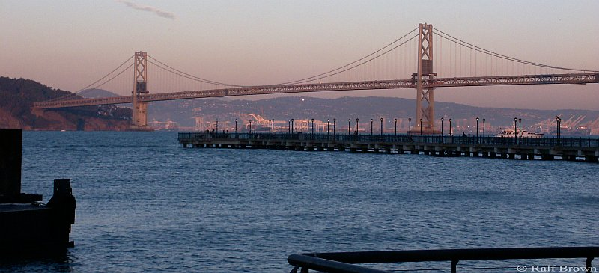

There are various places that can be pulled up on Google about the Oakland Bay Bridge but there are two that Maven would like to mention:

www.baybridgeinfo.org for a quick look or

www.library.ca.gov/crb/04/03/04-013/pdf for a longer perusal (50 pages)

So watch the movie and see how quick your eyes are whether you can catch!

LOCATIONS: The Black Camel (1931)

The Black Camel (1931) was the only Charlie Chan entry in Twentieth Century-Fox Studio’s series to actually be filmed on location in Honolulu, Hawaii.

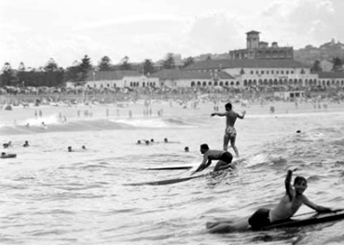

It starts off with a great shot like this one of Hawaiian natives surfing, one of whom may have been the legendary Duke Kahanamoku.
There was considerable publicity in the Honolulu Star-Bulletin since the studio sent what seemed to be the entire cast and crew to Honolulu.

(Courtesy of the Honolulu Star-Bulletin)

The publicity of their staying and filming various parts Royal Hawaiian Hotel and nearby beaches didn’t hurt!

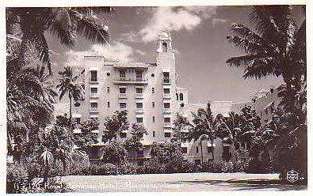

Unfortunately, the pink of the hotel couldn’t be appreciated in the black and white of The Black Camel.

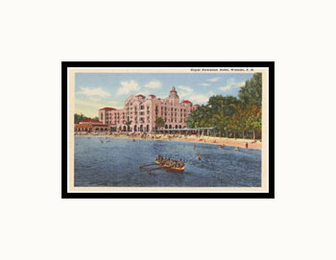
(An early postcard)

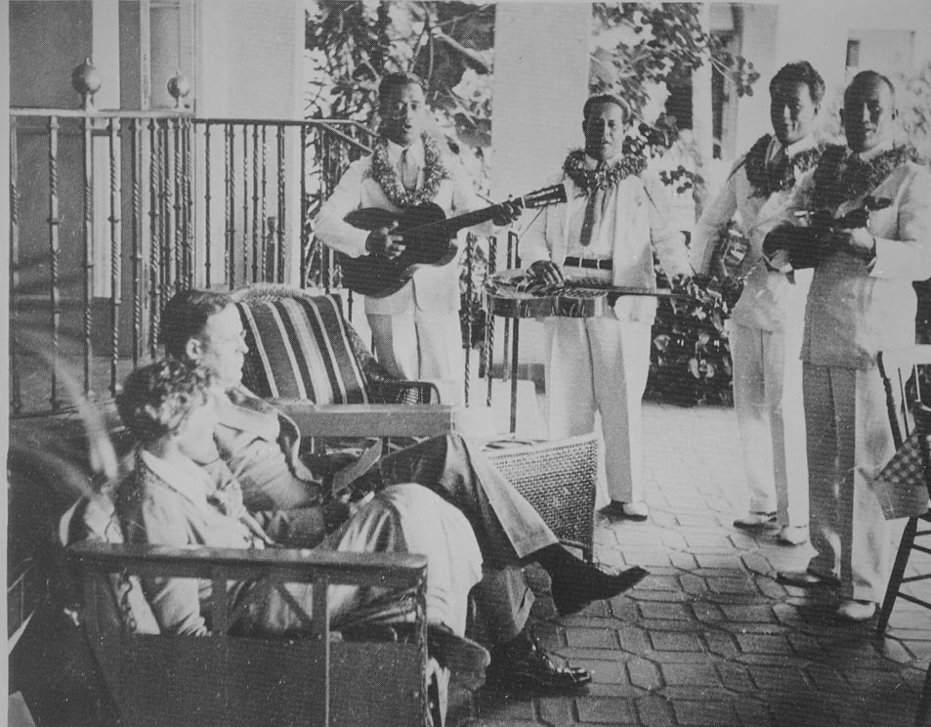
(Amelia Earhart and her husband, George P. Putnam)

The Royal Hawaiian Hotel had been justifiably famous as a luxury hotel and for such visitors as Amelia Earhart to Shirley Temple.
It continues to attract vacationers today, after a loving restoration that has kept much of the hotel intact from the time that The Black Camel was filmed there 70+ years ago.


(A more recent shot of the Royal Hawaiian Hotel.)

UNIVERSAL MONSTER GENEALOGY:
Abbott and Costello Meet Frankenstein (1948)

Maven couldn’t leave well enough alone!
Universal revived their monsters three years after the House of Dracula in an Abbott and Costello movie of all things.
Abbott and Costello Meet Frankenstein could be viewed as an illegitimate child to their monster movies but then you have to deal with Bela Lugosi as Dracula and Lon Chaney as the Wolf Man.
Okay, Glen Strange was repeating his Frankenstein Monster from the last two movies but he’s not Boris Karloff, is he?
Frank Ferguson plays a horror museum entrepreneur named McDougal who is bringing the bodies of Dracula and the Frankenstein Monster to Florida where Bud Abbott and Costello are to deliver them to his house of horrors.
While they are arranging the details of delivery, Larry Talbot phones from London to try to stop them.
One thing about this entry is that Lon Chaney, Jr.’s makeup as the Wolf Man isn’t done by Jack Pierce, Universal’s resident genius of their earlier monster movies but Bud Westmore.

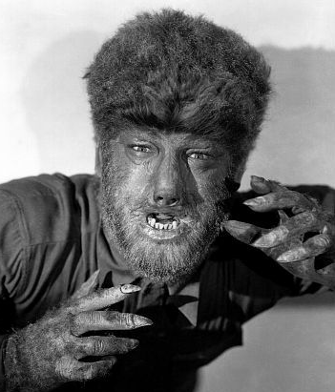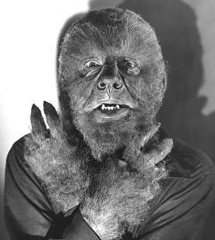
(Lon Chaney’s Wolf Man, created by both Jack Pierce, left, and Bud Westmore)

Westmore’s version almost makes Maven think of the childhood rhyme about “Fuzzy Wuzzy was a bear . . . “!
And this version is certain different in other ways, including the fact that Dracula, the Wolf Man and the Monster spend extended periods together.
All those movies and they finally get the guys together in one room!
This is also a first in that Dracula is the one who is seeking a new brain for the Monster. . . . Three guesses whose brain!

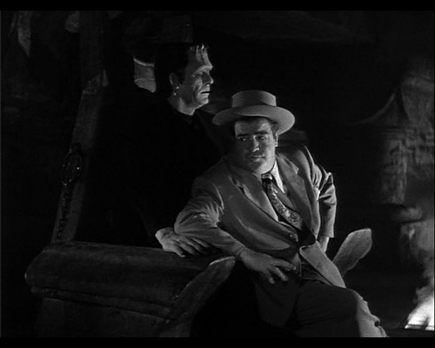
(Glenn Strange as the Monster and
Lou Costello as Wilbur Grey)

Dracula and Lou Costello have a great segment at the beginning of the movie that is typical Abbott and Costello.

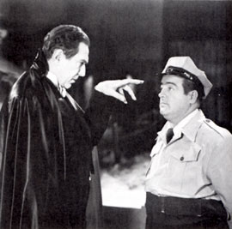
(Bela Lugosi as Count Dracula and
Lou Costello as Wilbur Grey)

Bud Abbott and Lou Costello get the crate of Dracula to the museum and Bud goes out to get the Monster off the truck.
Surprise! Surprise!
Lou gets frightened by candles that move as Dracula’s lid starts creaking open (in a scene similar to one later in Hold That Ghost [1941] with Joan Davis) and by our favorite Count climbing in and out of his coffin.
We also see Dracula activate the Monster by holding his ring close to the monster’s neck bolts and eyelids.
Dracula entrances Costello as Drac and his “protégé” leave, with a cute moment as the Monster is frightened by Costello’s presence.
Does Bud believe him?
No, and neither do McDougal or the Insurance Company’s representative.
Of course they don’t or we wouldn’t have any movie . . . and if they hadn’t thrown A&C into jail, Abbott and Costello wouldn’t have been bailed out of jail by a mysterious woman.
Turns out that she isn’t the lady doctor who has been making a play for Costello . . . Dr. Sandra Mornay (Lenore Aubert) who Dracula has brought to transplant Bud’s brain into the Monster for the Count’s complete command.
She’s Joan Raymond (Jane Randolph), the insurance investigator hoping to use a trick of Charlie Chan’s on Costello: Let the bird out of his cage and he’ll lead you to what you want to know and maybe she’ll solve the case.
This is one of the things that Maven loves about this movie: Seeing Lou Costello not only getting the girl but two of them and Bud Abbott being hacked about it throughout the movie!
The basic plot is no surprise.
Abbott and Costello and half the cast go to a masquerade party to give A&B, Lon Chaney and Bela Lugosi a chance to run amuck and get our intrepid heroes back to Dracula’s lair for the surgery.
Once back at the castle, we have more mayhem but with a difference . . . Dracula and the Wolf Man are fighting all over the place while the Frankenstein Monster chases Abbott and Costello all over the same territory.
So do our Universal Monsters get their final ending?
The Monster gets another “bath” by fire, the Wolf Man grabs Dracula as the later transforms into a bat and they both plunge off the balcony into the ocean . . . and who should show up at the end but . . . .

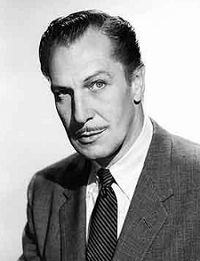
(Vincent Price as The Invisible Man [1940])

So this is the end of Maven’s Universal Monster Genealogy . . . unless Maven happens to remember any other classic Universal Horror Monster movies . . . .
BBBBwwwwwaaaaaahhhhhaaaaaaaaaaa!

Universal Monster Genealogy

Dracula (1931) Frankenstein (1931)
| |* Heinrich
| |
| |
| The Bride of Frankenstein (1935)
Dracula’s Daughter (1936) |
| |
| |
| Son of Frankenstein (1939)
| | Wolf* & Elsa |
| | |Peter || The Wolf Man (1941)
| | Ghost of Frankenstein (1942) |
| | | Ludwig |
Son of Dracula (1943) | | Elsa |
| |Frankenstein Meets the Wolf Man (1944) |
| | Elsa ( ?* ) |
| House of Frankenstein (1944) |
| House of Dracula (1945) |
| |
| | | A & C Meet Frankenstein (1948) |

*This is according to Son of Frankenstein (1939).
*Just who’s daughter is this Elsa, played by Ilene Massey?

P.S. This is an interesting list of who played whom in the Universal Monster Series. Maven is including it for those who want to check it out: www.hauntedjack.com/menbehind.html - Glenn Strange
WEBSITE OF THE MONTH: www.newattheroyal.com
Newt at the Royal



A popular part of the Royal Hawaiian Hotel is “Newt at the Royal” – www.newtattheroyal.com – where you can find Panama hats similar to the hat that Charlie Chan wore in the Twentieth Century-Fox series.

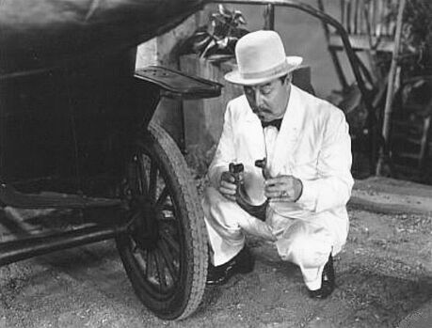
(Warner Oland in Charlie Chan’s Greatest Case
[1933], wearing his distinctive Panama Hat)

As a matter of fact, a Chanfan friend of Maven’s went there on an anniversary a few years ago and his wife surprised him with one from Newt’s during dinner at the Royal Hawaiian . . . not to mention the fun of realizing that they were there while a television commercial was being filmed.
You can also find the history and information about their famous Aloha Shirts:

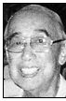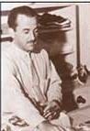
(Ellery J. Chun and George Brangier and their Aloha Shirt)

The Aloha Shirts were popularized in the 1930s by Ellery J. Chunn and George Brangier.
Brangier’s company, Branfleet, eventually became Kahala Sports Wear.
You can also have them send you their colorful brochure.
Just one more way to check out Honolulu!!

THE MAIN EVENT: Charlie Chan’s Secret (1936)

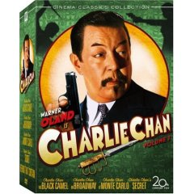

Fox has finally brought . . . Secret to DVD in their third collection of Chan films along with The Black Camel (1931), Charlie Chan on Broadway (1937), Charlie Chan at Monte Carlo ((1937), and the infamous Behind That Curtain (1929) that was switched from a Chan Mystery to a romantic role for Warner Baxter.
All the movies have been restored to looking like they are brand new and . . . Secret looks like it at the get-go.

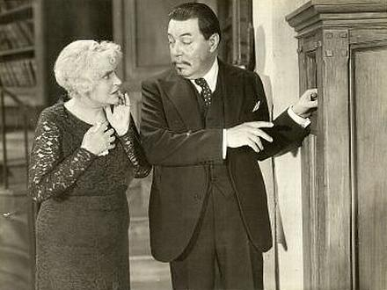
(Henrietta Crosman as Henrietta Lowell
and Warner Oland as Charlie Chan)

Charlie Chan’s Secret is not only one of Maven’s favorite movies. . . . Maven took her nom de Chan of “Mrs. Henrietta Lowell” after the lady who hires Charlie in this movie, played by the superb actress, Henrietta Crosman.
Scintillating choice of names, isn’t it?!
One think about . . . Secret is that Ms. Crosman’s wealthy matriarch takes an active part in finding her long-lost nephew, something like a much more active Miss Marple by Agatha Chirstie. She is certainly one of Hollywood’s stronger characters.

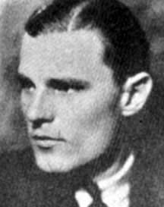
(Jerry Miley as Allen Colby)

Our favorite Chinese detective finds information about her nephew, Allen Colby, and heads for California to make his report.
He finds himself in a lovely nest of . . . well, are they the old-fashioned kind killers or do they have some other-worldly help?
Yep, Charlie Chan is smack up against ghosties, ghoulies, swindlers and murderers.
And nothing or anyone is as they seem as Chan tries to unravel his most spooktacular mystery.

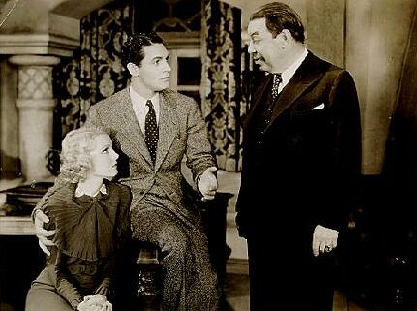
(Rosina Lawrence as Alice Lowell and Charles Quigley
as her newspaper boyfriend, Dick Williams)

There are a plethora of the usual suspects, including Mrs. Lowell’s two daughters and son-in-law, Dick Williams (a reporter romancing one of the daughters), Mrs. Lowell’s lawyer (Jonathan Hale as Warren T. Phelps) and . . .
If you have séances . . . you have to have a medium.

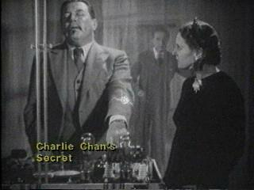
(Oland gets “short” with Arthur Edmund Carewe and Gloria Ray as Charlotta)
The “heebie-geebie” parts are a most interesting mixture.
Gloria Ray plays Charlotta straight, as a serious psychic who is trying to help Mrs. Lowell in the matriarch’s search for truth.
Arthur Edmund Carewe brings all his credibility from such movies as Lon Chaney, Sr.’s The Phantom of the Opera (1925/1929) and Mystery of the Waxed Museum (1933) with Lionel Atwill.
Can you trust him or not . . . at least until the scene when Charlie has discovered the source of their séance music and gets a charge out of it.

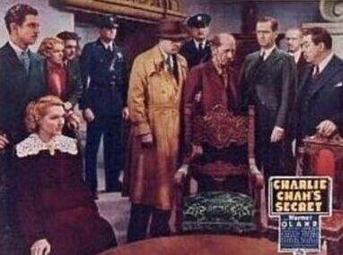
(Left to right, Edward Trevor as Fred Gage, Astrid Allyn as Janice
Gage, Rosina Lawrence as Alice Lowell, Charles Quigley as Dick Williams,
unknown, unknown, unknown, Egon Brecher as Ulrich, Ivan Miller as Morton,
Jonathan Hale as Warren T. Phelps, and Warner Oland as Charlie Chan)

And here you have all the suspects, albeit from a poster showing Charlie and the police bringing them together for the denouement in the séance room.
Certainly the coloring looks like they’ve been pulled from some other galaxy, doesn’t it?!
Not to mention that the house looks like it was designed by Frank Lloyd Wright on peyote.
No wonder they need spirits in this movie.
Where’s Maven’s wine . . . .
Maybe she can borrow a bottle some Sunday from her church . . . ?!
And what of the comic relief?
No Stepin Fetchit from Charlie Chan in Egypt (1935)?
The stereotypical black won’t show up again until the Charlie Chan franchise gets going again in the 1940s at Monogram studios.
Any more of the Chan children?

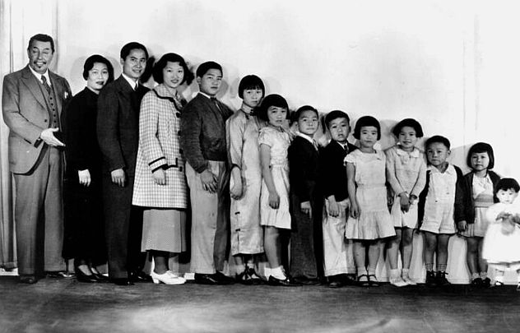

After the whole family shows in the movie before . . . Secret, Charlie Chan at the Circus?!?!
Nuh-uh.
He gets a butler!

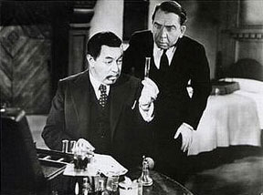
(Oland and Herbert Mundin as Baxter)

Maven is partial to Herbert Mundin as Mrs. Lowell’s Baxter, who adds to not only the comic relief but to helping Chan in his own way to solve the mystery.
Mundin has just the one shot in the Chan canon but he adds to a great – and very spooky – entry in the Charlie Chan movies.
Especially if you watch it on a cold and rainy night with a big bowl of popcorn, your favorite soda and . . . .
Did you hear that . . . .
Hmmm . . . .

THE B-FEATURE: Mr. Moto’s Gamble (1938)

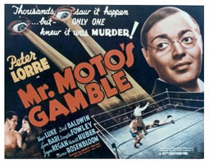

Mr. Mot’s Gamble was Twentieth Century-Fox Studio’s attempt to salvage what had already been done for Charlie Chan at the Ringside.
The set of the Chan movie was reputed to be a trouble set with Warner Oland waking off several times until he flat didn’t return one day.
There are stories that he had had to be kept drunk on the sets to help achieve his persona of the Chinese Detective based in Honolulu to the point that it may have backfired on the studio when he finally had an alcoholic breakdown of some sort.
He recovered enough to sign a new contract and given time off to return to Sweden.
Unfortunately, Fox had some $100,000 invested in Charlie Chan at the Ringside and scrambled around to recoup some of it.
And there is no telling how much Keye Luke’s love of boxing may have had to do with the conversion to . . . Gamble but he does add something of the Chan flavor as a cross-over of sorts as # 1 Son, Lee Chan.

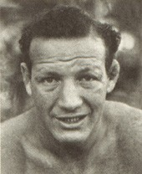
(“Slapsie Maxie” Rosenbloom
as “Knowout” Wellington”)

Mr. Moto’s Gamble has another interesting touch in a secondary sidekick with Lee Chan: Maxie Rosenbloom, whose style as a former light heavyweight boxing champion won him the nickname of “Slapsie Maxie.”

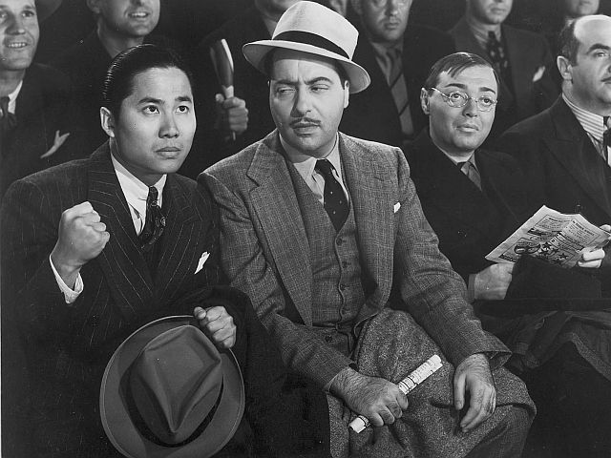
(Keye Luke as Lee Chan, Harold Huber as Lieutenant Riggs,
and Peter Lorre as Moto in Mr. Moto’s Gamble [1938])

The audience sometimes could tell that Peter Lorre wore just a touch of eyeliner in close-ups as the Japanese spy, Moto, but otherwise didn’t wear anything more than his glasses when he wore them.

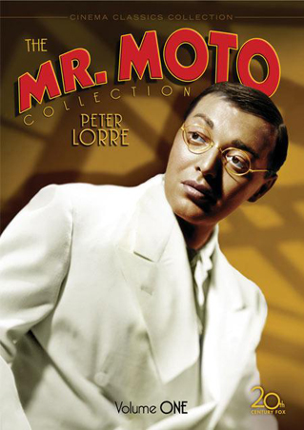
(The art work for the boxed sets of Mr. Moto # 1 and Charlie Chan # 3)
Another carry over from the Charlie Chan series was Harold Huber, a veteran of some four Chans from . . . on Broadway (1937) to the Sidney Toler years in . . . Rio (1941).
His performance here as Lieutenant Riggs is on a par with his Inspector Nelson in . . . Broadway: Deliciously vintage New York City!!
He even says that he’d still be single if he hadn’t worn that tiger-skin costume to that party . . . !
Maven would have loved to have gone to that party.

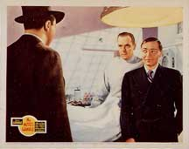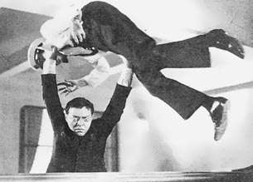
(Mr. Moto’s Gamble – 1938 versus Think Fast, Mr. Moto – 1937
. . . from mild to just plain oddball??!)

There is some dissension among the Chan vs. Moto lovers, citing Moto’s tendency to use force that included martial arts. (Ironically, a stunt double was used in those scenes.)
Moto also never came across as cute and loveable as Chan did in at least the Warner Oland years.

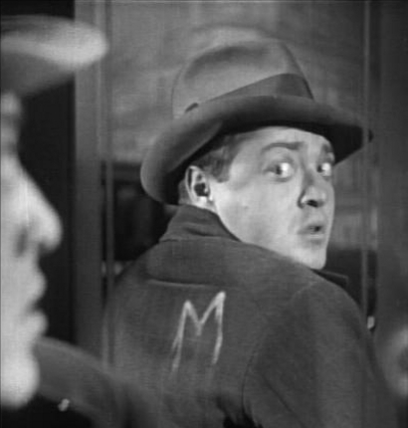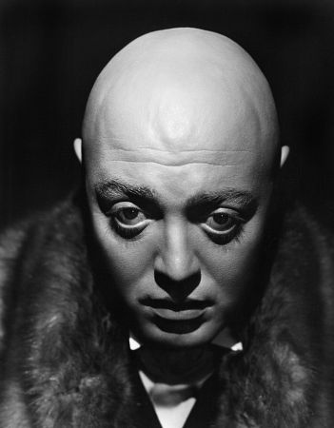
(As Hans Beckert in M [1931] and Gogol in Mad Love [1935])

It’s also rather difficult to forget Lorre’s creepy roles as the killer in the German-made M from 1931 or his Grand Guignol role as Dr. Gogol in Mad Love (1935).
But Mr. Moto’s Gamble is still a Moto film with lots of action both in and out of the ring, with Moto teaching a forensic course on the mainland who gets embroiled into the mysterious death of a boxer.
The audience is also treated to plenty of character actors like Ward Bond, Lyn Bari, Lon Chaney, Jr. and John Hamilton who went on to great success as Perry White on television’s Superman with George Reeves!
But what a way to be remembered!
<><><><><><><><><><><><><><><><><>

MAVEN’S CREAM OF THE CROP!

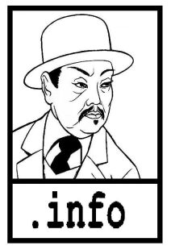

CHARLIE CHAN FAMILY – This is Rush Glick’s superb website devoted to the Great Chinese Detective based in Honolulu.
Rush is not only a gracious friend and teacher to Maven (among many!) but now he’s an expert that Fox Studio interviewed in their featurettes included in the boxed sets of their newly restored and released Chan DVDs.
Just click on www.charliechan.info!

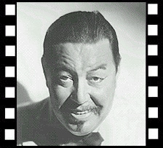

CHARLIE CHAN.NET – Kurt Schmidt has the message board that’s like a coffee house for Chan-aholics and has been around for some 10 years . . . longer than some marriages that Maven has known!
It’s just a click to www.charliechan.net!

TORY’S MYSTERY MOVIES – Maven has been getting movies from Doug Palmer for more years than she’s had her blogs and websites!
Doug has movies that Maven has never heard of . . . he’s that good! . . . plus various TV series and all worth checking out at www.torysmysterymovies.com/TorysAboutUs.cfm!

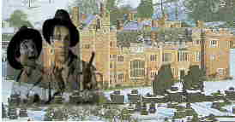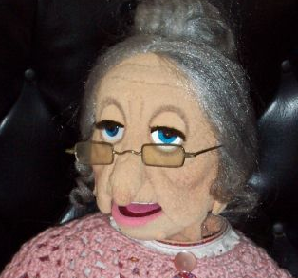
(Trillo and Suede’s Boxford Park and Lady Sarah)

TRILLO AND SUEDE – This is a link to Jonathan Geffner’s short subject, Boxford Park, starring his Trillo and Suede in a dummy noir story at www.trilloandsuede.com/movie.html.
You can download the movie at www.trilloandsuede.com/movielink.html that stars Lady Sarah, a delightful lady who can also be found at www.geffner.com.

<><><><><><><><><><><><><><><><><>

BACK ISSUES: Of The Old Movie Maven (aka TOMM)

Back issues of The Old Movie Maven are $3.50 each,
and make your check or money order payable to:

Virginia Johnson
The Old Movie Maven
P.O. Box 54493
Hurst, TX 76054

VOLUME 1 – Issue 1: Donnie Dunagan, James Arness and Peter Graves, Want-Ads, and Film Noir.

VOLUME 1 – Issue 2: Happy Valentine’s Day!, www.clarkgable.com, Olivia de Haviland and Joan Fontaine, Want-Ads, and Romantic Movies.

VOLUME 1 – Issue 3: GOING BATTIE WITH VINNIE: Or, The Price Is Right!, www.vincentprice.com, Charlie Chan on Broadway, Lady Sleuths in the Movies, Eve Arden, The Innes-Brown House, The Bat (1959) and The Invisible Man Returns (1940).

VOLUME 1 – Issue 4: Mae West, http://charliechanfamily.tripod.com, Blondes at the Movies, Charlie Chan Chat Room, Rush Glick, Psycho (1960), Want-Ads.

VOLUME 1 – Issue 5: GIRLS! GIRLS! GIRLS! Or, Do Blondes Really Have More Fun?, Dorothy Parker; www.charliechan.net; Kurt Schmidt, Nancy Drew; Shirley Temple and Orson Welles; Jean Harlow and Paul Bern; The Paul Bern House; Colleen Moore and Mary Astor; Colleen Moore’s Doll House.

VOLUME 1 – Issue 6: A FAMILY AFFAIR; Or, Who’s Your Daddy?; John Barrymore; www.lonchaney.com; Charlie Chan; Perry Mason; Happy Mother’s Day!; The First Face Transplant; A Marriage Made . . . Only in Hollywood?, House of Dracula; The Quiet Man; Lon Chaney, Father and Son; Guess Who?; Want-Ads; Back Issues.

VOLUME 1 – Issue 7: WHODUNIT; Or, Brother, Can You Spare a Joke?; Bob Hope; www.imdb.com; Ernest Morrison; Dead End Kids/East Side Kids/Bowery Boys*; Haunted Spooks ; The Cat and the Canary (1927) and (1939) and The Ghost Breakers; FLASH: Harold Lloyd; Mickey Rooney and Ava Gardner; Charlie Chan in Egypt (1934); The Smiling Ghost.

VOLUME 1 – Issue 8: WHOZAT; Or, Character Actors . . . from A to Z; Character Actors; Let’s Get Started; Let’s Get Started (Who Did What In Which); Whozat? Cartoon.

VOLUME 1 – Issue 9: DUELING DOCTORS; Or, Calling Dr. Howard, Dr. Fine, Dr. Howard; Maven’s Battie Family; A Day at the Races; The Three Stooges; A Dr. Jekyll and Mr. Hyde Quiz; Dr. Kildare vs. Dr. Christian; Universal Monsters’ Genealogy – Dracula’s Dr. Van Helsing; The Mad Scientist; Grouch Marx; Stooging the Blues Away . . . Men in Black (the 1934 version!); http://theoldmoviemaven.tripod.com.

VOLUME 1 – Issue 10: LUGOSI: THE UNIVERSAL DRACULA; Or, Taking the BITE out of Crime-fighters!; Happy Halloween; Bela Lugosi Quotes; www.lugosidve.com and www.artgreenhaw.com/music.html; Gary Rhodes and Art Greenhaw; Munsters’ Mansion (www.munstermansion.com); Angelo Rossitto; LUGOSI: Hollywood’s Dracula; The Lugosi Mystique.

VOLUME 1 – Issue 11: THE AMERICAN HOME IN FILM: Or, The Home Front Circa World War II; Paul Tibbets, the Enola Gay, etc.; Shirley Temple; http://myweb.wvnet.edu/~u0e53/carlalaemmle.html; Carla Laemmle; Shirley Temple Paper Dolls; Boston Blackie; Universal Monsters’ Genealogy – Frankenstein; Charlie Chan Collection, Volume 2;Gene Markey; Tora! Tora! Tora! (1970); The Home Front.

VOLUME 1 – Issue 12: THE BATTLE OF THE SEXES: Or, Is There Really Sex in the Cinema?; Sex in the Cinema 101; Walter Winchell; Carla Laemmle; Shirley Temple Black; Star of Midnight (1935); Universal Monsters’ Genealogy: The Bride of Frankenstein (1935 – And a glance back at Dracula – 1931); Powell/Loy Still?; Charlie Chan; Tarzan (1932); The Thin Man (1934).

