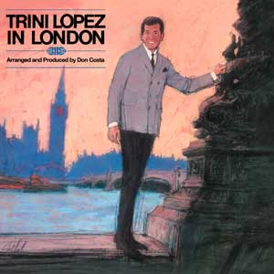
(Trini Lopez in London: The album that he made in – surprise! –
London while filming The Dirty Dozen [1967])

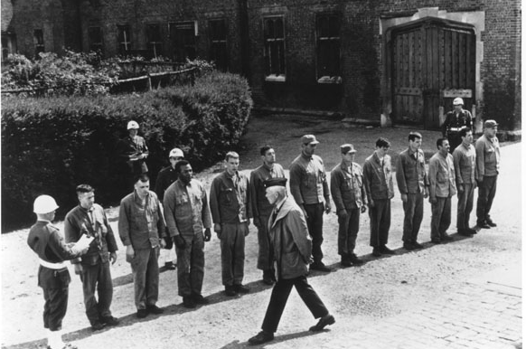

“The Dirty Dozen” with (left to right)

February, 2007 VOLUME 3, Issue 2

The Old Movie Maven

BARRYMORE, WAYNE AND CO.;
Or, Johns in the Movies.

~~~

The Old Movie Maven (TOMM) is published once a month for
those lovers of classic movies and the actors, directors,
costume designers, make-up artist, cameramen
and the other people who never got enough
credit for all their hard work
over the years.

COMMENTS, QUESTIONS AND SUGGESTIONS ABOUT SUBSCRIPTIONS AND BACK ISSUES CAN BE SENT TO

Virginia Johnson
Publisher/Editor

P.O. Box 54493 theoldmoviemaven@yahoo.com Hurst, TX 76054 http://tommenterprises.tripod.com

SUBSCSRIPTION:
One (1) Issue - $ 5.00
Six (6) Months - $15.00
One (12) Year - $30.00
Back Issues - $ 5.00 @

<><><><><><><><><><><><><><><><><>

ALL MOVIES ARE AVAILABLE COMMERCIALLY OR ON YOUR
LOCAL CABLE CHANNELS UNLESS OTHERWISE NOTED.

<><><><><><><><><><><><><><><><><>

TABLE OF CONTENTS:

FROM MAVEN’S DESK: PAGE: 4

B-FEATURE: JOHN WAYNE PAGE: 32

BACK ISSUES: PAGE: 35

CHARLIE CHAN ANNEX: CHINATOWN,
FU MANCHU AND CHARLIE CHAN PAGE: 5

HOLLYWOOD MARRY-GO-ROUND:
MARY BETH HUGHES AND TED NORTH PAGE: 27

MAIN EVENT: JOHN BARRYMORE PAGE: 29

MAVEN’S BOOKSELF:
THE CASINO MURDER CASE (PHILO VANCE) PAGE: 22

MAVEN’S CREAM OF THE CROP: PAGE: 34

MAVEN’S SERIES:
THE CASINO MURDER CASE (Philo Vance) PAGE: 23

PERSON OF THE MONTH: TRINI LOPEZ PAGE: 25

QUOTE OF THE MONTH: Warner Oland PAGE: 24

UNIVERSAL MONSTERS GENEALOGY: FOREBEARS, OFFSHOOTS, KISSIN’ COUSINS AND WANNABES
THE INVISIBLE MAN RETURNS (1940) PAGE: 12

UNIVERSAL MONSTERS GENEALOGY:
THE WITCH’S DUNGEION: 40 YEARS OF CHILLS PAGE: 14

WEBSITE OF THE MONTH: www.trinilopez.com PAGE: 11

<><><><><><><><><><><><><><><><><>
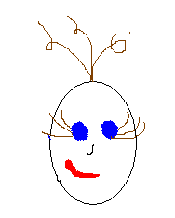

FROM MAVEN’S DESK:

The quote this month is from Charlie Chan’s Courage (1934) with Warner Oland as the Chinese actor: Always pleasant journey which ends among friends.”

Which is what we have this month, many old friends!

You’ll find many in the second part of this month’s Universal Monster Genealogy, The Witch’s Dungeon©.

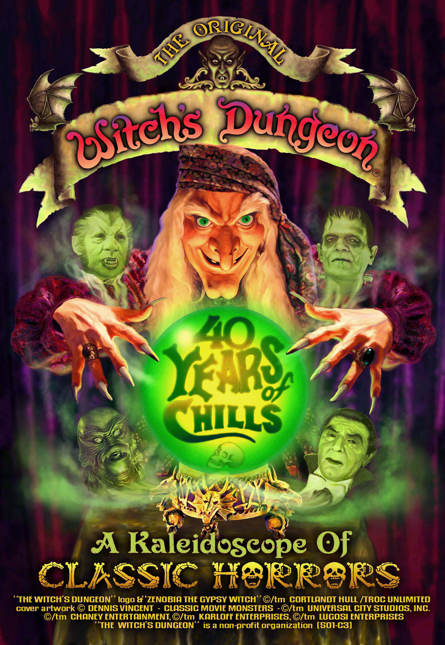
(© The Witch’s Dungeon.)

Not to mention Warner Oland and Fu Manchu in the Charlie Chan Annex plus such heavy hitters as John Barrymore and John Wayne. . . .
This is a big issue so Maven will let you get on with enjoying this issue!

QUOTE OF THE MONTH: Warner Oland

“Always pleasant journey which ends among old friends.”

Warner Oland as Charlie Chan

(Charlie Chan’s Courage – 1934)

CHARLIE CHAN ANNEX:

CHINATOWN, FU MANCHU AND CHARLIE CHAN*

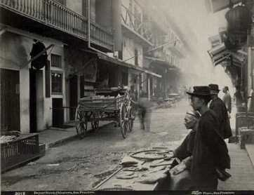

In San Francisco and Oakland in the late nineteenth century, Chinatown was a tough beat. Gambling, opium, male and female prostitution, slavery and other profitable crimes flourished in the midst of Asian immigrants trying to adjust to a harsh, new, and tremendously different world than the one they left behind.
The society outside Chinatown, which was mostly white, was ambivalent about their presence, and sometimes quite hostile. In Chinatown itself, of the burdens the Chinese had to bear, one of the most difficult was the tongs. The tongs were modeled on the social associations that have played an important role in Chinatown life for centuries. Some associations were (and still are) publicly known and served benevolent purposes. Others were secret or semisecret political, or even revolutionary, still others had criminal purposes. In the United States and England the tongs were simultaneously benevolent social organizations and criminal conspiracies. In their beneficial aspect, they were of great value to the Chinese. But when the tongs fought each other for control of the rackets, the highbinders (professional assassins, also known as hatchet men) came into their own, and men and women were not safe. Highbinder murders were quick, as the highbinders were an active menace to residents and visitors alike, Chinatown remained isolated and was looked on by the majority community mainly as a vice district.

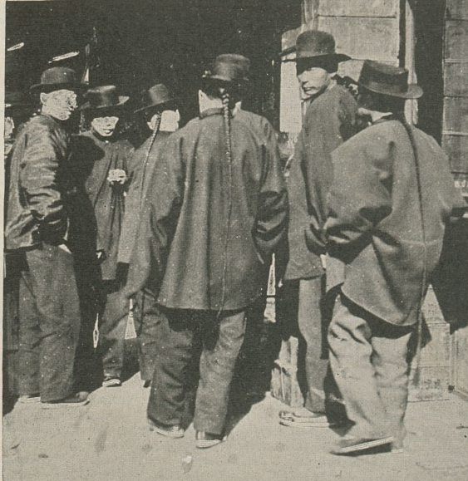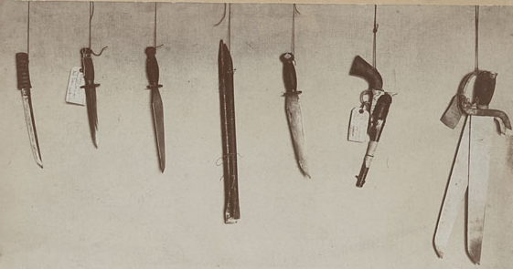
(Highbinders and their weapons)

The special Chinatown squads, along with the regular beat officers in San Francisco and Oakland were an important part of the effort to control routine crime in Chinatown. But they performed an even more important function that was vital to the assimilation of the Chinese into American society: they helped to suppress the violence of the tongs. For many of the years that he ran the central district (downtown) in Oakland, Captain J. Frank Lynch had a magnificent Oriental rug in his office—alas, long since disappeared. It was a gift he had been given by the Chinese merchants for his part in negotiating peace among the local tongs. He was very proud of that rug.
Interacting with the Chinese was not without cost to the reputation of the police departments. This was especially true in the area of gambling enforcement. The tongs never really bought the idea that gambling should be illegal; instead, they bought a lot of the police officers, and paid them off to allow the lotteries to function.
When the highbinders disappeared and Chinatown grew quiet, the Chinese and their outside neighbors began to come to terms with one another. Chinatown underwent a transformation from a red light district into a tourist attraction. Chinese culture rose in the estimation of the majority population. Chinese peoples began moving into the surrounding society and absorbing as much of its culture as was valuable to them.
The racial and cultural turmoil of the tong war days in the background against the dramas of Fu Manchu and Charlie Chan were enacted in the world of thrillers and mystery stories. Fu Manchu, the great master of the tongs, came first.

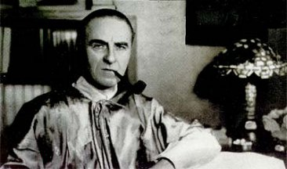
(Sax Rohmer, creator of “Fu Manchu.”)

Sax Rohmer, the English Orientalist and student of the occult, created Dr. Fu Manchu in 1913. He published thirty novels about him, the last of which appeared in 1959. Villains of Fu Manchu’s stripe are out of fashion nowadays. Mystery writer Bill Pronzini summed up the current opinion of him and his creator when he wrote, “Dr. Fu Manchu and the other Oriental supercriminals [sic] were a product of the ‘Yellow Peril’ hysteria of the first quarter of this century, and certainly do not bring credit to writers . . . and racial groups different from their own.”
Sax Rohmer was an avid student of Middle Eastern and Far Eastern culture. Maybe he was a racist, but if so, not in the ordinary way. In an autobiographical sketch he wrote, “I cannot doubt that I spent at least one incarnation beside the Nile. Throughout my school days I studied hieroglyphics. . . . The Middle East . . . enthrall[ed] me—especially Egypt. Interest in the Far East was to come later. When I took up the study of art, my own paintings were almost exclusively Oriental in character.” It seems that his involvement with China and the Chinese was a rather complicated and idiosyncratic mix of attraction and repulsion.
But he was also a professional writer who had the luck to create a notable character. Dr. F Manchu belongs to the melodramatic tradition of ingenious weapons, trap doors, secret hiding places, wild chases, hairbreadth escapes, and plots to conquer the world. He is a brother to Professor Moriarty, projecting the same qualities of malevolent omnipresence: in the early years of the century any unsolved crime in London must have been committed by one or the other of them. In Sax Rohmer’s novels the reader gets a full dose of what Robert Corrigan ahs called “the overriding tone of paranoia which informs melodrama. . . . For melodrama’s great achievement is its capacity to give direct objective form to our irrational fears.”

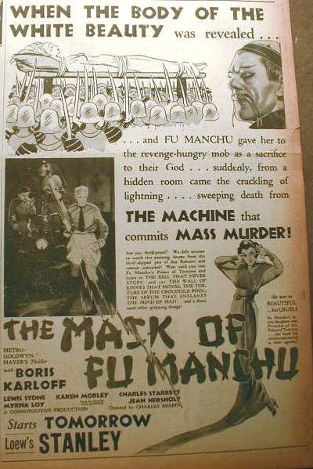
(Advertisement for The Mask of Fu Mancu
(1932) with Boris Karloff as Fu Manchu.)

For of course the Fu Manchu stories depend on a circumstance that generates paranoia; Fu Manchu can never conquer the world, nor can he ever be finally defeated and disposed of by Nayland Smith. Fu Manchu must survive if the stories are to continue. Consequently, on one story after another, the brilliant Nayland Smith and the fiendishly clever, infinitely resourceful, and deadly Fu Manchu behave, by any realistic standard, like bumbling nitwits. The tales are really chains of non sequiturs. If someone is late for an appointment, Nayland Smith knows to a certainty that Fu Manchu is responsible. Fu Manchu spends years training exotic animals to kill his enemies, when any competent tong master would hire a highbinder, who would dispatch the target in a minute.

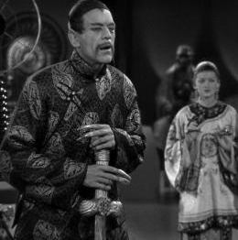
(Boris Karloff as Fu Manchu and Myrna Loy as
Fah Lo See in The Mask of Fu Manchu [1932].)
Sax Rohmer kept writing Fu Manchu stories up to the time of his death. By then, the world had changed enormously. Asian nations had grown powerful beyond anyone’s expectations back in 1916 but fear of the Yellow Peril had largely abated by 1959. And Fu Manchu’s place in popular entertainment had been taken by Charlie Chan.

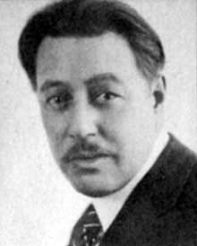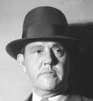
(Warner Oland, who became Charlie Chan,
and Sidney Toler, who replaced him.)

Earl Derr Biggers wrote his novels of Charlie Chan, the Hawaii-born detective, between 1925 and 1932. Charlie Chan became an almost mythic figure—like Sherlock Holmes or, at a more serious level of literature, Babbitt or Elmer Gantry—a character whose life transcends the stories in which he appears. There were so many Charlie Chan movies (at least thirty) that it is surprising to realize that Biggers actually wrote only six novels. In the movies Charlie Chan—as played by Warner Oland (who had also played Fu Manchu) and Sidney Toler—was a man in whom you could place absolute confidence.

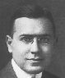
(Earl Derr Biggers
as a young man)

Biggers said of him, “Sinister and wicked Chinese are old stuff, but an amiable Chinese on the side of law and order had never been used. . . . If I understand Charlie Chan correctly, he has an idea that if you understand a man’s character you can nearly predict what he is apt to do in any set of circumstances.”
In the 1925 novel The Chinese Parrot, Charlie Chan made his first visit to San Francisco’s Chinatown. It was Chinese New Year’s Eve:

At a little after eight, the detective from the islands left the friendly glow of Union Square and, drifting down into the darker stretches of Post Street, came presently to Grant Avenue. A loiterer on the corner directed him to the left, and he strolled on. In a few moments he came to a row of shops displaying cheap Oriental goods, for the tourist eye. His pace quickened; he passed the church on the crest of the hill and moved on down into the real Chinatown.
Here a spirit of carnival filled the air. The façade of every Tong House, outlined by Hundreds of glowing incandescent lamps, shone in yellow splendor through the misty night. Throngs milled on the narrow sidewalks—white sightseers, dapper young Chinese lads in college-cut clothes escorting slant-eyed flappers attired in their best, older Chinese shuffling along on felt-clad feet, each secure in the knowledge that his debts were paid, his house scoured an scrubbed, the new year auspiciously begun.
At Washington Street Chan turned up the hill. Across the way loomed an impressive building—four gaudy stories of light and cheer. Gilt letters in the transom over the door proclaimed it the home of the Chan Family Society. For a moment the detective stood, family pride uppermost in his thoughts.

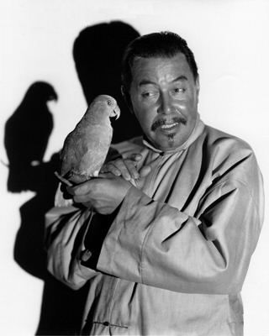
(Warner Oland as Charlie Chan in the 1927
movie version of The Chinese Parrot.)

In an obituary of Earl Derr Biggers, The Nation said that Charlie Chan symbolized the sagacity, kindliness, and charm of the Chinese people, and that “his epigrams redistilled the wisdom of the ages in a new and captivating fashion.”
Today, with large numbers of new Asian immigrants in the United States, law enforcement officials have expressed apprehension about rising crime rates in Chinatown. The triads, crime syndicates from the Far East, have made an appearance. Their representatives are almost as sinister as Fu Manchu. They will come up against Excellent Asian-American police officers.

*From Fatal Fascination: Where Fact Meets Fiction in Police Work by Phil and Karen McArdle, 1988, Houghton-Mifflin Company, Boston. Pages 156 – 163.

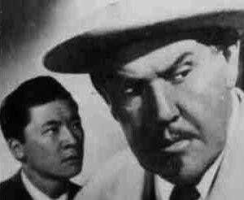
(This article had a picture of Sidney Toler and Victor Sen Yung “as
Charlie Chan and his number one son.” This shot is as accurate
a copy of that photograph as the description of their characters!)

CONTINUED - PART 2

