DECEMBER, 2007 VOLUME 2, Issue 12

The Old Movie Maven

AMERICA GOES TO WAR;
Or, A Day Which Will Live in Infamy.

~~~

The Old Movie Maven (TOMM) is published once a month for
those lovers of classic movies and the actors, directors,
costume designers, make-up artist, cameramen
and the other people who never got enough
credit for all their hard work
over the years.

COMMENTS, QUESTIONS AND SUGGESTIONS ABOUT SUBSCRIPTIONS AND BACK ISSUES CAN BE SENT TO

Virginia Johnson
Publisher/Editor

P.O. Box 54493 theoldmoviemaven@yahoo.com Hurst, TX 76054 http://tommenterprises.tripod.com

SUBSCSRIPTION:
One (1) Issue - $ 5.00
Six (6) Months - $15.00
One (12) Year - $30.00
Back Issues - $ 5.00 @

<><><><><><><><><><><><><><><><><>

ALL MOVIES ARE AVAILABLE COMMERCIALLY OR ON YOUR
LOCAL CABLE CHANNELS UNLESS OTHERWISE NOTED.

<><><><><><><><><><><><><><><><><>

TABLE OF CONTENTS:

FROM MAVEN’S DESK: PAGE: 3

B-FEATURE: The Man Who Came to Dinner (1944) PAGE: 19

BACK ISSUES: PAGE: 24

BLOOPERS: Tora! Tora! Tora! (1970) PAGE: 6

CHARLIE CHAN ANNEX:
PART 1: WARNER OLAND IN NON-CHAN ROLE PAGE: 8

PART 2: LEE CHAN AS A FOREIGN AGENT? PAGE: 9

LOCATIONs:
VASQUEZ ROCKS, LOS ANGELES COUNTY, CA PAGE: 10

MAIN EVENT: TORA! TORA! TORA! (1970) PAGE: 16

MAVEN’S BOOKSELF: The Invisible Man PAGE: 16

MAVEN’S CREAM OF THE CROP: PAGE: 27

QUOTE OF THE MONTH:
The Werewolf of London (1935) PAGE: 4

TRIVIA:
JACK PIERCE AND HIS WEREWOLF MAKEUP PAGE: 12

UNIVERSAL MONSTERS GENEALOGY:
FOREBEARS, OFFSHOOTS . . . PAGE: 13

WEBSITE OF THE MONTH:
A DAY WHICH WILL LIVE IN INFAMY PAGE: 4

<><><><><><><><><><><><><><><><><>


FROM MAVEN’S DESK:

December 7, 2007, is the 66th anniversary of the Japanese attack on Pearl Harbor, Hawaii.
Maven would like to pay tribute not only to the lives affected in that event but the movie based on it, Tora! Tora! Tora!
Maven has something of a bias: her mother had friends who had been there, a doctor in the US Navy and his nurse wife who both had helped to take care of those hurt in the attack. One of their treasures that this couple managed to get out was a fruit bowl that they gave Maven’s mother as a wedding present shortly there after.
The Man Who Came to Dinner was a comedy with the likes of Betty Davis, Ann Sheridan and Monte Wooley that came out on January 1, 1942. It was worked well as an antidote for the American Public still in shock from the attack.
And Maven would like to take a speech from another movie made during the days of World War II because she thinks it still holds true for us today in the aftermath of September 11, 2001:

[From Since You Went Away (1944), with Lionel Barrymore as the clergyman giving the sermon:]

In these troublous times when many of our loved ones are making the supreme sacrifice, I have searched the holy scriptures and my heart for some message of comfort and inspiration to you. On other occasions I have quoted from St. John and the prophet Zachariah. I’ve reminded you of the 23rd Psalm, “Thy rod and thy staff, they comfort me.”

Today I offer you the words of a Maryland lawyer [Francis Scott Key], from another day when Americans were fighting to preserve their sacred heritage of liberty:

“Oh, just be it ever when free men stand shall stand
Between their loved home and the war’s desolation!
Blest with victory and peace, may the heav’n rescued land
Praise the Power that hath made and preserved us a nation.
Then conquer we must, when our cause it is just.
And this be our Motto: “In God is our trust.”

Those words have become the last stanza of our national anthem.

NOTE: This doesn’t include the last two lines of the last stanza:

“And the star-spangled banner in triumph shall wave
O’er the land of the free and the home of the brave!”

For those who want to check this, it’s just over one hour and forty-five minutes into the movie.
Now you’ll know the rest of the story.

QUOTE OF THE MONTH: The Werewolf of London (1935)

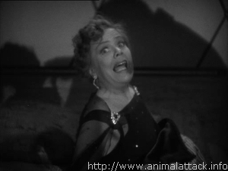
(Spring Byington as Ettie Coombs after
seeing the Werewolf of London [1935])

My wicked worldliness has caught up with me at last.
The Babu of Garoka always said it would.

Ettie Coombs (Spring Byington)

WEBSITE OF THE MONTH:

A DAY WHICH WILL LIVE IN INFAMY

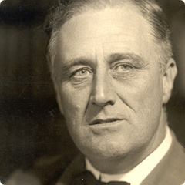
(Thirty-second President Franklin Delano Roosevelt)

How many of us know that phrase, from Franklin D. Roosevelt’s speech asking Congress to declare war on Japan, December 8, 1941?
We all should if we learned our nation’s history properly.
How many of us remember ever hearing the whole speech? Or even past a clip of FDR saying “A day which will live in infamy. . . “?
Maven can’t so Maven did her research.
There is a site that has the audio version and a copy of FDR’s speech:

www.umkc.edu/lib/spec-col/ww2/PearlHarbor/fdr-speech.htm

This is about serious stuff, folks, but well-worth the time to check out for the 66th anniversary of a defining moment in our country’s history.

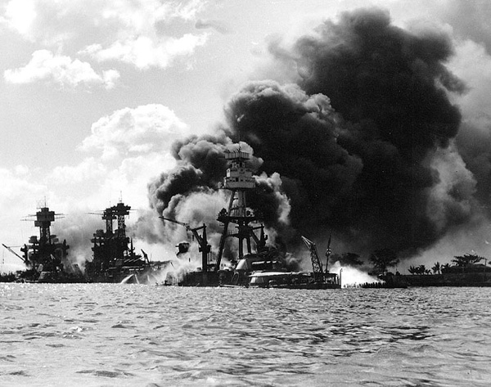
(The USS Arizona, Pearl Harbor on December 7, 1941,
from www.aviation-history.com/airmen/pearl.htm
which has personal memories of the day.)

And besides . . . movies like TORA! TORA! TORA! are great examples of incredible stories told to hold the audiences’ attention, albeit for upwards of three hours.
Maven does have a problem with one reviewer who complained that the movie’s makers spoiled the ending because everybody already knew the ending. . . .
Not to mention the reviewer who complained that the attack wrecked the ending of a great movie: Pearl Harbor (2001) with Ben Affleck.
Picky, picky, picky!
As far as Maven is concerned . . . this romance got in the way of a perfectly good story.
It says something about Hollywood that they found the story behind December 7, 1941, wasn’t enough to pull in today’s movie audiences.
Maybe they didn’t remember the day that remain in infamy anymore than your average American of today.
BLOOPERS: Tora! Tora! Tora! (1970)

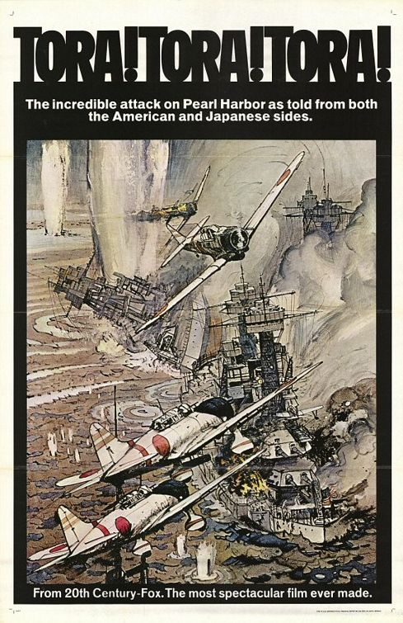
(Poster for the movie Tora! Tora! Tora! [1970])

There are loads of goodies on The Internet Move Database goofs page for Tora! Tora! Tora! (1970) over at www.imdb.com/title/tt0066473/goofs.
They go from all the planes used in the film (that were either not in use in 1941 or otherwise improperly used) to dressing the people (watches and parts of uniforms developed after World War II) to memorials or other monuments (that weren’t built until after 1945), etc.


(The U.S. Navy Band)

Such as the U.S. Navy Band playing The Star-Spangled Banner at the beginning of the attack seems to have the audio and visuals out of sync plus seems to have played it twice.


(The Flying Fortress, models B-17 F and B-17 G)

The movie also substituted B-17 Fs and B-17 Gs of the Flying Fortress for the B-17 D used at the beginning of World War II.


(The B-17 D model of the Flying Fortress)


(The U.S.S. Nevada)

The full-scale replica of the U.S. Nevada in the movie has too many guns versus the miniature used in the Battleship Row scene.


(The U.S. Capital)

The U.S. Capitol shown in the movie was the right building, alright. It was just the wrong time since the building had wooden braces on it while the columns were being rebuilt at the time that Tora! Tora! Tora! was made.
Aw, heck.
Just go to www.imdb.com/title/tt006473/goofs!!

CHARLIE CHAN ANNEX:
PART 1: WARNER OLAND IN NON-CHAN ROLE

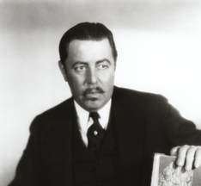

One of Warner Oland’s non-Charlie Chan roles was as a werewolf in Werewolf of London (1934). According to www.imdb.com/title/tt0027194/trivia:

The “original theatrical trailer” provided as a bonus feature on the DVD is actually the re-edited 1935 trailer, with only Henry Hull and Valerie Hobson identified by name, and a Realart re-release title card prepared for the 1951 re-issue. Scenes with Warner Oland are prominently featured, but his name never appears, a typical attempt to disguise the age of the film, since Oland had been dead for many years by the time it was re-released.

“Release.”
“Re-release.”
Maven wonders what Universal calls it when a movie has been released so many times that everybody has forgotten how often!!

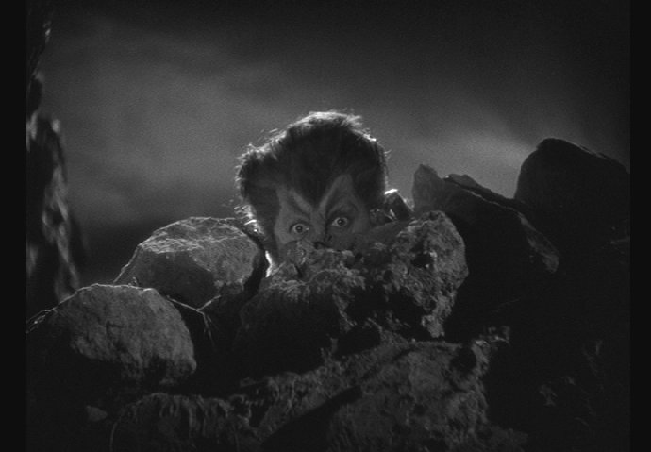

Maven always wants to laugh at this makeup of Warner Oland as a werewolf in Werewolf of London . . . . What WERE they thinking about at Universal?!?!
Did Universal need Oland to look like this to make Henry Hull’s makeup look better and/or more frightening?!

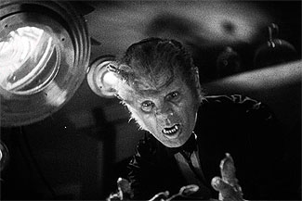
(Henry Hull’s makeup as
The Werewolf of London [1935])

And it says something about Oland and Hull’s acting . . . that they could keep from laughing their heads off in this scene!

PART 2: LEE CHAN AS A FOREIGN AGENT?!

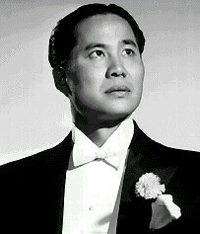
(Keye Luke)

One of Keye Luke’s best-known roles was as Charlie Chan’s Number One Son Lee, not to mention as Master Po in the television series Kung Fu (1972 – 1975).

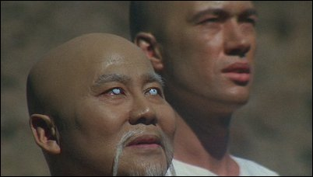
(Keye Luke [left] as Master Po and David Carradine
as Kwai Chang Caine in Kung Fu [1972 – 1975].)

Some might remember Luke in movie series like Dr. Gillespie (Lionel Barrymore carried on [1942 – 1948] after Lew Ayers left the Kildare series) as Dr. Lee Wong How and Mr. Moto’s Gamble (1938 – with Peter Lorre as Moto). The Moto movie was a make-over of Charlie Chan at the Ringside with Luke as Lee Chan taking a forensic course with Peter Lorre as Moto.

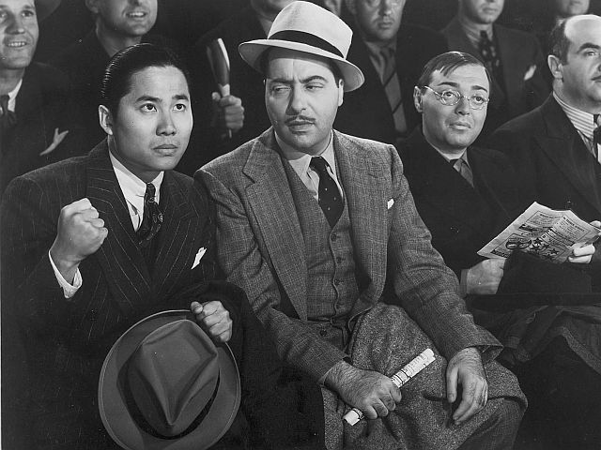
(Mr. Moto’s Gamble (1938) with Keye Luke, Harold
Huber and Peter Lorre in the title role.)

He was also a surgeon in the Japanese Embassy in Germany during World War II in Invisible Agent (1942), albeit briefly in a scene with . . . Peter Lorre.
Did Luke and Lorre have something go on here?!
What would Papa Chan have said if he knew?!?!

LOCATIONS: VASQUEZ ROCKS, LOS ANGELES COUNTY, CA


(Vasquez Rocks)

The opening scene of Werewolf of London (1935) that’s supposed to be in Tibet was actually Vasquez Rocks, a Los Angeles County Park in Aqua Dulce.
It was used for a lot of series and movies. . . .


(Vasquez Rocks)

Information on the park is at

http://employees.oxy.edu/jerry/vasquez.html
(William Shatner as Captain Kirk with a friend!)

This picture is from the episode called “Arena” from Star Trek (1966 – 1969) with William Shatner as Captain Kirk and Ted Cassidy as Gorn . . . yes, THAT Ted Cassidy! . . . all 6’9” of him!!!

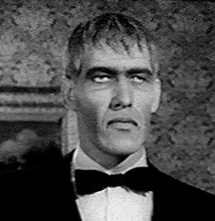
(Ted Cassidy as Lurch, his most famous role,
in The Addams Family [1963 – 1966].)

As a matter of fact, Maven is just barely old enough (no snickers from the peanut gallery, please!) to remember Cassidy leaving his afternoon show on weekdays on the ABC affiliate for the Fort Worth/Dallas area, WFAA, for Hollywood.
Maven has heard that he went straight from here west for his audition for The Addams Family (1964 – 1966) as Lurch. (www.imdb.com).

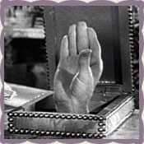
(“Thing” from The Addams Family [1964 – 1966])

Maven has also come across a tidbit that she hasn’t been able to confirm . . . that Cassidy was also . . . Thing!
Maven can’t remember Lurch and “Thing” in the same scene one way or the other so please e-mail her if you know anything!

TRIVIA: JACK PIERCE AND HIS WEREWOLF MAKEUP

An interesting fact about Universal’s werewolf make-ups:

The well-known “Wolf Man” makeup used on Lon Chaney, Jr. was actually created by Universal Pictures makeup designer Jack P. Pierce for Henry Hull in Werewolf of London,” After makeup tests, Hull declined to wear the makeup, citing his dislike of the time-consuming makeup application. A less-hairy version was then devised by Pierce, and it is this version that is seen in the film. A still photograph of the original test makeup survives, however and has been published. [www.imdb.com/title/tt0027194/trivia]

Yes but published WHERE?!?!

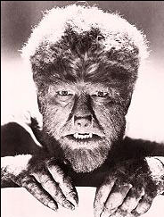
(Lon Chaney, Jr., left; Henry Hull, Warner Oland)

Side-by-side comparison makes Oland’s makeup look dorky to Hull’s and makes Hull’s look downright realistic and both look like that compared to Lon Chaney, Jr.’s Wolf Man, in Maven’s humble opinion.

UNIVERSAL MONSTER GENEALOGY: FOREBEARS, OFF-SHOOTS, KISSIN’ COUSINS AND WANNABES

THE WEREWOLF AND SHE-WOLF OF LONDON

So you thought that Abbott and Costello Meet Frankenstein (1948) was the last of the Universal Monster Genealogy?!?!
Au Contraire, my friends!
This month goes to The Wolf Man’s cinematic ancestor, The Werewolf of London (1935) and off-shoot, The She-Wolf of London (1946).
Maven has the production notes that Universal Studios included with the DVD set* with both movies and decided to include them for more fun watching them and in relation to The Wolf Man:

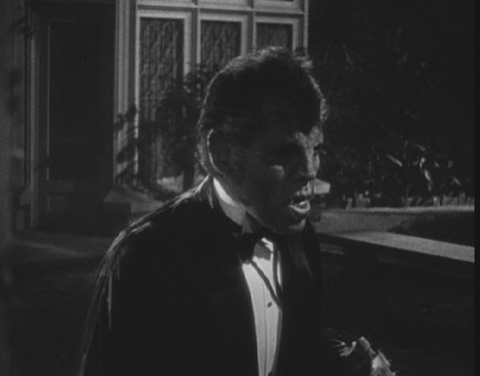
(Henry Hull in the transformation
scene in The Werewolf of London [1935].)

Tales of men transforming into wolves date back beyond the Middle Ages. Werewolves have also been part of movie history nearly from the medium’s inception. The Werewolf, a 1913 silent, still remains the best guess for the first-ever movie of this type, with its tale of a witch raising a daughter who becomes a werewolf.

The Werewolf was made by Universal, the studio which in 1932 announced The Wolf Man as a starring vehicle for Boris Karloff. The film was not made.

Two years later, Universal revealed that Henry Hull and Bela Lugosi would star in their upcoming Werewolf of London, to be directed by Kurt Neumann.

Both Lugosi and Neumann fell by the wayside; Stuart Walker, born two years and 100 miles from fellow Kentuckian [Henry] Hull, stepped in as director. The first classic werewolf movie began production on January 28, 1935, just two days after the date typed on screenwriter John Colton’s final draft.

One uncredited contributor to the Werewolf of script was Aben Kandel, who two decades later co-wrote one of the 1950s most popular horror hits, I Was a Teenage Werewolf.

Most of the film was shot at Universal. The “Tibetan” exteriors were shot at Vasquez Rocks, an otherworldly-looking locale not far from Los Angeles.

During production, the film’s title was changed to The Evil Hour, but it reverted to Werewolf of London before release.

Leading lady Valerie Hobson recalled director Walker as “a rather weakfish but awfully nice director.” On Henry Hull: “A very good and powerful actor, but he didn’t photograph very well!”

In 1964, Hull talked about Werewolf with a local (Connecticut) reporter. Hull thought he looked rather young and handsome—“before I turned into a werewolf, that is.” Asked if the film scared his grandchildren, he chuckled, “I understand they just laughed. Probably thought it was one of the funniest comedies they had ever seen!”

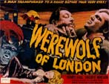
(The Werewolf of London [1935])

[And now . . . for equal time!]

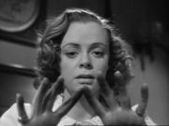
(June Lockhart, the heroine/villainess of The She-Wolf of London [1946]?

Following in the tracks of Universal’s Werewolf of London and The Wolf Man—as well as such non-Universal man-beasts as The Undying Monster and The Mad Monster—came a female werewolf, terrorizing a foggy English park in the 1946 horror whodunit She-Wolf of London.

Actually, the idea of a distaff lycanthrope (werewolf) was not new, even in 1946: The first-ever movie of this type, the 1913 silent The Werewolf, concerned a girl who becomes one. Coincidentally, that film was also made by Horrors,” Universal.

Una O’Connor, revered for her quirky performance in The Invisible man and Bride of Frankenstein, was originally slated to play housekeeper Hannah, and Forrester Harvey was signed to play Latham—a role similar to one he played in The Wolf Man.

O’Connor was replaced by Eily Malyon; Harvey died in mid-production, and Lloyd Corrigan substituted.

To simulate fog in the Park scenes, “bee smoke” was used. It did the trick—but made it tough on the actors. “They’d roll that stuff in about ankle-height, and then it would rise,” star Don Porter recalled. “Trying to do lines and keep from choking was a little difficult.”

She-Wolf was quickly (December 8 – 21, 1945), with retakes shot on Christmas Eve. The last shot of the day, shot on a soundstage, featured Porter and June Lockhart in a buggy. When the director yelled his final “CUT”, the crew stampeded for the exits. “It was like an evacuation!” Lockhart laughs.

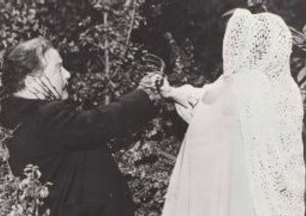
(Lloyd Corrigan fighting off The She-Wolf of London [1946].)

Universal Monster Genealogy

Dracula (1931) Frankenstein (1931)
| | Henry
| |
| The Bride of Frankenstein (1935)
Dracula’s Daughter (1936) | Werewolf of London (1935)
| | |
| | |
| Son of Frankenstein (1939) |
| | Wolf* & Elsa |
| | |Peter The Wolf Man (1941)
Ghost of Frankenstein (1942 |
| | Ludwig |
Son of Dracula (1943) | |Elsa |
| |Frankenstein Meets the Wolf Man (1944 |
| | Elsa ( ?* ) |
| House of Frankenstein (1944) |
| House of Dracula (1945) |
| The She-Wolf of London (1946)
| |
|Abbott and Costello Meet Frankenstein (1948) |

*This is according to Son of Frankenstein (1939).

*Just who’s daughter is this Elsa, played by ( ? ).

*This Wolf Man Double Feature that Universal Studios brought out is not to be confused with The Wolf Man Legacy Collection that Universal brought out that included both Werewolf . . . and She-Wolf . . . plus Frankenstein Meets the Wolf Man (1943) and other goodies.

MAVEN’S BOOKSHELF: The Invisible Man by H. G. Wells

Maven has been a fan of www.gutenberg.org/wiki/Main_Page for some time.
You can go that website and download the e-text to The Invisible Man by H. G. Wells at
www.gutenberg.org/files/5230/5230-h/5230-h.htm

You can also download the audio version of Wells’ novel (presuming you can handle the electronic voice!) at
www.gutenberg.org/etext/8974

NOTE: The audio can be downloaded more easily by chapter at Maven’s website at
http://tommenterprises.tripod.com/id58.html

THE MAIN EVENT: TORA! TORA! TORA! (1970)

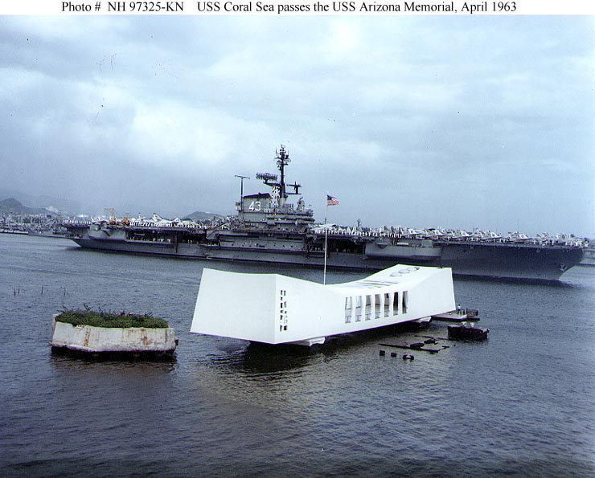
(“Photo # NH 97325-KN USS Coral Sea passes the USS Arizona Memorial, April 1963 – From www.history.navy.mil/photos/images/h97000/h97325k.jpg)

Now it’s time for the Main Feature and Maven can’t get any “Mainer” than the Second World War . . . the day that will live in infamy.
This is the 66th Anniversary of the Japanese attack on Pearl Harbor on December 7, 1941.
The Pearl Harbor Memorial of the USS Arizona is still visited by people from all over the world.


(A replica of the Japanese Zero that was used in
the filming of Tora! Tora! Tora !www.af.mil)

Tora! Tora! Tora! (1970) was filmed with a view to showing both sides of the war that defined a generation around the world, even to having separate productions.

(A Poster for the 1970 that examined both sides of World War II)

Is it accurate?
It’s about as accurate as Hollywood can make it. . . . Considering what has come out from that city that purports to be accurate, Maven considers Tora! Tora! Tora! to be fairly accurate.
It certainly has some heavy hitters in it.

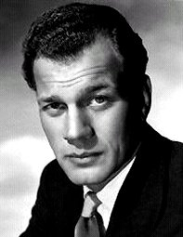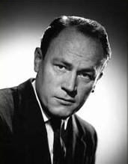
(Joseph Cotten as Henry L. Stimson, U. S. Secretary
of War and E.G. Marshall as Colonel Rufus S. Bratton)

You have Joseph Cotton and E. G. Marshall as Secretary of War Henry L. Stimson and E. G. Marshall as Colonel Rufus S. Bratton as their very best.
Not to mention James Whitmore as Admiral William Halsey and Martin Balsam as none other than Admiral Husband E. Short, Commander-in-Chief of the U.S. Pacific Fleet.

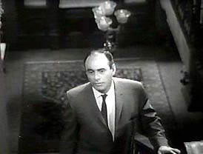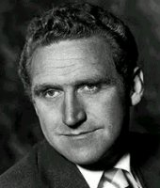
(Martin Balsam as Admiral Husband E. Short [Commander-in-Chief, U.S. Pacific Fleet] and James Whitmore [as Admiral William F. Halsey]

Tora! Tora! Tora! wasn’t romanticized as many historical movies are, with a hero and heroine who struggle throughout the film and various struggles until they are either united or tragically separated at the end of the movie.
Tora! . . . was three hours long as it was, dealing with the days leading up to December 7, 1941 (and December 8th to the Japanese since they are across the International Date Line).
Perhaps the time could have been cut down if they hadn’t had so many little side notes in the movie, such as Norm Alden as the Army Corps pilot (Major Truman Landon) who lead a scheduled flight of planes that WERE expected on Dec. 7th.

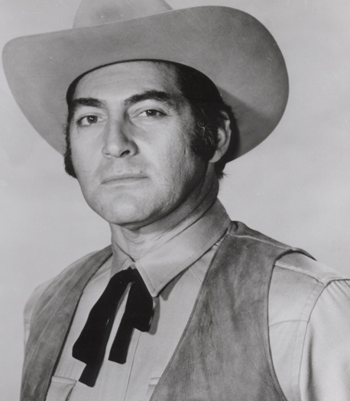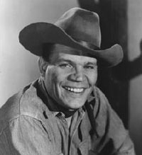
(Norm Alden as Major Truman H. Landon, US Army Air
Corps and Neville Brand as Lieutenant Kominsky, USA.)

Or Neville Brand (as Lieutenant Kominsky) who tries to tell Richard Anderson (as Captain John Earle) that there may be a Japanese sub in Pearl Harbor. Brand’s anger later when Anderson finally faces the attack is one of the movie’s highlights for Maven.

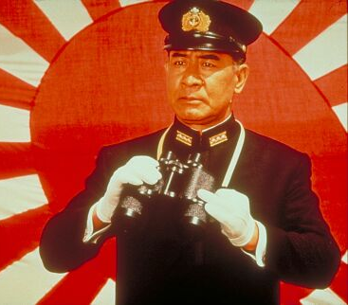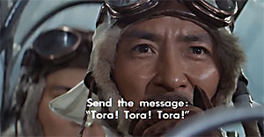
(So Yamamura as Vice-Admiral Isoroko Yamamoto
and Takahira Tomura as Lt. Cmdr. Fucida

The Japanese sequences are every bit as good as the American parts, from writing to filming and acting.
Maven found the movie to be riveting from the get-go, even with at three hours in length.
When you are dealing with the US trying to translate the code that Japan used to communicate with its Embassy as their Ambassador is sparing for time in Washington, D. C.; the Japanese Navy trying to get to Hawaii on time for the scheduled for the attack and all the details around these scenes that flesh out the goings-on beautifully.
Tora! Tora! Tora! is now on DVD and Maven recommends it, along with “googling” Pearl Harbor for more information and pictures on an event that underscores the term “world war.”

THE B-FEATURE: The Man Who Came to Dinner (1944)

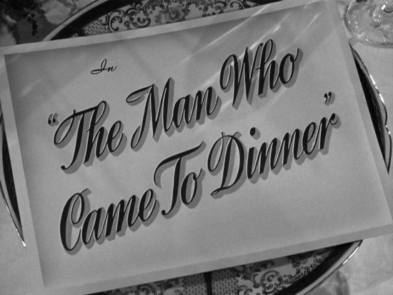

The Man Who Came to Dinner on January 1, 1942, shortly after the Japanese attack on Pearl Harbor, Hawaii, on December 7 and was a much-needed diversion to America after the bombing there.
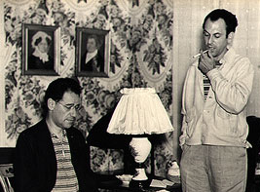
(The writers behind The Man Who Came to Dinner
[1943]: George S. Kaufman [left] and Moss Hart)

The writers, George S. Kauman and Moss Hart, based the movie on a real situation in their lives . . . :

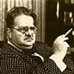
(Alexander Woollcott, on whom Kaufman and
Moss based their Sheridan Whiteside.)

Alexander Woollcott, a famed member of the literary set based at the Algonquin Hotel, was too well-known to arrive at a friend’s home and move in and take everything over—including the lives of his hosts.
It wasn’t too far for Kaufman and Hart to turn their friend’s proclivities into what would happen if Woollcott ended up stuck at a friend’s house for a semi-permanent period of time?
The ensuing creativity of Kaufman and Hart became a famed play that was turned into a comedy vehicle for Bette Davis, who wanted a radical change from the movies that she had been making.
It was an incredible choice for all who were involved!


(Bette Davis who stars as “Maggie Cutler”
in The Man Who Came to Dinner [1942].)
Maven found this picture of Bette Davis recently but looking at it now . . . it’s beginning to look like she’s been decapitated from the rest of her by whoever the photographer was!
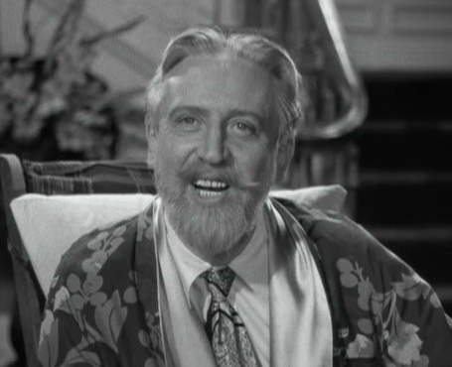
(Monte Woolley, left, as “Sheridan Whiteside” in The Man Who
Came to Dinner [1942], who was based on Alexander Woollcott.)

Bette Davis played the secretary, Maggie Cutler, to Sheridan Whiteside (Monte Woolley), a character based on Alexander Woollcott who was a member of the literary group that included Dorothy Parker, Robert Benchley and Harpo Marx.

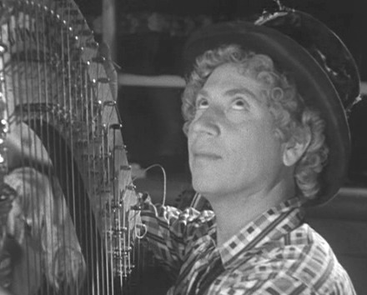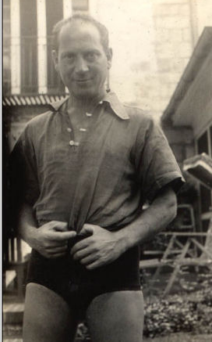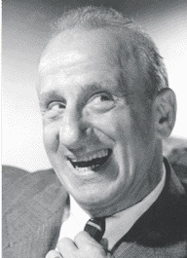
(Harpo Marx, in and out of character, who was the basis
for the character of Banjo, played by Jimmy Durante.)

Yes, THAT Harpo Marx!
Kaufman and Hart were so acquainted with the “Algonquin Group,” as they were called, that they used Marx as a model for another role in The Man Who Came to Dinner, “Banjo,” who seemed just as likely to fit the actor playing him—Jimmy Durante!

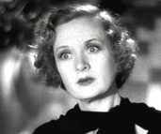
(Billie Burke as Millicent Jordan in Dinner at Eight [1933],
in which she appeared with Grant Mitchell as Ed Loomis)

If all this background material wasn’t enough—and it never is for Maven—Billie Burke had acted with Grant Mitchell in Dinner at Eight (1933) and they had graduated to playing a married couple in Man . . . , Ed and Daisy Loomis.

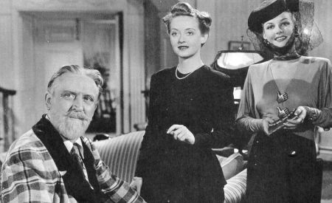
(Monte Woolley, Bette Davis and Ann Sheridan
in The Man Who Came to Dinner [1942].)

The plot line is simple since Kaufman and Hart based it on Woollcott’s fondness on literally moving, lock, stock and barrel, in friend’s homes.
Simple?
You decide.
Stanley Whiteside is on a lecture tour through Messalia, Ohio, when he is injured going to the home of Ed and Daisy Loomis.
“Injured” doesn’t quite describe the mayhem that Whiteside creates, from his calls to and from such notables as Eleanor Roosevelt to lunch visits with prison inmates and Chinese who have just come from the White House.
This isn’t to mention crates arriving for him with penquins and an octopus in them.
This on top of banishing the Loomis family upstairs, taking over their entire first floor that includes the butler, cook, front staircase and telephone.
Bette Davis’ Maggie falls in love with a local journalist which seems to be the only thing that really upsets Whiteside.
At least enough to make he DO something about it.
Notch up the mayhem even more as he brings in his “Blossom Girl” in the form of Ann Sheridan as actress Lorraine Sheldon, who has a reputation on at least two continents as she has pursued “Lord Bottomly.”

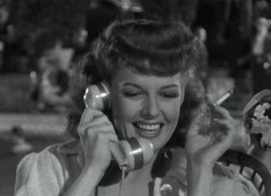
(Ann Sheridan as “Lorraine Sheldon” in
The Man Who Came to Dinner [1942].)

Maggie and Lorraine have a “history,” which ratchets the mess even further as Whiteside as brought her in to woo the local journalist, Bert Jefferson, who’s falling for Maggie.

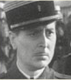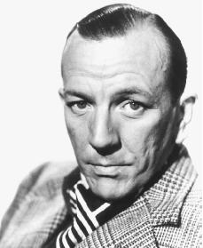
(Reginald Gardiner, whose character of Beverly
Carlton was based on Noel Coward, right.)

Throw in Reginald Gardiner and Jimmy Durante as Beverly Carlton and “Banjo” and you have as close a recipe as you can get to an asylum.
This movie was so well-received that it begat at least one cartoon . . .

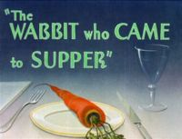
(A take-off of The Man Who Came to Dinner that
starred Bugs Bunny and Elmer Fudd)

www.nonstick.com/sounds/Bugs_Bunny/ltbb_002.wav

http://wilstar.com/midi/fuddquiet.wav

‘Nuff said!

<><><><><><><><><><><><><><><><><>

MAVEN’S CREAM OF THE CROP!

CHARLIE CHAN FAMILY – This is Rush Glick’s superb website devoted to the Great Chinese Detective based in Honolulu.
Rush is not only a gracious friend and teacher to Maven (among many!) but now he’s an expert that Fox Studio interviewed in their featurettes included in the boxed sets of their newly restored and released Chan DVDs.
Just click on www.charliechan.info!

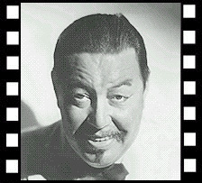

CHARLIE CHAN.NET – Kurt Schmidt has the message board that’s like a coffee house for Chan-aholics and has been around for some 10 years . . . longer than some marriages that Maven has known!
It’s just a click to www.charliechan.net !

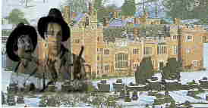
(Trillo and Suede’s Boxford Park and Lady Sarah)

TRILLO AND SUEDE – This is a link to Jonathan Geffner’s short subject, Oxford Park, starring his Trillo and Suede in a dummy noir story at www.trilloandsuede.com/movie.html.
You can download the movie at www.trilloandsuede.com/movielink.html that stars Lady Sarah, a delightful lady who can also be found at www.geffner.com.

<><><><><><><><><><><><><><><><><>

BACK ISSUES: Of The Old Movie Maven (aka TOMM)

Back issues of The Old Movie Maven are $3.50 each,
and make your check or money order payable to:

Virginia Johnson
The Old Movie Maven
P.O. Box 54493
Hurst, TX 76054

VOLUME 2 – Issue 1 – January, 2007 – Life Behind the Camera: Trini Lopez; 42nd Street, 1933; www.archive.org; Universal Studio’s Back Lots; A Christmas Carol/ Scrooge, 1951; Dracula’s Daughter, 1936; Betty Boop and Bugs Bunny; Trini Lopez; 42nd Street, 1933; The Death Kiss, 1932; Back Issues.

VOLUME 2 – Issue 2 – February, 2007 – THERE BE GIANTS HERE: Be There Giants?; Bela Lugosi; www.jamesarness.com; DC – 4; The Thing from Another World, 1951; Boris Karloff in Son of Frankensetin, 1939; Iverson Ranch, Los Angeles, CA; Brass Bancroft; Charlie Chan, Boris Karloff and Bela Lugosi; Sara Karloff; Son of Frankenstein, 1939; Fun and Games on the Set of Son of Frankenstein, 1939; The High and the Mighty, 1954; The Thing from Another World, 1951; Maven’s Cream of the Crop; Back Issues.

VOLUME 2 – Issue 3 – March, 2007 - SPOOKTACULAR HOLLYWOOD: A Curse on Your House; Bela Lugosi; Charlie Chan’s Secret, 1936; TRIVIA – Part 1: The Maltese Falcon, 1941; TRIVIA – Part 2: The Wolf Man, 1941; Charlie Chan . . . Psyschic?; Return to Glennascaul, 1951; The Wolf Man, 1941; Hollywood and the Supernatural (1993) and The Wolf Man (1941); The Wild Goose; Evelyn Ankers; Haunted Gold, 1932; Maven’s Cream of the Crop; Back Issues.

VOLUME 2 – Issue 4 – April, 2007 – LADIES NIGHT IN HOLLYWOOD: Tonight Is Ladies’ Night . . . ; The Women (1939); W.C. Fields; www.annegwynne.com; Popeye, the Sailor Man; Nancy Drew (played by Bonita Granville); Inner Sanctum – Weird Woman (1944); The Ghost of Frankenstein (1942); Tara from Gone with the Wind (1939); The Old Dark House (1932) and Laurence Olivier; Aunt Sarah; Dinner at Eight (1933); The Women (1939); Maven’s Cream of the Crop; Back Issues.

VOLUME 2 – Issue 5 – SATURDAY MATINEES: Once upon a time . . . ; Elmer Fudd; Charles Lane; Looney Tunes; www.whata-a-charater; Charlie Chan in Egypt (1935); The Adventures of Smilin’ Jack, 1943); Son of Dracula (1943); Monument Valley, Utah/Arizona; Luxor and the Pyramids of Giza; John Ford; Ed Golusky; Valley of the Kings (1954); Stagecoach (1939); Maven’s Cream of the Crop; Back Issues.

VOLUME 2 – Issue 6 – TOO FUNNY FOR WORDS: Grouch and Gorillas; Charlie Chan’s Secret; How to Make a Gorilla; www.pulpanddagger/canuck/Kong_mask.html; Nancy Drew (2007); Hildegarde Withers by Stuart Palmer; Hildegard Withers; Frankenstein Meets the Wolf Man (1943); A Day at the Races (1937); The Gorilla (1939); Maven’s Cream of the Crop; Back Issues.

VOLUME 2 – Issue 7 – COSTUME DESIGNERS 101: Raindrops and Other Things; Bette Davis as Margo Channing in All About Eve (1950); Travis Banton; Psycho: Behind the Scenes of the Classic Thriller; The Wizard of Oz; House of Frankenstein; Edith Head; Orry-Kelly; Maven’s Cream of the Crop; Back Issues.

VOLUME 2 – Issue 8 – NIFTY FIFTIES’ CREATURE FEATURES: The Fifties in Hollywood; Gojira (1954); Professor Wes Davis; Gojira (1954)/Godzilla (1956); House of Dracula (1945); http://tommenterprises.tripod.com; Gojira (1954); Godzilla, King of the Monsters (1956); Maven’s Cream of the Crop; Back Issues.

VOLUME 2 – Issue 9 – CHARLIE CHAN LIVES!: Jeez, It’s the Cops!; Charlie Chan (Warner Oland); Charlie Chan’s Secret (1936) Audio Commentary and The Black Camel (1931); Hamilton McFadden and Violet Dunn; Abbott and Costello; Earl Derr Biggers; SURPRISE!; The Oakland Bay Bridge; The Black Camel 91931); Abbott and Costello Meet Frankenstein (1948); www.newtattheroyal.com; Charlie Chan’s Secret (1931); Mr. Moto’s Gamble (1938); Maven’s Cream of the Crop; Back Issues.

