FEBRUARY, 2007 VOLUME 2, Issue 2

The Old Movie Maven

THERE BE GIANTS HERE;
Or, The Jolly Green Giant Runs Amuck!

~~~

The Old Movie Maven (TOMM) is published once a month for
film lovers of classic movies and the actors, directors,
costume designers, make-up artist, cameramen
and the other people who never got enough
credit for all their hard work
over the years.

COMMENTS, QUESTIONS AND SUGGESTIONS ABOUT SUBSCRIPTIONS AND BACK ISSUES CAN BE SENT TO

Virginia Johnson
Publisher/Editor

P.O. Box 54493 theoldmoviemaven@yahoo.com Hurst, TX 76054 http://theoldmoviemaven.tripod.com

SUBSCSRIPTION:
One (1) Issue - $ 3.00
Six (6) Months - $15.00
One (12) Year - $30.00
Back Issues - $ 3.50 @

<><><><><><><><><><><><><><><><><>

ALL MOVIES ARE AVAILABLE COMMERCIALLY OR ON YOUR
LOCAL CABLE CHANNELS UNLESS OTHERWISE NOTED.

<><><><><><><><><><><><><><><><><>
TABLE OF CONTENTS:

FROM MAVEN’S DESK: Be There Giants? PAGE: 3

ARCHITECTURE OF THE MONTH: DC-4 PAGE: 4

B-FEATURE: The Thing from Another World (1951) PAGE: 19

BLOOPERS: The Thing from Another World (1951) PAGE: 5

BACK ISSUES: PAGE: 25

CHARLIE CHAN ANNEX:
Charlie Chan, Boris Karloff and Bela Lugosi PAGE: 7

FLASH: Fun and Games . . .
Son of Frankenstein (1939) PAGE: 14

LOCATIONS: Iverson Ranch PAGE: 5

MAIN EVENT: High and the Mighty (1954) PAGE: 15

MAVEN’S CREAM OF THE CROP: PAGE: 24

MAVEN’S SERIES: Brass Bancroft PAGE: 6

PERSON OF THE MONTH: Sara Karloff PAGE: 9

QUOTE OF THE MONTH: Bela Lugosi PAGE: 3

TRIVIA: Boris Karloff in Son of Frankenstein (1939) PAGE: 5

UNIVERSAL MONSTERS GENEALOGY:
Son of Frankenstein (1939) PAGE: 11

WEBSITE OF THE MONTH:
www.jamesarness.com PAGE: 4
<><><><><><><><><><><><><><><><><>

FROM MAVEN’S DESK: Be There Giants?

This issue has been a great deal of fun for Maven!
Coming up with the title for starters brought a wealth of movies and actors and characters to choose from.
Maven was lucky about one thing . . . the final release of John Wayne in High and the Mighty (1954) and Island in the Sky (1953) after years of being held up by copyright issues.
Picking John Wayne was the easy part, since he was a giant in the movie industry anyway you defined the word . . . as a movie star and as one of the tallest actors in Hollywood at over 6’4”.
So does Maven then pick Island in the Sun where Wayne costars with James Arness who was even taller at 6’7”?
Or pick Them! (1954) where Arness goes eye to eye with Fess Parker, a mere 6’5”.
Or go with The Thing from Another World where Arness gets the biggest part of his life as the seven foot cutie-pie from outer carrotdom?!
And then there is The Son of Frankenstein with Boris Karloff and Bela Lugosi, themselves giants in the genre of horror movies, with Basil Rathbone and Lionel Atwill who weren’t too shabby in their own right!
Maven got very lucky this month with getting Sara Karloff, only child to Boris, to answer some questions about having such an icon for a father, especially after she’d just had shoulder surgery.
Maven is honored to know a lady who is as gracious a gentlewoman as her father was a gentleman.
Hurrah for the House of Karloff!

QUOTE OF THE MONTH: Bela Lugosi

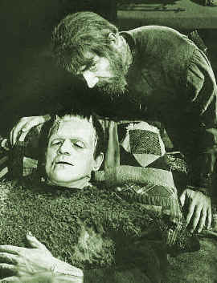

Ygor (Bela Lugosi), about the Frankenstein Monster (Boris Karloff):
“He’s my friend. . . . He . . . he does things for me!”

WEBSITE OF THE MONTH: www.jamesarness.com

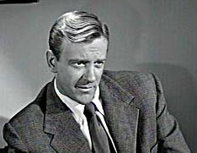

This is James Arness’ website and he frequently posts there on his comings and goings, biography, articles, autographs, products, you name it.
Suffice it to say that Maven has it earmarked on her list of favorites!

ARCHITECTURE OF THE MONTH: DC-4


(An American Airlines DC-4 like the plane used in
The High and the Mighty [1954])

The Main Event this month is The High and the Mighty with John Wayne heading an incredible cast in the forerunner of disaster films like Airport to Towering Inferno.
This was out of circulation for decades but we have it now on DVD (with commentary and other extras) to enjoy a classic anyway you look at it: Wayne at his best; interviews with other actors, directors, etc., about the making of the movie; a riveting story by Ernest Gann; a tale of fractured lives and loves; and a glimpse at a bygone era in airplane travel.

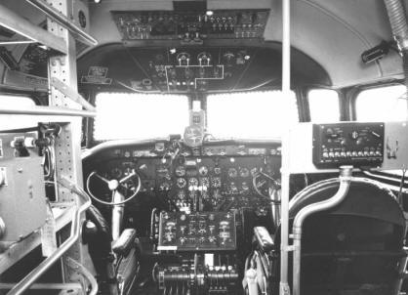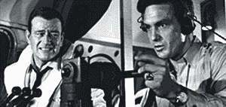
(The cockpit of a DC-4 and how it looked in High and the Mighty [1954] with John Wayne as co-pilot Dan Roman and Robert Stack as pilot John Sullivan)

Who wouldn’t enjoy looking at the vintage clothes of the times (and not have to bother with the girdles?!), the airplanes (that took longer to get there!) and the service passengers used to get on them (now you’re lucky if you get nuts in-flight!)

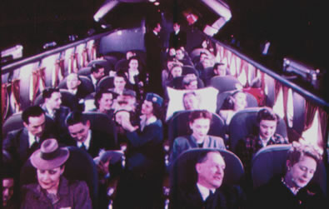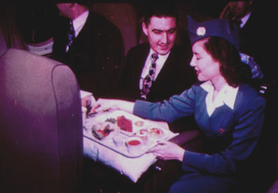
(Don’t you love the color?! This is what flight travel was all about back
in the fifties—complete with edible food in a real meal deal!!)

Of course . . . on the other hand . . . now just anybody can fly. . . .
Maven knows some people who could tell you stories about the passengers that they have had to deal with that would make you think twice about even calling an airline . . . !
Maybe one of these days . . . !

BLOOPERS: The Thing from Another World (1951)

One little goodie from the set is when the thermite bomb goes off to free the flying saucer from the ice. The camera follows the resulting cloud upwards and, incidentally, showing the top of the background and the studio behind it.
Lt. Ken Ericson is listed but he is addressed and referred to as “Mac” or MacPherson.
And something that Maven has never understood is why do they keep registering radioactivity but nobody worries about how much exposure they may be absorbing!

TRIVIA: Boris Karloff in Son of Frankenstein (1939)

According to www.imdb.com:

Boris Karloff became a father for the first time [with daughter, Sara] while filming this movie. When he was told that the baby had been born, he immediately went to the hospital to see his wife and child while still in costume. When he arrived, in full Monster makeup and clothing, he created a panic though out the hospital.

LOCATIONS: Iverson Ranch, Chatsworth, Los Angeles, CA

Check out http://employees.oxy.edu/jerry/iverson.htm for a list of all the movies made there, like Haunted Gold (with John Wayne – 1932) plus some snappy snapshots:

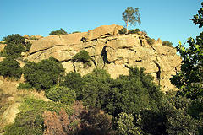

MAVEN’S SERIES: Brass Bancroft

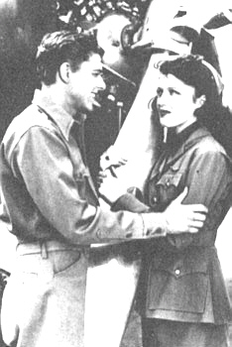
(Ronald Reagan and Roselle Towne in
“Secret Service of the Air” in 1939)

Brass Bancroft was a movie character who has had a very special place in cinematic and American history.
He was a pilot for Oriental Express on their China Clipper, circa 1930s, and played by a very young Ronald Reagan.
The irony, and the accompanying history, lies in the fact that Reagan played Brass Bancroft in Secret Service in the Air (1939), first in the series when Bancroft is recruited into the Secret Service branch of the Treasury Department.
Forty plus years later, Ronald Reagan was luckily in the company of his own Secret Service agents in his first months of being President of the United States when John Hinckley tried to assassinate him.

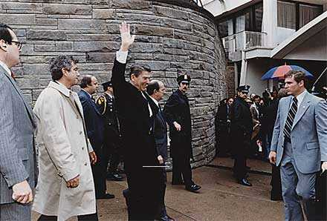
(President Ronald Reagan and staff, including his Secret Service
Agents, moments before John Hinkley tried to shoot him.)

No one realized that President Reagan had been hit in his left lung by a ricocheting bullet when the head of his Secret Service unit, Jerry Parr, pushed him into his limousine and directed their drive to make for the White House.
They had to change course to George Washington Hospital when Parr saw the President coughing up pinkish froth.

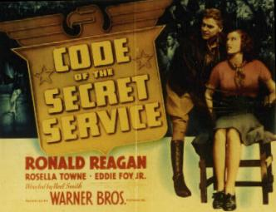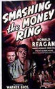
(Reagan and Towne in the second and third Bancroft films.)

Agents Timothy McCarthy (in the chest) and Thomas Delehanty (in the neck) and White House Press Secretary James Brady (in the head) also survived, although Brady never fully recovered.
Are the Brass Bancroft movies worth watching?
They are kind of light fare and full of plot holes, especially if compared to other movies made in 1939, but great fun . . . especially if you remember what happened to Ronald Reagan.

CHARLIE CHAN ANNEX:
Charlie Chan, Boris Karloff and Bela Lugosi

Ha!
Bet you never thought that the old Charlie Chan series had any biggies!
Well . . . Maven knows her biggies!
One of the two earliest Charlie Chan movies that are still available for “Chanaholics” is The Black Camel (1931) with Bela Lugosi as Tarneverro, a psychic who has come to Honolulu by request of the heroine (Dorothy Reviers as Sheilah Fayne).

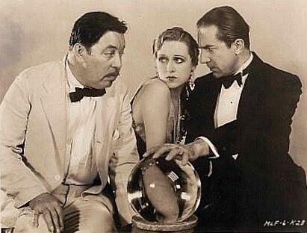
(Warner Oland as Chan, Dorothy Reviers as Fayne,
and Bela Lugosi as Tarnevvaro)
The Black Camel is a mixed bag: Story-wise, it follows the novel of the same name by Earl Derr Biggers.
It was also the only Chan film made on location in Honolulu and includes (among other sites) the Royal Hawaiian Hotel that can still be recognized from some of the scenes.
And it has lots of red herrings a major problem some people have with The Black Camel. . . . Acting in Hollywood was still in the transition period from the silent era of movie-making and a lot of actors still chewed the scenery like they had during the silents.
Warner Oland is also in transition as Charlie Chan in this movie but he had already begun to make the role his own.
Do these things matter?
Maven thinks not as they are balanced out by the story, Oland as Chan, the scenery, and scenes of Chan at breakfast with his family and at the wheel of his car (one of the few times that happens in the series).
Oland is the Chan in one of the two other Chans that have Boris Karloff . . . . He is Gravelle in Charlie Chan at the Opera (1936), a singer who begins to regain his memory in an asylum.

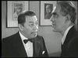
(Warner Oland as Chan and Boris Karloff as
Gravelle in Charlie Chan at the Opera)

Sounds like it’s perfect for Karloff?
It gets better as his Gravelle escapes to look for his ex-wife.
The story steps up in suspense as it switches to the opera house where Carnivale (an original opera written by Oscar Levant) is being performed, starring Gravelle’s ex.

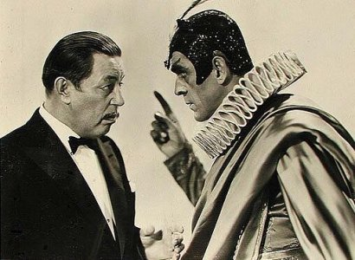
(Oland and Karloff in . . . Opera)

Charlie Chan at the Opera is one of the most beloved Chan movies and Karloff is a major part of why we love it, especially when # 1 son, Lee, shows up!
At the other extreme is Behind That Curtain, another Chan story based on one of Bigger’s novels, that is only obtainable to Maven’s knowledge by knowing somebody who already has the movie.
Behind . . . was made in 1929 and can be more difficult to watch than . . . Opera since actors were only then beginning to understand that talkies required different techniques then the silents.

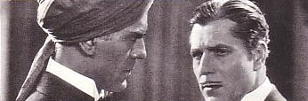
(Boris Karloff as Beetham’s Manservant and Warner
Baxter as Col. Beetham in Behind That Curtain [1929])

A lot of Chanaholics have a problem with this movie since it was made into a vehicle for Warner Baxter and poor Charlie Chan (E.L. Parks) doesn’t come into the movie until almost at the end and even then only has a few minutes of screen time before having his big moment happen off screen!!
But Boris Karloff is a shining presence in both Charlie Chan at the Opera and Behind That Curtain, being the versatile actor that he is.
He utilizes the skills in Behind . . . that he would make famous two years later as the Frankenstein Monster and handles the role as the escaped lunatic in . . . Opera equally well, again winning the sympathy of the audience!

PERSON OF THE MONTH: Sara Karloff

Maven has been lucky this month with family insights from Sara Karloff, daughter of a Hollywood icon so well-known that he could be billed by his last name alone: Boris Karloff, of course!
Ms. Karloff was kind enough to answer Maven’s questions to better appreciate the man behind the various roles he brought his talents to in movies . . . :

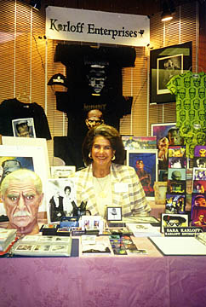
(Sara Karloff and her Famous Father)

My father was the antithesis of the roles he played. He was a kind, gentle, soft spoken, funny, articulate, well educated, well read English gentleman.
He was very modest and conservative in his life style, he seldom, if ever, about his work at home. I can’t really remember at what point I became aware of his extraordinary fame.
But I son know that I was 19 when I saw Frankenstein for the first time and that was on television, not on the big screen.
Both Frankenstein and the Mummy were made before I was born so I never had a chance to see him in one of his classic monster make-ups.
Since I really don’t like scary movies I can’t remember the first of my father’s movies in a theater. But I so remember visiting him on the sets of A Comedy of Terrors [1964] and The Raven [1963].
Although Bela Lugosi, Jr., is a great friend of mine I never had a chance to meet his father. I did however get a chance to meet Peter Lorre and Vincent Price.
One of my favorite films of my father’s is Targets [1968], in which he plays an aging horror film star . . . brilliant casting. He so enjoyed working with and admired Peter Bogdonovich.
Although I have been asked to do interviews for documentaries about my father, his films and the horror genre, I have never ever considered entering the “family business”.

Thank you, Ms. Karloff, for great answers about another Hollywood giant!
You will always be welcome here!

UNIVERSAL’S MONSTER GENEALOGY:
SON OF FRANKENSTEIN (1939)

Now we come to the Son of Frankenstein, the first male offspring in the classic era of Universal’s Monsters.
It’s not really fair to compare Son of . . . with Dracula’s Daughter (1935) since both are well-written with talented people involved all around.
Besides, it has Bela Lugosi as Ygor in one of Lusgoi’s best performances, even if he does look like he needs an extreme makeover in it!
Compare Lugosi’s role of Ygor to his “non-appearance” in Dracula’s Daughter as the “star” funeral pyre scene.

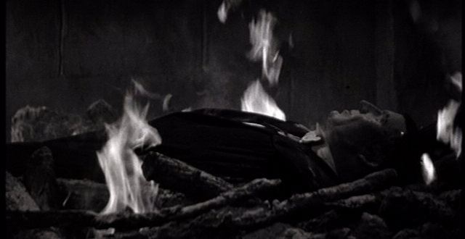

If that’s Bela Lugosi in that scene with Gloria Holden then Maven has a twin named Angelina Jolie-Pitt!!

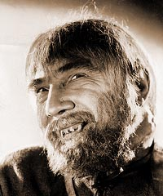
(Bela Lugosi as Ygor in another masterpiece makeup by Jack Pierce . . . Maven never fully appreciated his Ygor makeup until she saw this still)

But Lugosi has a much meatier role in Son of Frankenstein . . . .
The audience is informed that Henry Frankenstein took over as Baron in Bride of Frankenstein (1935).
In Son of Frankenstein, Basil Rathbone’s Baron Wolf von Frankenstein (now we are “von” Frankenstein!) doesn’t remember his father and whines that people are so ignorant that they refer to the Monster as Frankenstein.
All this on a train as the newest Frankenstein is enroute to the family home with his wife, Elsa (Josephine Hutchison), and son, Peter (Donnie Dunagan).

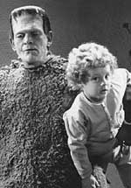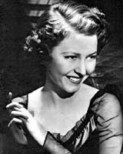
(Donnie Dunagan as the youngest Frankenstein with a friend
and Josephine Hutchison as the Baron’s wife.)

They are met at the train station by a group of villagers who start out hostile at the beginning of Son of Frankenstein and just get more so throughout the movie.
Frankenstein Castle now looks like a bad dream of Frank Lloyd Wright’s after getting some bad ice cubes in his liquor—It may have been Art Deco but comes across more Art Decked-Out.
Would you really want to live in it?!
Maven doesn’t even want to think about the heating bills in these places!
The first visitor that Baron and Baroness Frankenstein have is Herr Inspector Krogh, a policeman with a wooden arm that replaced one that the Monster had torn out when Krogh was a child.
Maven found herself fascinated, waiting to see if Lionel Atwill ever slipped up as Krogh and actually used that arm (he does but only as a handy place to put his darts when he’s invited to a game by the Baron!).

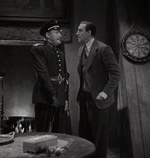
(Lionel Atwill as Inspector Krogh and Basil
Rathbone as Wolf von Frankenstein)

Don’t ask Maven why Germans are so formal—adding the equivalent of our Mr. plus his title of Inspector—because she didn’t get that far in her study of German at University!
“Wolfie” (as Maven lovingly calls Basil Rathbone’s character) checks out his father’s laboratory in the old watchtower and nearly gets “boulderized” by Ygor (Bela Lugosi).
Sorry, Maven couldn’t resist that!

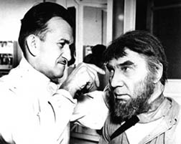
(Pierce at work on Lugosi)

They wind up (down?!) in the catacombs under the laboratory as Wolfie comes across his father’s final resting place with the old Baron’s name as Heinrich von Frankenstein. (Maven is using the term “final resting place” with tongue firmly planted in cheek since little in these series stayed final!)
The old baron’s change of name from Henry is amusing to Maven--Didn’t the writers watch or remember Frankenstein (1931) and Bride of Frankenstein, two of the studio’s most popular movies of the thirties.
And we thought Anna Nicole Smith had problems with her late husband’s son over her hubby’s estate!
Ygor shows Frankenstein what is left of the Monster, suggesting that the Monster and the Baron are half brothers.
Great.
It wasn’t bad enough that Universal made Bride of Frankenstein ambiguous as to who Frankenstein’s bride actually was but now we are left wondering just who is the Son of Frankenstein.
Of course, Maven wouldn’t want to get in an argument about it. . . . Would you want to tell somebody that looks that big with bolts in his neck that he’s the illegitimate one?! And who’s going after the DNA sample?!

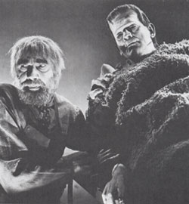
(Bela Lugosi as Ygor and Boris
Karloff as the Monster)

So Ygor talks Wolfie into fixing the Monster up and no mention is made of how Ygor recovered the Monster from the blown-up watchtower, how the Monster lost the power of speech he got in Bride of Frankenstein, the twenty pounds or so the Monster has gained, or that the laboratory now has a sulfur pit down in the basement that’s heated upwards of 800 degrees.
If you think that sentence was long, come back at Christmas and see Maven’s wish list.
And Inspector Krogh drops by to let the family know that the locals from the village of Frankenstein are dying to run amuck.
Like villagers ever run any other way in these movies?!
It’s like going after horrible space aliens and their atomic space modulators with ordinary Earth guns and bullets.
Didn’t work then and won’t work now!
You know the rest . . . the villagers run amuck, the Monster runs amuck, Frankenstein runs amuck and then we get to the grand finale when the Monster decides on revenge when he finds his friend, Ygor, is dead.
He takes Wolfie’s son, Peter, out to the laboratory with Frankenstein, Krogh, Elsa and Peter’s nanny (Amelia) in hot pursuit.

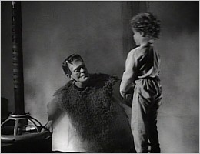
(The Monster and Peter von Frankenstein)

Peter gets saved and the Monster lands in the 800 degree sulphur pit.
Does he stay there?
Yes but only as long as it took Universal to figure out whether Son of Frankenstein was successful enough to continue the franchise.
Guess what?
It was successful enough but fate intervened before a sequel was made and they all involved Lon Chaney.
This is an ironic period in the Universal Monsters Genealogy: Boris Karloff retired as the Monster and Lon Chaney, Jr., takes over as the newest icon in the Universal Pantheon as The Wolf Man (1941) as well as two of Universal’s other icons.
Yep.
Chaney appeared as the Monster in Ghost of . . . (1942) and as the Son of . . . (1943), who turned out to be Dracula himself.
Universal’s Monsters would never be quite the same.

UNIVERSAL’S MONSTER GENEALOGY CHART:

Dracula (1931) Frankenstein (1931)
| |
| |
| The Bride of Frankenstein (1935)
Dracula’s Daughter (1936) |
| |
| Son of Frankenstein (1939)
? ?

FLASH:
“Good evening, Mr. And Mrs. America, from boarder to boarder,
coast to coast and all the ships at sea, let’s go to press . . . . “
[Walter Winchell]

Fun and Games on the Set of Son of Frankenstein (1939)

Who’d a thunk it?!
Regardless of when you first watched these movies . . . in first run theatres like Maven’s mother, on television like Maven or on cable or DVDs . . . we never thought of anybody in the Universal Monster Series as whooping it up!
But Maven has the proof that they did!

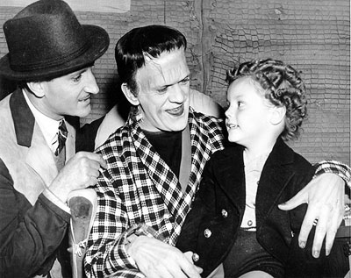
(Off screen had everybody smiling . . . with Boris Karloff looking more
like Fred Gwynne as he and Basil Rathbone talk to Donnie Dunagan.)

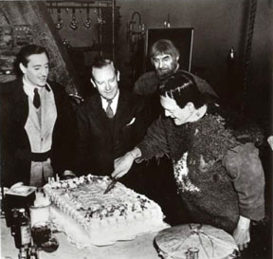
(Just don’t ask Maven who the guy is between Basil
Rathbone and Bela Lugosi and Boris Karloff!)

These pictures teach us one valuable lesson: If you have some creepy critters running around, better to invite them in for treats to get on their good side.
Otherwise . . . good luck on finding the good side of any of these babies!

THE MAIN EVENT: The High and the Mighty (1954)

A flight leaves Honolulu for San Francisco and begins to have engine trouble . . . . Will it make San Francisco or will it crash into the Pacific Ocean?
That is the plot of The High and the Mighty from 1954.
Simple.
Right . . . like cotton candy.
You’ll enjoy it but you may find yourself so wrapped up in it that you need a list of who’s who in trying to keep it straight.
But, like cotton candy, you won’t be able to resist it!
Trust Maven . . . she knows these things!

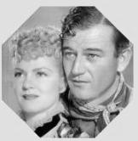
(John Wayne first big movie was Stagecoach
in 1939 with Claire Trevor)

John Wayne is co-pilot Dan Roman, one of whose passengers is May Holst (played by former co-star, Claire Trevor), who decides to go after Ken Childs, who is . . .

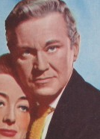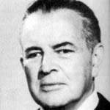
(David Brian as Ken Childs and Sidney
Blackmer as Humphrey Angew)

Stalked by Humphrey Agnew (Sidney Blackmer) who is sitting next to Jose Locota (John Qualen) . . . .

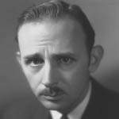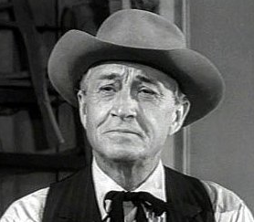
(John Qualen as Jose Locota and Paul Fix as Frank Briscoe)

Who sits across the aisle from Frank Briscoe (Paul Fix), in front of . . .

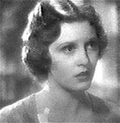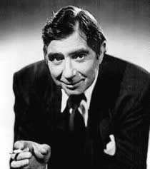
(Julie Bishop [formerly Jacqueline Wells]
and Robert Newton as the Pardees)

Lillian and Gustave Pardee (Julie Bishop and Robert Newton), who sit in front of . . . .

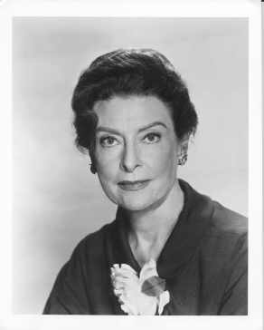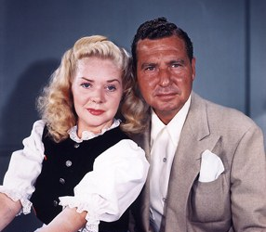
(The Josephs, played by Ann Doran and
Phil Harris, with real-life wife Alice Faye)

Ed and Clara Joseph (Phil Harris and Anne Doran), who sit across from . . . .

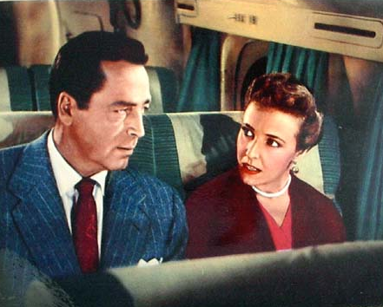
(John Howard and Loraine Day as the Rices)

Howard and Lydia Rice (John Howard and Loraine Day) and the four of them sit in the row in front of Dorothy Chen, who is . . . .

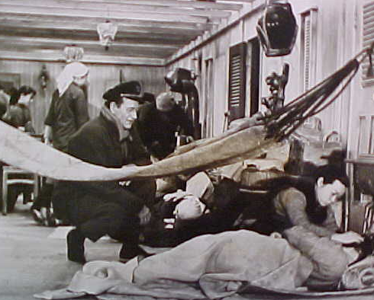
(John Wayne, left, and Joy Kim, lower right corner,
appeared together in Blood Alley the next year.)

Played by Joy Kim, who would later work with John Wayne in Blood Alley (1955) as he had appeared in Stagecoach with . . .


(Clair Trevor)

Clair Trevor.
Please excuse Maven while she catches her breath.
[In through the nose . . . out through the mouth . . . in through the nose . . . .]
There is a lot more to the plot of High and the Mighty, of course.
It set the tone for future disaster movies like the Airport movies, Towering Inferno, and The Poseidon Adventure: We are introduced to a group of people, played by well-known actors, who end up together in a situation that turns out to be . . . well . . . they’re called disaster movies for a good reason!
Were there disaster films before High and the Mighty?
There were films like San Francisco (1936) but they didn’t involve well-known actors as a small group of people in one place that frequently became claustrophobic during the course of the movie because of [place your favorite disaster here].
Besides . . . High and the Mighty is the only one that audiences had to wait decades to see.
Was it worth waiting for?
You bet!
Is it the perfect film?
No, but you won’t care once you start getting involved as the characters start to reacting to one another and the possibility of the plane crashing.
Take John Qualen’s Jose Locota, a family man on his way home to his family in San Francisco.
He’s one of those people who doesn’t have much in the way of worldly goods or experience and normally wouldn’t get any attention but his Locota ends up one of the good guys in this picture well worth rooting for! Especially when he becomes the self-appointed guard for Humphrey Agnew (Sidney Blackmer).
We certainly root for Pedro Gonzalez Gonzalez as a ship’s ham radio operator who helps out by contacting the mainland to start the rescue effort (including an adult Carl “Alfalfa” Switzer as a co-pilot in one of the rescue planes).
And there are several people that Maven would like to deck upside the head to shut them up, one being the aforementioned Humphrey Agnew who feels he has been cuckolded by Ken Childs (David Brian).
Lorraine Day is a whiny rich “witch” of a wife who spends most of the movie complaining on the many ways her husband is deficit.
The first real disaster film, John Wayne, Jordon Almonds and a bucket of hot buttered popcorn.
What a combination!

THE B-FEATURE: The Thing from Another World (1951)

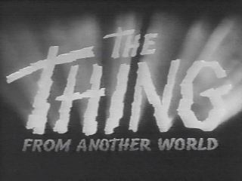

It’s hard to imagine Matt Dillon in a science fiction movie but he was, twice. Them! was made in 1954, the same year as High and the Mighty, and the other was The Thing from Another World (1951).

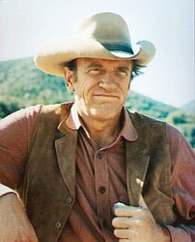
(James Arness in his ground-breaking role on television as Matt Dillon in
Gunsmoke [1955 – 1975] with a handful of movie sequels made in the 90s.)

It’s hard to imagine Matt Dillon as an alien from outer space in The Thing, but he was!

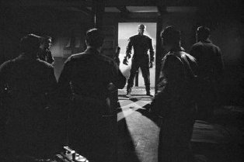
(James Arness as . . . The Thing . . . !)

The Thing from Another World was set up in the cold and wintery northern reaches of Canada.
A bunch of scientists in a research camp up there has called in the United States Air Force to help investigate a sudden and unexplained nearby crash.
Our intrepid Air Force finds the site and discover a saucer-shaped disc encased in ice.
They decide to get it out by trying to thaw the ice around it with a thermite bomb.
They manage to blow the unidentified flying disc up in the process.
(This was apparently overlooked in the booklet Bombs – What to Do and When to Do It . . . at www.sfmuseum.org/war/bombs.html!)
They do manage to find the pilot, still encased in ice.
Do they try to melt the ice around him?
No but they do try and chop the huge block of ice that he’s in and take him back to the research camp in their airplane.
We’re talking about getting a block of ice that’s supposed to be over seven feet long and maybe four feet deep dug out and into a plane that didn’t look like it had enough room for the men, their sled dogs and equipment.
And this before a blizzard sets in.
Makes Maven wonder what they would have done with his airship if they had had to get it back!

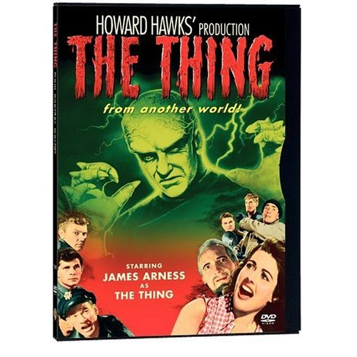
(A lobby card showing James Arness in close-up
and really needing a manicure.)

So they get the unidentified flying pilot to the camp and immediately get into an argument with the scientists about thawing the alien out or leaving him as an alien-sicle.
The Air Force wins out until one of the men put to guarding it covers the ‘sicle’s ugly snout with a blanket that he conveniently forgets is still plugged in.

Of course, we wouldn’t have a movie if he hadn’t de-iced the bugger!

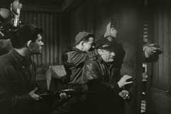
(Notice the Thing getting a hand
in on the right of this scene.)

Let’s give our favorite alien a hand for being resourceful in figuring out where the camp keeps its two-legged treats all ready for snacking.
Not to mention in figuring out how to store these same “goodies” for late night treats!
One of the scientists, Dr. Carrington, decides to start his own nursery from the seeds they find under the Creature’s palm skin, from when it lost its arm in a run-in with the camp’s sled dogs.

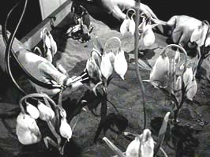
(Dr. Carrington’s Thing nursery.)

This Dr. Carrington (Robert Cornwaite) comes across as a comic book scientist, so single-minded in his trying to save the Thing for study that some in the audience might want to throw the kerosene on him instead of using it to sauté the Thing for dinner.

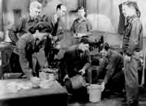
(Anyone for a fire-grilled Veggie Burger?!)

One difference in this science fiction movie from others is the secondary story between our hero and heroine: Captain Patrick Hendry (Kenneth Tobey) and Nikki Nicholson (Margaret Sheridan).

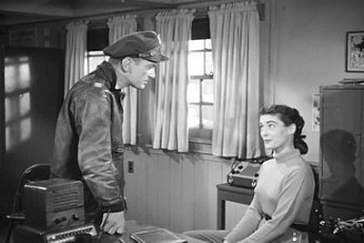
(Kenneth Tobey as Pat Hendry and
Margaret Sheridan as Nikki Nicholson)

Their relationship is woven in and out of the larger story, with Nikki teasing him about such things as her out-drinking him on their date down in Anchorage.
Margaret Sheridan’s portrayal of one of only two women on the base is rare in 1950s movies . . . her Nikki is not only assertive and self-sufficient while still feminine.
Just unusual is the men around her enjoy having her around and teasing Hendry about her being one of the guys.

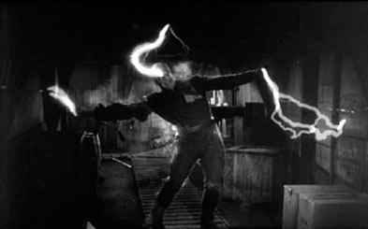
(James Arness’ Thing being voted the Hottest Man in Hollywood?!)

The Thing is finally reduced to nothing by the equivalent of an electric chair and Hollywood left it like that . . . no sequel that would dilute the effect of original until John Carpenter tried to remake it in 1982.
He proved, once again, that remakes don’t work . . . unless you prefer blood and guts and gore to good old-fashioned storytelling . . . .
How can you get better and/or scarier than Matt Dillon in an intergalactic carrot costume shopping for dinner among the United States Air Force?!
You can’t!

MAVEN’S CREAM OF THE CROP!

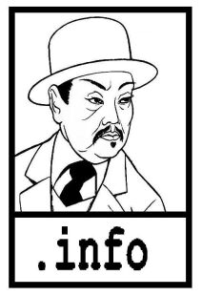

CHARLIE CHAN FAMILY – This is Rush Glick’s superb website devoted to the Great Chinese Detective based in Honolulu.
Rush is not only a gracious friend and teacher to Maven (among many!) but now he’s an expert that Fox Studio interviewed in their featurettes included in the boxed sets of their newly restored and released Chan DVDs.
Just click on www.charliechan.info!

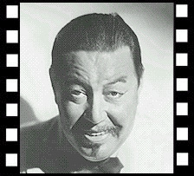

CHARLIE CHAN.NET – Kurt Schmidt has the message board that’s like a coffee house for Chan-aholics and has been around for some 10 years . . . longer than some marriages that Maven has known!
It’s just a click to www.charliechan.net!

TORY’S MYSTERY MOVIES – Maven has been getting movies from Doug Palmer for more years than she’s had her blogs and websites!
Doug has movies that Maven has never heard of . . . he’s that good! . . . plus various TV series and all worth checking out at www.torysmysterymovies.com/TorysAboutUs.cfm!

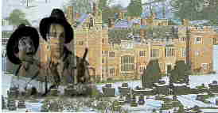
(Trillo and Suede’s Boxford Park and Lady Sarah)

TRILLO AND SUEDE – This is a link to Jonathan Geffner’s short subject, Boxford Park, starring his Trillo and Suede in a dummy noir story at www.trilloandsuede.com/movie.html.
You can download the movie at www.trilloandsuede.com/movielink.html that stars Lady Sarah, a delightful lady who can also be found at www.geffner.com.

<><><><><><><><><><><><><><><><><>

BACK ISSUES: Of The Old Movie Maven (aka TOMM)

VOLUME 1: Index is available for $10.00
VOLUME 1: Set (all the magazines) is now available for $10 and
back issues of The Old Movie Maven are $3.50 each,
and make your check or money order payable to:

Virginia Johnson
The Old Movie Maven
P.O. Box 54493
Hurst, TX 76054

Or theoldmoveimaven@yahoo.com
For any comments, questions and/or suggestions.

BACK ARCHIVES: Volume 1 Index
Available Upon Request

VOLUME 2 – Issue 1: LIFE BEHIND THE CAMERA: Or, Creative Chaos; Be There Giants?; Trini Lopez; Universal Studios’ Back Lots; The Death Kiss (1932); A Christmas Carol/Scrooge (1951); Betty Boop and Bugs Bunny; Forty-Second Street (1933); Trini Lopez; Forty-Second Street (1933); Dracula’s Daughter (1936); www.archive.org.

VOLUME 2 – Issue 2: THERE BE GIANTS HERE; Or, The Jolly Green Giant Runs Amuck!; Be There Giants?; DC-4; The Thing From Another World (1951); Boris Karloff in Son of Frankenstein (1939); Iverson Ranch Chatsworth, Los Angeles, CA; Brass Bancroft; Charlie Chan, Boris Karloff and Bela Lugosi; Sara Karloff; Son of Frankenstein (1939); The High and the Mighty (1954); The Thing From Another World (1951)

