April, 2007 VOLUME 2, Issue 4

The Old Movie Maven

LADIES’ NIGHT IN HOLLYWOOD;
Or, First Ladies, Shady Ladies and Oh, Mama!

~~~

The Old Movie Maven (TOMM) is published once a month for
those lovers of classic movies and the actors, directors,
costume designers, make-up artists, cameramen
and the other people who never got enough
credit for all their hard work
over the years.

COMMENTS, QUESTIONS AND SUGGESTIONS ABOUT SUBSCRIPTIONS AND BACK ISSUES CAN BE SENT TO

Virginia Johnson
Publisher/Editor

P.O. Box 54493 theoldmoviemaven@yahoo.com Hurst, TX 76054 http://theoldmoviemaven.tripod.com

SUBSCSRIPTION:
One (1) Issue - $ 3.00@
Six (6) Months - $15.00
One (12) Year - $30.00
Back Issues - $ 3.50 @

<><><><><><><><><><><><><><><><><>

ALL MOVIES ARE AVAILABLE COMMERCIALLY OR ON YOUR
LOCAL CABLE CHANNELS UNLESS OTHERWISE NOTED.

<><><><><><><><><><><><><><><><><>

TABLE OF CONTENTS:

FROM MAVEN’S DESK: PAGE: 3

ARCHITECTURE OF THE MONTH:
GONE WITH THE WIND (1939) PAGE: 15

BACK ISSUES: PAGE: 29

CARTOON CORNER: Popeye the Sailor Man PAGE: 5

CHILDREN’S CORNER: Nancy Drew (B. Granville) PAGE: 5

HOLLYWOOD MARRY-GO-ROUND
The Old Dark House and Laurence Olivier PAGE: 17

MAIN EVENT # 1: Dinner at Eight (1933) PAGE: 21

MAIN EVENT # 2: The Women (1939) PAGE: 25

MAVEN’S CREAM OF THE CROP: PAGE: 27

MAVEN’S SERIES: INNER SANCTUM –
Weird Woman (1944) PAGE: 9

PERSON OF THE MONTH: Aunt Sarah PAGE 17

QUOTES OF THE MONTH: The Women (1939) PAGE: 3

TRIVIA: W. C. Fields PAGE: 4

UNIVERSAL MONSTERS GENEALOGY:
The Ghost of Frankenstein (1942) PAGE: 10

WEBSITE OF THE MONTH: www.annegwynne.com PAGE: 4

<><><><><><><><><><><><><><><><><>

FROM MAVEN’S DESK: 

“Tonight is ladies’ night and the feeling’s right!”
That was a song from Kool and the Gang back in the day when Maven was just a little pamphlet but it’s still appropriate!
This month is the ladies’ issue: from Nancy Drew to Norma Shearer to Joan Crawford with something for everybody!
This issue marks a change—temporarily—in that you will be treated to two Main Events: Dinner at Eight (1933) to The Women (1939) with all star casts covering such diversity as Jean Harlow and Marie Dressler and Rosalind Russell and Paulette Goddard.

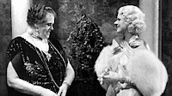
(Marie Dressler and Jean Harlow
in Dinner at Eight [1933])

The last two ladies had a cat fight in their script in the Reno part of the movie. Russell and Goddard did it good and proper with all the others threading in and out of the action but still . . . the two got the last word . . . er, bite in.
The whole thing was realistic to the point that Goddard had a permanent scar on her thigh where Russell bit her!
Plus an Adrian Fashion Show in color right in the middle of The Women.
[Too many copies of the movie have the section poorly integrated into the actual scenes but, heck, it’s still worth watching!]
So call the girls over, load up on the goodies and turn off the cell phones.
It’s Ladies’ Night Out in Hollywood!

QUOTES OF THE MONTH: The Women (1939)

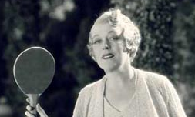
“Get me a bromide . . . and put some gin in it.”
Countess De Lave (Mary Boland)
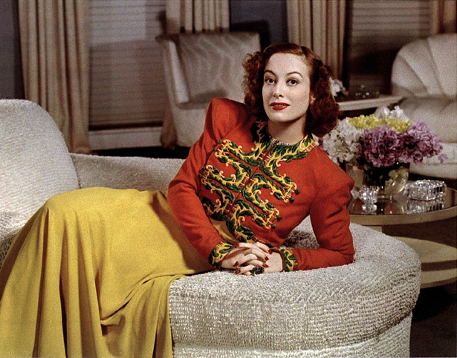
“There’s a name for you ladies but it isn’t used in high society
. . . except in a kennel.”
Crystal Allen (Joan Crawford)

TRIVIA: W.C. Fields

www.larrytt.com/celebrities_playing_tt/YouCantCheatAnHonestMan.gif

Maven came across this little snippet of W.C. Fields playing ping-pong with Ivan Lebedeff.
The woman to the right of Fields is listed as Constance Moore but looks more like middle-aged gossip columnist Hedda Hopper than the heroine in Missing Guest (1938).

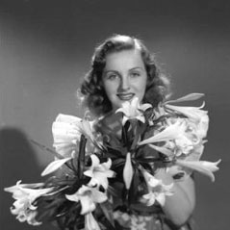
(The younger Constance Moore)

The younger Moore spent time at Universal, where she did such movies as Missing Guest (the remake of the 1933 Secret of the Blue Room) to singing parts at Republic Pictures in movies like Show Business (1944).
But there’s no mistaking the Fields inimitable style.
Where else would you find him playing ping pong but in The Old Movie Maven?!

WEBSITE OF THE MONTH: www.annegwynne.com

This website is devoted to Anne Gwynne who appeared in such movies as The Black Cat (1941), Flash Gordon Conquers the Universe (1940), The Strange of Dr. Rx (1942) and Weird Woman (1944), of course. (See Maven’s Series)
She was born in Waco, Texas, and went to Hollywood in 1939, a year that seemed to have the highest production of movies made ever from classics like GONE WITH THE WIND to Charlie Chan in the City of Darkness and Charlie McCarthy, Detective with Gwynne.

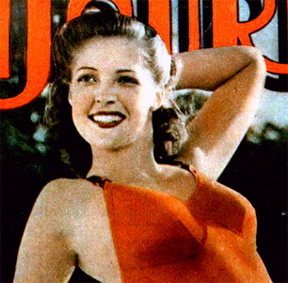
(Anne Gwynne)

She was Nan Kirkland in Murder in the Blue Room (1944), a remake of Secret of the Blue Room (1933) with Gloria Stuart as the heroine and the later The Missing Guest (1938) with Constance Moore. (See more on Moore in the Trivia section.)
Anne Gwynne gets to sing with an orchestra in . . . Blue Room and welcomes her show business friends, the Jazzy Belles (in the roles that had been meant for the Ritz Brothers).
Check out this website that has lots more of Gwynne: stills, pictures and articles all for clicking onto the website!

CARTOON CORNER: Popeye the Sailor Man

Maven has been asked about her Popeye cartoons: They are in the two disc 75th Anniversary Collector’s Edition of Popeye the Sailor Man Classic Cartoons.
Plus Olive Oyl, of course!
They are from VCI Entertainment (www.vcientertainment.com - # 8375) and cover the early Max Fleischer period (the thirties) and the later Famous Studio period (from 1942 to 1957).
The extras include commentary and liner notes by Jerry Beck, a top animation historian, and a “Popeye Classic Movie Poster Gallery.”
You’ll enjoy the artistry and the technical skill involved as you watch these versions . . . with or without your children.
Trust Maven since that’s how she watched them!
Plus, that way, you don’t have to share your popcorn, hot dogs or drinks with the kids either!

CHILDREN’S CORNER: Nancy Drew (Played by Bonita Granville)

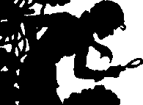

Nancy Drew has been a staple in Girls’ Literature since 1930.
It was inevitable that Hollywood would eventually get around to making movies of her.
But did they have to make a mish-mash of her?!

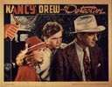
(Bonita Granville as Nancy Drew, Frankie Thomas as
“Ted” Nickerson and John Litel as Carson Drew)

How did Warner Bros. Studio start fouling the basic formula up?
Nancy’s ubiquitous boyfriend, Ned Nickerson, has inexplicably become “Ted”.
The Drews’ housekeeper, Hannah Gruen, has become “Effie,” the name of Hannah’s niece.
Nancy . . . the perfect . . . Nancy . . . who can do anything . . . Nancy . . . detective without peer . . . has become . . . Nancy . . . the whiner . . . Nancy . . . the can’t-do-squat . . . and, worst of all, . . . Nancy . . . the blond ditz.

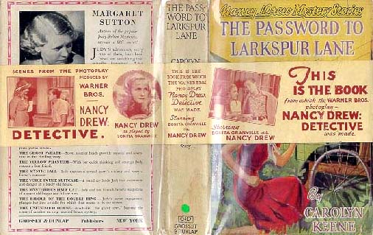
(The Password to Larkspur Lane . . . the basis
[loosely] of Nancy Drew, Detective)

At least two of the movies were based on books and Nancy Drew, Detective was one of them . . . from The Password to Larkspur Lane.
A wealthy alumna, Mary Eldredge, of Nancy’s school wants to donate $250,000 to the school and disappears before she turns over the money.
Nobody thinks anything of it except Nancy (Bonita Granville) who ropes Ted (Frankie Thomas) into helping her find the elderly Mrs. Eldredge.
Maven guesses that the original book character of Helen Corning wouldn’t draw the crowd they wanted and that’s why the studio added His Nibs, Mr. Nickerson.
Why change his name?
Maybe “Ned” just didn’t have any punch?
Whoever thought up the idea should have been the one who got punched.

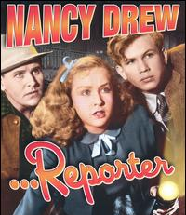
(Bonita Granville and Frankie Thomas)

In Nancy Drew, Reporter, our heroine finagles a chance to cover the trial of Eula Denning (Betty Amann), accused of murdering her benefactress for money.
This is a great entry.
Nancy tricks Ted into helping her.
She lies to get them into jail to see Denning.
She lies to get Ted into a gym so she can scout around.

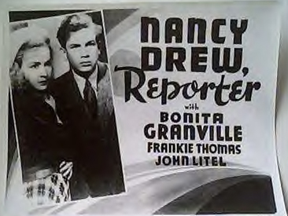
(Bonita Granville and Frankie Thomas)

She coerces Ted to lie over the phone to find out where a suspect lives.
They end up having to sing for their dinner in a Chinese restaurant.
And, sin of sins, Nancy tricks her father, Carson Drew (John Litel) into defending Eula Denning.
Lovely child, isn’t she?!
Can you say juvenile delinquent?

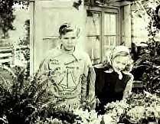
(Frankie Thomas and Bonita Granville
in Nancy Drew . . . Trouble Shooter)

NancyDrew . . . Trouble Shooter is another real pip.
Carson Drew finally has a chance for some female companionship, which always made Maven wonder just why his relationship with his daughter was played up in the books as being such a beautiful thing. Now Hollywood would have them on the couch being psychoanalyzed . . . if that.
On second thought . . . make that separate couches!
This movie also has Willie Best playing Apollo Johnson, the usual role where he’s supposed to be not only ignorant but very superstitious as well.
Rene Riano’s “Effie” isn’t much better. She’s directed to play the part more like Hannah Gruen’s niece who’s named “Effie” in the books—flighty and fidgety.
At least she has some reason to be in this movie since she ends up with poison ivy.

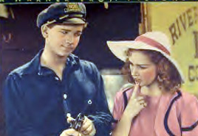
(Frankie Thomas with Bonita Granville looking
like she’s more a toddler than teenager!)

Nancy Drew and the Hidden Staircase is the other Drew movie based on one of the original stories: The Hidden Staircase.
The movie stays fairly close to the book where she helps two old ladies keep their house but with some glaring changes.
Nancy investigates the hidden staircase with Ted in broad daylight where she does it by herself in the middle of a rainy night by herself in the book.
Not only was there no “Ted,” “Ned,” or any other boyfriend in the original, Dad Drew was out of town for part of the story.
And the hidden staircase wasn’t nearly as long and scary as in the book where the ceiling leaked and rats ran around.
And the house with the staircase in the original story didn’t have any lights OR telephone.
Try explaining THAT to your cell phone-using grandkids!!!!

MAVEN’S SERIES: Inner Sanctum – Weird Woman (1944)

Universal Studios put out a six-movie series with Lon Chaney, Jr., that were unique at the very least:
Calling Dr. Death, 1943; Dead Man’s Eyes, Weird Woman, (1944); Frozen Ghost, Strange Confession (1945).

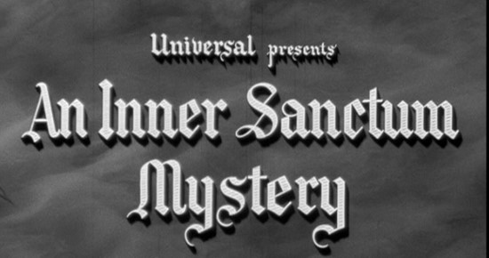

One of them was Weird Woman (1944) with Chaney playing opposite two of Universal’s most popular actresses, Evelyn Ankers and Anne Gwynne.

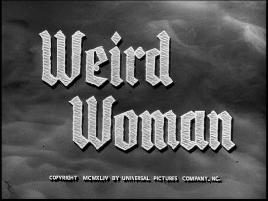

This movie brings together Ankers and Gwynne with Lois Collier, who were life-long friends after making so many movies at Universal.

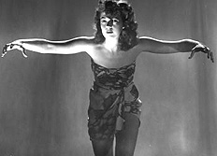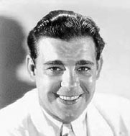
(Anne Gwynne and Lon Chaney, Jr.:
“Who do the voodoo that you do so well.”)

The story involves Lon Chaney is Norman Reed, an anthropologist studying the superstitions of a backwards native tribe that just happens to include Anne Gwynne as Paula Clayton.
They find that Reed had known her father, a well-known anthropologist who came to the island to study the voodoo practices that his daughter has taken to heart while growing up there.

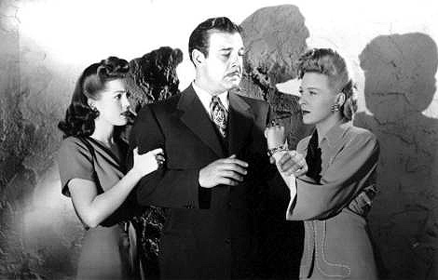
(Anne Gwynne, Lon Chaney and Evelyn Ankers)

The home-coming party that Ilona Carr (as Evelyn Ankers) gives in honor of Reed turns out to be a surprise party for her when he comes back with the much-younger Paula as his wife.
Carr tries to date up Reed anyway, married or not.

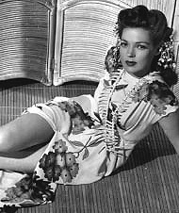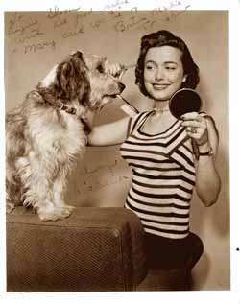
(Anne Gwynne and Lois Collier)

He won’t have any of it so Miss “Angry Ankers” decides to spend the rest of the movie trying to get rid of Gwynne by working against the newlyweds, even using two of the students: Margaret Mercer (Lois Collier) who works in her office and the boy who loves her, David Jennings (Phil Brown).

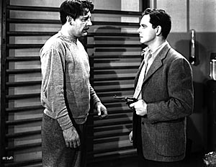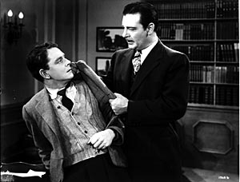
(Lon Chaney and Phil Brown)

Her plan goes unfortunately awry when the young Jennings decides to become Mercer’s white knight and goes after the Professor with a gun.
They struggle and . . . .
You guessed it.
The gun goes off, Jennings dies and Reed stands accused of Murder.
Is Weird Woman Shakespearean Theatre.
No but it (and the other INNER SANCTUM movies) have their own little niche for off-beat old-dark-house-mystery lovers for that dark and rainy hour or two!
Especially, the accompanying Strange Confession . . . but that’s for another issue of The Old Movie Maven!

UNIVERSAL MONSTER GENEALOGY:
The Ghost of Frankenstein (1942)

Let’s check the score card:
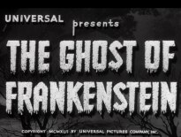

Dracula has (unofficially) three wives and one daughter.
Frankenstein has a Bride and gets his second son, Ludwig, in Ghost of Frankenstein (1942).
And Ghost . . . has our second cross-over: Ygor is again played by Bela Lugosi from Dracula (1931) but the Monster looks an awful lot like The Wolf Man, Lon Chaney, Jr.

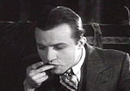
(Dwight Frye in a still from Dracula [1931])

The Son of Frankenstein (1939) left off with Baron Peter von Frankenstein and family becoming very touchy-feely with the citizens of the village Frankenstein.
Did it last?
Sure . . . until the beginning of The Ghost of Frankenstein when the locals are again in ferment . . . complete with an older Dwight Frye in a straight role as a villager.
The local citizenry complain to the city council about all the things going wrong in the area that they think is attributable to the now empty Frankenstein Castle.
Au contraire!
The council lets what is rapidly turning into a mob do what they want with the castle.
These days the city council would have to vote on it, demand permits and police protection, and try to tell them where they can meet and when.
So what happens?
They go to blow up the castle and discover that Ygor is still there and alive and well and . . . tada! He’s pushing the huge stones off the crenellation around the roof onto the locals below!
Isn’t that fun, kiddies!
Maven wonders whether she could use it on the Internal Revenue . . . . Never mind!

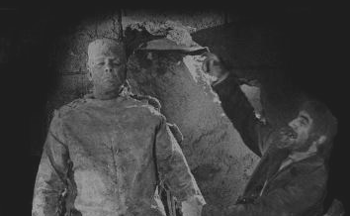
(Lon Chaney, Jr., as the Frankenstein
Monster and Bela Lugsoi as Ygor)

And what of . . . the Monster?
He’s still in the sulfur pit that has miraculously dried up since Son of . . . with the Monster inside.
At least until the castle falls apart courtesy of the villagers and that’s when we find out that the Monster . . . still lives!!
Maven wants to know where he got his insurance—Blue Cross/Blue Culture Dish?!
Igor gets him away from the castle into the open air where the Monster is struck several times by lightning that rejuvenates him.
Maybe Maven should skip her next botox injection . . . .

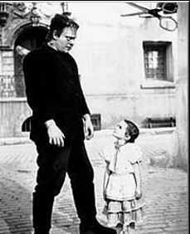
(Lon Chaney, Jr., as the Monster
and Janet Ann Gallow as Cloestine)

So Ygor and the Monster make their way to Ludwig von Frankenstein, M.D. and second son of Henry Frankenstein of Frankenstein (1931), who works with patients with diseased minds.

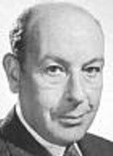
(Sir Cedric Hardwicke as
Ludwig Von Frankenstein)
The Monster meets a little girl who isn’t afraid him, the second time he encounters such a child after Little Maria in the original movie.
So what happens?
The villagers run amuck and corral him to lock him up . . . like that ever does any good . . . as Policeman Erik (Ralph Bellamy) goes to get Dr. Frankenstein for advice on what to do with the creature.
The doctor shows up and won’t admit to knowing the Monster.
That ticks the Monster into running amuck and lights out to Dr. Frankenstein’s place.
And Ghost . . . has our second cross-over: Ygor is again played by Bela Lugosi from Dracula (1931) but the Monster now looks an awful lot like The Wolf Man, Lon Chaney, Jr.
Dr. Frankenstein starts to dissect the Monster and who should pop up but dear old Dad (who looks suspiciously like Cedric Hardwicke) who urges him to continue on with Daddy’s goal . . . just maybe do him one better by using a new brain.
Guess who should show up and won’t play well with the others?!
Yep, and Dr. Frankenstein lets out his gas the Monster to stop him.
No, no, not that kind, which is what Maven has been tempted to use after some bad dates.
Unfortunately, Elsa and Dr. Kettering are also in the corridor and they end up whiffing the stuff as well.

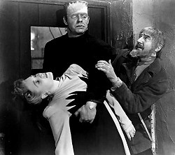
(Evelyn Ankers as Elsa, Lon Chaney as
the Monster and Bela Lugosi as Ygor)

Elsa recovers but Dr. K doesn’t.
“Dr. K.”
Sounds like a new health cereal, doesn’t it?
So the good doctor ends up freshening the Monster’s bolts as he decides to use the brain of his assistant, Dr. Kittering.
Ygor decides differently . . . he talks Dr. Bohmer (Dr. F’s other assistant played by Lionel Atwill) into using Ygor’s brain in the Monster’s body so they will both be immortal.

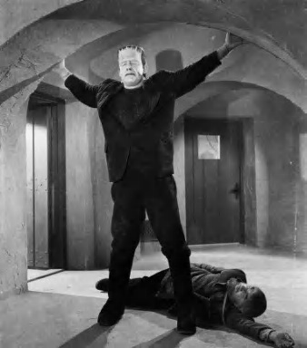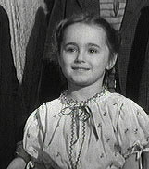
(Lon Chaney and Bela Lugosi on the left
and Janet Anne Gallow on the right)

Well, our friendly neighborhood Monster decides he wants the brain of little Cloestine instead so he kidnaps her.
Ygor talks Dr. Bohmer (Lionel Atwill) into using Ygor’s brain as Dr. Frankenstein and Elsa talk Cloestine away from the Monster and things go downhill from there.
The villagers run amuck . . . do they do anything else in these movies?! . . . as the Monster and Dr. Bohmer realize that the Monster is now blind since Ygor’s blood doesn’t match his and won’t feed his optical nerve.
Don’t you love the science in these films?!?!
Erik and Elsa manage to get out as the villagers burn up the building with the Monster inside and that’s the end of Universal’s Monster Series.
Yea, right!
If you look closely, that ain’t the real Monster burning up in the flames.
So . . . stay tuned!

NOTE: The Society to Prevent Cruelty to Animals was on hand to make sure that no monsters were injured during the filming of this movie.

Universal Studios Monster Genealogy

Dracula (1931) Frankenstein (1931)
| | Werewolf of London (1932)
| | | Invisible Man (1933)
| | | |
| The Bride of Frankenstein (1935) | |
Dracula’s Daughter (1936) | | |
| | | |
| | | |
| Son of Frankenstein (1939) | |
| | Peter | Invisible Man Returns (1940)
| | The Wolf Man (1941) |
| Ghost of Frankenstein (1942) | |
| | Ludwig | |
| | | (Evelyn Ankers | |
? ? ? ?
ARCHITECTURE OF THE MONTH:

TARA FROM GONE WITH THE WIND 1939

One of the crown jewels of movie-making in that golden year of 1939 was David O. Selznick’s GONE WITH THE WIND by Margaret Mitchell.

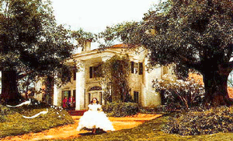
(GONE WITH THE WIND [1939] with
Vivien Leigh as Scarlett O’Hara)

The Atlanta-born Mitchell wrote GWTW from 1926 to 1929 while recovering from several injuries.

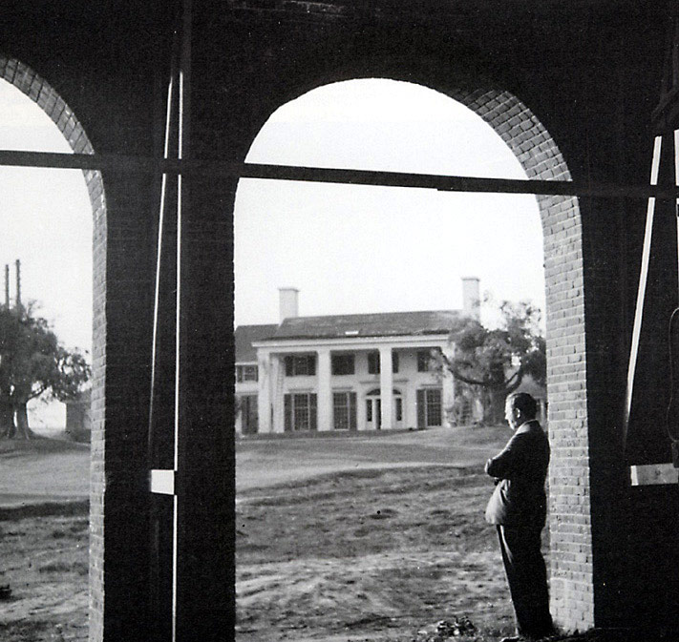
(Another view of Tara with David
O. Selznick in the foreground)

Kay Brown brought a pre-publication copy of it to the attention of her boss, David O. Selznick, in 1936 and urged him to buy it.

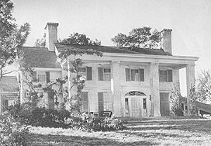
(Another view of Tara in 1939)

Which he did—for $50,000—a mere pittance in Hollywood, even in the middle of the depression.

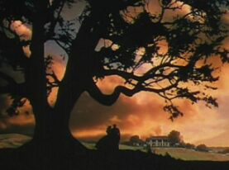
(The Intermission still of Scarlett and her
father, Gerald O’Hara, with Tara in the distance)

One major blooper that Selznick made, however, was that Scarlett O’Hara’s home, Tara, didn’t look like what he put up on the silver screen! It was originally slapped together as the O’Hara Family grew.

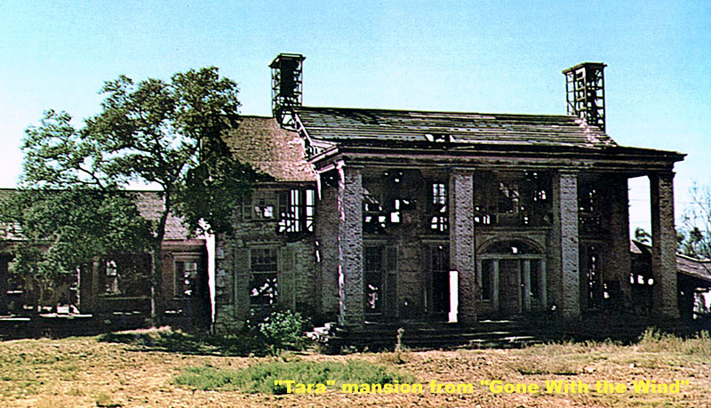
(Tara before it was torn down in 1959)

If you want to read more about Margaret Mitchell, you can check out www.gwtw.org/margaretmitchell.html.
For more on the movie GONE WITH THE WIND, you can look it up at David O. Selznick’s collection at www.hrc.utexas.edu/exhibitions/online/gwtw/ or at Internet Movie Database at www.imdb.com/title/tt0031381/.

HOLLYWOOD’S MARRY-GO-ROUND:

What does The Old Dark House of the early thirties have in common with Sir Laurence Olivier?

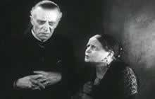
(Ernest Thesiger [Horace Femm] and Eva Moore
[Rebecca Femm] in The Old Dark House)
Eva Moore, who played Rebecca Femm in . . . House, was the mother of Jill Esmond, who was married to Laurence Olivier at the time.

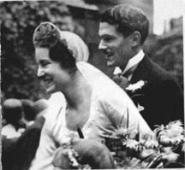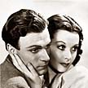
(Sir Laurence Olivier with his first wife Jill Esmond
[left] and with his second wife, Vivien Leigh)

Olivier began living with Vivien Leigh before they came to America and his divorce from Esmond went through in 1939.
That was the year that Leigh appeared in GONE WITH THE WIND and shortly before Olivier made Rebecca with Alfred Hitchcock in 1940.
Olivier and Leigh had to maintain separate living arrangements when they arrived in Hollywood for fear that their love affair would be found out.
You can’t tell who’s married to whom when without Maven, can you?!

PERSON OF THE MONTH: Aunt Sarah

Maven was privileged to interview a most interesting lady, Lady Sarah Weinstein, star of the Trillo and Suede movie, Oxford Park.

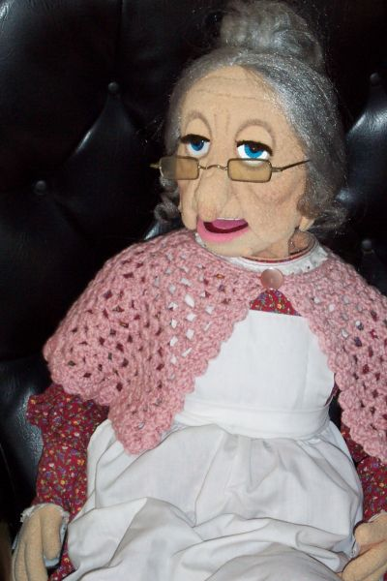
(Aunt Sarah)

I understand that you are a Lady in the English sense as well as in the sense of being a “gentlewoman”. . . . Did your family approve of our going into the acting profession?
My family approved of my doing anything that would get me out of our tenement apartment. There were a dozen of us crowded into one room. I had to share a suitcase with three siblings.

Did you have any formal training?
I had an on the job education. A talent scout discovered me one day as I was drinking a malted at Shmulik’s deli on Delancey Street, on New York’s Lower East Side. He immediately introduced me to Syd Chaplin, who was in New York casting a film called The Hoochy-koochy Dancer. I was cast in the lead role.
The film was a big success in its day, but has gone missing for decades.
Rumors suggest that it may be found together with another missing film, Charlie Chan Carries On, since the two films often played at theaters as a double feature.
By the way, the title of the Chan film refers to the fact that Chan was carrying on with me!

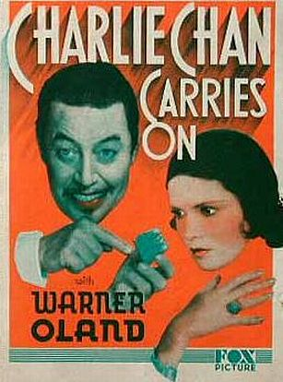
(Charlie Chan Carries On [1931] with Warner Oland as the
Detective and Marguerite Churchill as Pamela Potter)

How long have you know Jonathan Geffner and Company like Sam, Suzy, Sayid and the others?
Not long, only a couple of decades.

How do you all get along?
They’re a nice bunch, but they fail to appreciate my thespian talents for what they are. Modesty prevents me from commenting further.

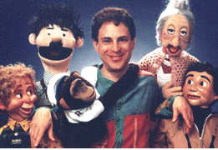
(Ezra, Shmendrik, Chippy, Jonathan,
Aunt Sarah and Sam)

When did you find out about Jonathan Geffner’s movie project, Boxford Park?
Jonathan showed me the script in 2004.

Did Jonathan and Ian Lewis [of the Farnham Film Company] want you from the get-go and write the role of Sarah, Lady Oxford, for you?
Jonathan had me in mind, of course, when he wrote it. When Ian met me, he realized Jonathan’s mistake immediately; I was clearly better suited to play the role of Laura, the young ingénue. But, sadly, that role had already been cast [with Catherine Bellamy].

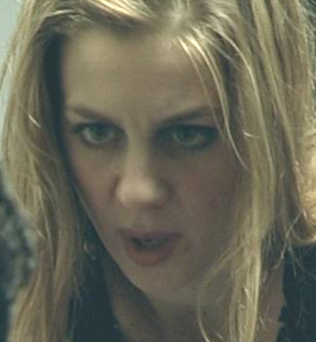
(Catherine Bellamy as Laura)

Did you know early on what a pivotal role you would have?
I was taken aback by the brevity of my role. This was quite foolish of Jonathan, not to better utilize my talents. But modesty prevents me from mentioning how many of my fans have insisted that my performance is the shining glory of the film.

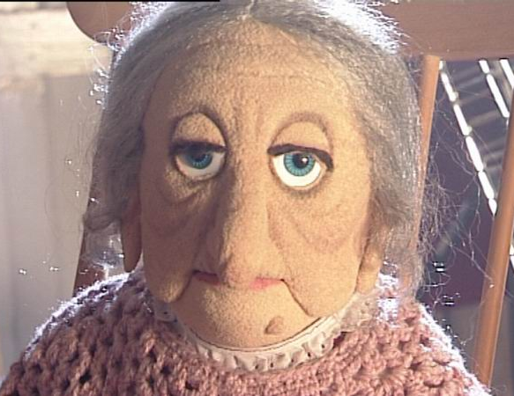
(Aunt Sarah)

Did you enjoy the change of scenery in England?
I love the overcast, rainy, gloomy, dark, dank, depressing English countryside.

Was it easy to work with a British cast?
Oh, yes, they appreciate a true thespian artist more than do their American counterparts. The girl who played Laura (Catherine Bellamy), in particular, was a doll.

Do you think there is a future in Dummy Noir?
It is the only film genre that will ultimately survive the test of time.

Maven’s readers want to know . . . there have been rumors about how well you knew Charlie Chaplin and his brother, Syd, that you were Charlie’s “protégé.” Can you comment?
I was the protégé of both Chaplins. They fought over me till their dying breaths.

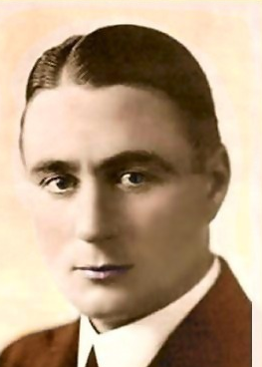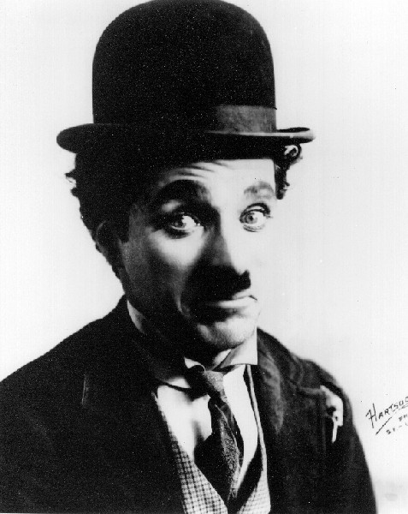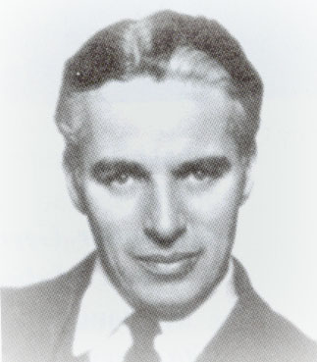
(Syd Chaplin and his brother Charlie Chaplin
as “The Little Tramp” and as himself.)

Is it true that you had to change your name to Penelope Blueblood for the title role in the Hollywood Epic The Shtetle Seductress?
Yes, it was deemed more fitting for my image.

And that Charlie was so jealous over you that Syd had to replace you so that they had to rework the project into what became The Great Train Robbery (1903)?
Quite true, but not the 1903 version, of course. It was the little known remake of 1923.

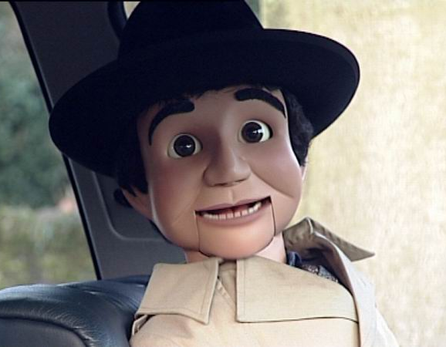
(Sam Suede, a frequent co-star of Aunt Sarah’s)

Do you have a favorite movie, actor, actress?
My favorite movie is Oxford Park.
Favorite actor? Sam Suede.
Favorite actress? Modesty prevents me.

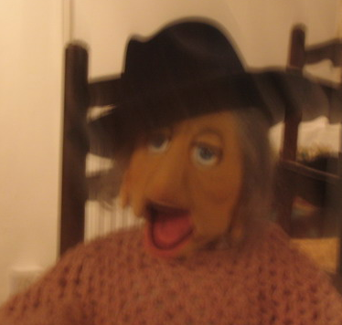
(Aunt Sarah as a chic member
of Frank Sinatra’s Rat Pack.)

What is your opinion of Effie Snodgrass, Charlie McCarthy’s lady friend?
A lovely gal, though a bit course.

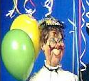
(Effie Snodgrass)

Do you feel like a lone standard bearer for Lady Dummies?
I have come to accept this burden of being the Quintessential Lady Dummy.

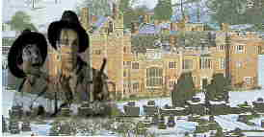
(From the Making of . . . Documentary)

By the way, if you have not yet done so, please watch the Making of . . . documentary on the www.trilloandsuede.com web site. It contains a lovely interview with me.

THE MAIN EVENT # 1: Dinner at Eight (1933)

Can you imagine Jean Harlow on the same movie set as The Wizard of Oz’s Glenda the Good Witch?
How about Lionel and John Barrymore in the same movie without appearing in any scenes together?!

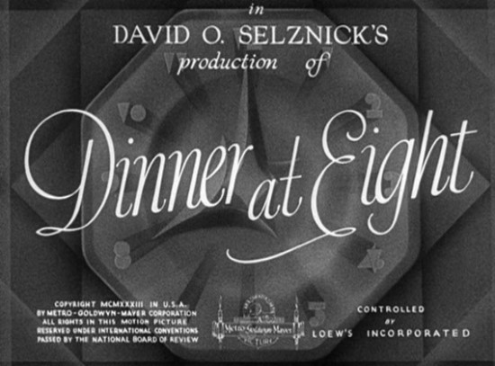

That is exactly what you get in Dinner at Eight (1933).
Millicent Jordan (Billie Burke) finds out that Lord Ferncliff is visiting from New York so she gets busy planning a dinner for them on Friday night at 8 o’clock.
Then the stuff hits the fan as we find out what the hosts and guest do to and with each other as the dinner approaches.

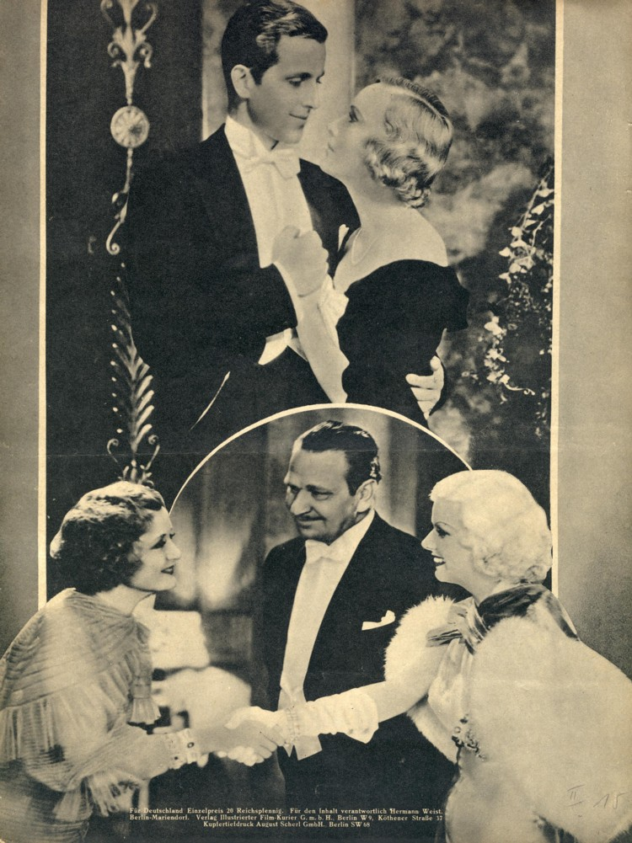
(Top, Philip Holmes and Madge Evans; Bottom, from
left, Billie Burke, Wallace Beery and Jean Harlow)

There is Millicent’s husband, Oliver Jordan (Lionel Barrymore), and her daughter, Paula (Madge Evans).

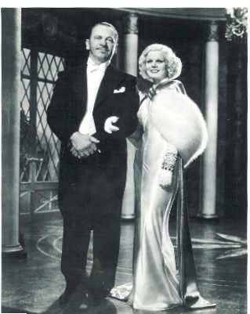
(Lionel Barrymore and Jean Harlow,
looking like Beauty and the Beast)

Oliver spends most of the movie worrying about his family shipping company going under, not knowing that he has wanted Dan Packard (Wallace Beery) to be invited to dinner—The very man who is trying to buy up Jordan’s Shipping Line.

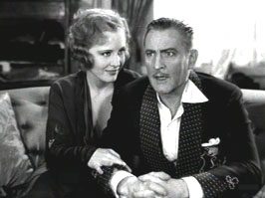
(Madge Evans and John Barrymore)

Paula wants to call off her engagement to Ernest DeGraff (Phillip Holmes) because she’s in love with Larry Renault (John Barrymore).
He’s in New York to get work in a play that’ll put his career back on the right track.

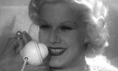
(Jean Harlow)

Dan Packard’s wife, Kitty (Jean Harlow), wants to go to the Jordans’ dinner for Lord Ferncliff about as much as she wants to continue the affair that she’s having with Dr. Wayne Talbott (Edmund Lowe).
And then there is Marie Dressler.
The fabulous Marie Dressler.
In a field of beautiful thoroughbreds, Marie Dressler is a Clydesdale that helps pull the Budweiser truck.
You know the ones . . . the ones that may be big but they can carry whatever you throw at ‘em!

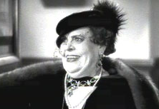
(Marie Dressler as Carlotta Vance)

She plays a former actress who held her audiences (especially the men) in her thrall in her youth and she’s returned to New York for help converting the “gifts” of former admirers into cash.
Which brings her to Oliver Jordan’s offices in hopes that he can buy her Jordan stock—the only things she ever bought for herself.
He can’t afford to and turns to his next guest for help, Dan Packard (Wallace Beery), who’s too busy cheating Jordan to realize that his wife, Kitty (Jean Harlow), is carrying on with Dr. Talbott who later gives Jordan a check-up that reveals that his heart is giving out.
The balance of the movie revolves around how these characters interact but you have to give credit especially to Dressler and Harlow who steal every scene they’re in.
Marie Dressler is a delight whether she’s remembering the soft spot she developed for Jordan when he wanted to marry her years before, trying to get along with his wife, Millicent (Billie Burke), or telling Paula Jordan that her great lover, Larry Renault (John Barrymore) has . . . .
Maven can’t tell everything!
But she can tell you that Jean Harlow is superb as Kitty Packard, going from doing her baby talk to get her husband to go to the Jordan’s for dinner to giving Wallace Beery as her husband as good as she gets.
The supreme moment of the movie, however, is at the last but well worth it.
Everyone is going in to dinner at the Jordans’ and Dressler and Harlow are bringing up the rear when Harlow stops and announces that she recently read a nutty kind of a book about civilization.
Dressler stops dead in her tracks at the idea of Harlow even knowing what a book IS and then Harlow tells her that “machinery is going to take place of every profession?”

(Marie Dressler as Carlotta Vance
and Jean Harlow as Kitty Packard)

Marie Dressler looks Jean Harlow up and down and says, “My dear, that is something that YOU need never worry about!”

THE MAIN EVENT #2: The Women (1939)

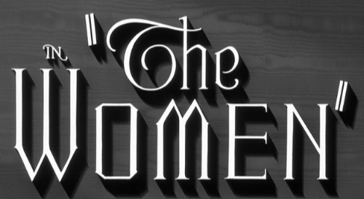

The Women (1933) was originally a Broadway play written by Clare Booth (later Luce) that became a successful movie with some 150 parts that were all played by women and girls.

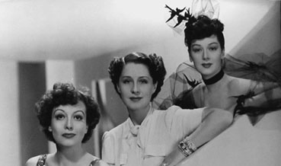
(Joan Crawford as Chrystal Allen, Norma Shearer as
Mary Haines, and Rosalind Russell as Sylvia Fowler)
It became two hours and twenty minutes marathon of women talking about men, gossiping about other women and conspiring to get around these other women to get their hooks into the men they were talking about.
Sounds like the military should have recruited the cast into the army and navy and sic-ed them on the Axis Powers.
We would never have had the second world war if they had used these “ladies”!! One glance at these females advancing and any army would surrender!!
It all starts off with Sylvia Fowler (Rosalind Russell) finds out a juicy tidbit of news about her cousin, Mary Haines (Norma Shearer)—Mary’s husband is “seeing” a salesclerk, Crystal Allen (Joan Crawford).
Sylvia phones Edith Potter (Phyllis Povah) to clue her in before they both show up at Mary’s for lunch.

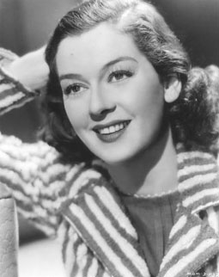
(Rosalind Russell – Sylvia Fowler)

Will Mary find out?
Will her “friends” tell her?
Will Mary and Crystal ever come face to face?
Does this sound like a really boring movie?!

(Joan Crawford as Crystal Allen).

Yep, but for two things.
One is the behind-the-scenes rivalry between Joan Crawford and Norma Shearer, widow of former M-G-M producer Irving Thalberg.
They would show up at the set and sit there in their cars, waiting, until director George Cukor ordered them into the sets.
This kind of thing boils over onto the screen.
Then came the one scene the two actresses had together:*

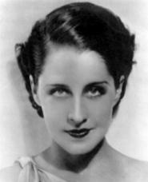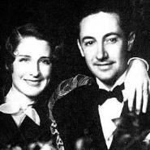
(Norma Shearer – Mary Hanes – and
with her husband, Irving Thalberg)

Crawford was prepared to deliver the offstage lines, as she always did for other actors (lazier stars retired to their dressing rooms and allowed the script clerk or director to “feed” the lines). She positioned herself in a chair at the side of the camera and took out her knitting. She was working on an afghan that required large needles.
Norma delivered her lines in front of the camera. Joan answered with her lines, but she never looked at Norma. She continued gazing at her knitting. The needles moved at a furious pace, and they clicked. Loudly, “Joan, darling, I find your knitting distracting,” Norma said.
Joan seemed not to hear. The scene continued, and the flashing needles grew louder. The tension mounted and crew members looked from the irritated Shearer to the oblivious Crawford, then to Cukor, who seemed like an unwilling explorer on the brink of a volcano. Again Norma started the scene, and again Joan’s needles distracted her. “Mr. Cukor,” Norma said with icy control, “I think that Miss Crawford can go home now and you can give me her lines.”

Cukor dragged Crawford off the set, bawled her out and told her she’d have to apologize to Shearer when Crawford returned to the set the next day.
Crawford showed up but without apologizing and Shearer remained icy to her for the rest of the scene.

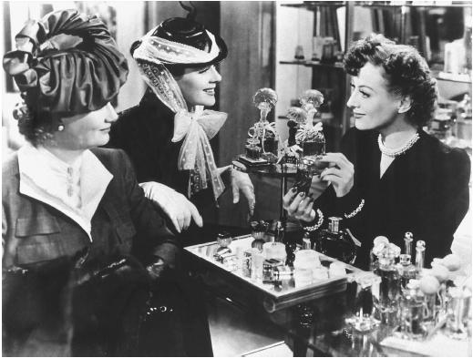
(Phyllis Povah as Edith Potter, Rosalind Russell as
Sylvia Potter and Joan Crawford as Crystal Allen)

The rest of the movie has that edge, from Sylvia and Edith sneaking around to find “the other woman”—Crystal—to Sylvia joining Mary in Reno, Nevada, and landing smack in the middle of a cat fight with Paulette Goddard as Miriam Aarons, the other woman in Sylvia’s own marriage to Sylvia getting her comeuppance in a night club ladies’ lounge.
Myrna Loy wrote about appearing in a revival of the play, grateful that things had changed for women.
Maven read that and realized that Myrna Loy never knew the women in Maven’s family!!!

*Joan Crawford: A Biography by Bob Thomas, Simon and Schuster, 1978, New York, pages 132 - 3

<><><><><><><><><><><><><><><><><>

MAVEN’S CREAM OF THE CROP!

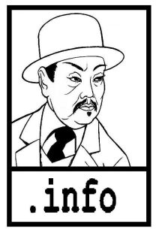

CHARLIE CHAN FAMILY – This is Rush Glick’s superb website devoted to the Great Chinese Detective based in Honolulu.
Rush is not only a gracious friend and teacher to Maven (among many!) but now he’s an expert that Fox Studio interviewed in their featurettes included in the boxed sets of their newly restored and released Chan DVDs.
Just click on www.charliechan.info!

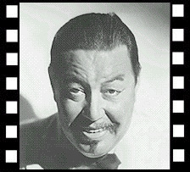

CHARLIE CHAN.NET – Kurt Schmidt has the message board that’s like a coffee house for Chan-aholics and has been around for some 10 years . . . longer than some marriages that Maven has known!
It’s just a click to www.charliechan.net!

TORY’S MYSTERY MOVIES – Maven has been getting movies from Doug Palmer for more years than she’s had her bogs and websites!
Doug has movies that Maven has never heard of . . . he’s that good! . . . Plus various TV series and all worth checking out at www.torysmysterymovies.com/TorysAboutUs.cfm!

(Trill and Suede’s Oxford Park and Lady Sarah)

TRILLO AND SUEDE – This is a link to Jonathan Heffner’s short subject, Oxford Park, starring his Trill and Suede in a dummy noir story at www.trilloandsuede.com/movie.html.
You can download the movie at www.trilloandsuede.com/movielink.html that stars Lady Sarah, a delightful lady who can also be found at www.geffner.com.

<><><><><><><><><><><><><><><><><>

BACK ISSUES: Of The Old Movie Maven (aqua TOMM)

Back issues of The Old Movie Maven are $3.50 each,
and make your check or money order payable to:

Virginia Johnson
The Old Movie Maven
P.O. Box 54493
Hurst, TX 76054

BACK ARCHIVES: Volume 1 Index
Available Upon Request

VOLUME 2 – Issue 1: LIFE BEHIND THE CAMERA: Or, Creative Chaos; Be There Giants?; Trini Lopez; www.archive.com; Universal Studios’ Back Lots; The Death Kiss (1932); A Christmas Carol/Scrooge (1951); Betty Boop and Bugs Bunny; Forty-Second Street (1933); Trini Lopez; Forty-Second Street (1933); Dracula’s Daughter (1936); www.archive.org.

VOLUME 2 – Issue 2: THERE BE GIANTS HERE; Or, The Jolly Green Giant Runs Amuck!; Be There Giants?; www.jamesarness.com; DC-4; The Thing From Another World (1951); Boris Karloff in Son of Frankenstein (1939); Iverson Ranch Chatsworth, Los Angeles, CA; Brass Bancroft; Charlie Chan, Boris Karloff and Bela Lugosi; Sara Karloff; Son of Frankenstein (1939); The High and the Mighty (1954); The Thing From Another World (1951).

VOLUME 2 – Issue 3: SPOOKTACULAR HOLLYWOOD; Or, They Really Do See Dead People!; A Curse on Your House!; Trivia – Part 1: The Maltese Falcon (1941); Trivia – Part 2: The Wolf Man (1941); www.snopes.com/movies/films/ozsuicide.asp; Charlie Chan . . . Psychic?; Return to Glennascaul (1951); The Wolf Man (1941); Hollywood and the Supernatural and The Wolf Man; The Wild Goose; Evelyn Ankers; The Magnificent Ambersons (1942); Haunted Gold (1932) with John Wayne.

VOLUME 2 – Issue 4: LADIES’ NIGHT IN HOLLYWOOD; Or, First Ladies, Shady Ladies and Oh, Mama!; Trivia – W.C. Fields; www.annegwynne.com; Popeye the Sailor Man; Nancy Drew (Played by Bonita Granville); INNER SANCTUM – Weird Woman (1944); The Ghost of Frankenstein (1942); HOLLYWOOD’S MARRY-GO-ROUND; Lady Sarah Weinstein; Dinner at Eight (1933); The Women (1939)

